**MINISTRY OF EDUCATION AND TRAINING**

**FPT UNIVERSITY**

Capstone Project Document

Smart Buy

|  |  |
| --- | --- |
| **Group 1** | |
| **Group member** | Doan Ho Anh Triet – Team Leader – SE60763  Huynh Thanh Viet – Team Member - SE60666 (Dropped out)  Dang Huu Hoang – Team Member - 60486  Tran Trung Dung – Team Member - 60236 |
| **Supervisor** | Mr. Kieu Trong Khanh |
| **Ext. Supervisor** | N/A |
| **Capstone Project code** | SmartB |

-Ho Chi Minh City, 01/2014-

*This page is intentionally left blank*

***ACKNOWLEDGEMENTS***

We wish to thank various people for their contribution to this project: Our teachers for their advice and participation in the final review, our friends for their valuable technical support.

Special thanks should be given to Mr. Kieu Trong Khanh, our research supervisor for his professional guidance and the useful, constructive recommendations throughout the course of this project.

# Table of Contents

Table of Contents 4

List of Tables 7

List of Figures 9

Definitions, Acronyms, and Abbreviations 12

A. Introduction 13

1. Project Information 13

2. Introduction 13

3. Problem Definition 13

4. Proposed Solution 13

4.1 Feature functions 13

4.2 Advantage and disadvantage 13

5. Functional Requirement 14

5.1 Data Management 14

5.2 Suggestion 14

5.3 View Price 14

5.4 User Management 14

5.5 Market Management 14

5.6 Mobile Device 14

6. Role and Responsibility 14

B. Software Project Management Plan 15

1. Problem Definition 15

1.1 Name of this Capstone Project 15

1.2 Problem Abstract 15

1.3 Project Overview 15

2. Project organization 16

2.1 Software Process Model 16

2.2 Roles and responsibilities 17

2.3 Tools and Techniques 18

3. Project Management Plan 19

3.1 Iteration 19

3.2 Iteration Detail 20

3.3 All Meeting Minutes 22

4. Coding Convention 22

C. Software Requirement Specification 24

1. User Requirement Specification 24

1.1 Guest Requirement 24

1.2 Member Requirement 24

1.3 Staff Requirement 24

1.4 Admin Requirement 24

1.5 System Requirement 24

2. System Requirement Specification 24

2.1 External Interface Requirement 24

2.2 System Overview Use Case 26

2.3 List of Use Case 26

3. Software System Attribute 65

3.1 Usability 65

3.2 Reliability 65

3.3 Availability 65

3.4 Security 65

3.5 Maintainability 65

3.6 Portability 66

3.7 Performance 66

4. Conceptual Diagram 67

Data Dictionary 68

D. Software Design Description 69

1. Design Overview 69

2. System Architectural Design 70

3. Component Diagram 71

4. Detailed Description of Components 72

4.1 Class Diagram 72

4.2 Class Diagram Explanation 73

4.3 Sequence Diagram 77

5. User Interface Design 81

5.1 Guest, Member Design 81

5.2 Admin Interface Design 93

5.3 Staff Interface Design 96

5.4 Mobile Interface Design 113

6. Database Design 122

6.1 Entity Relationship Diagram 122

6.2 Data Dictionary 123

7. Algorithms 128

7.1 Dynamic Programming 128

7.2 String Comparison 130

E. System Implementation & Test 132

1. Introduction 132

1.1 System Overview 132

1.2 Test Approach 132

2. Database Relationship Diagram 133

3. Performance Measures 134

3.1 Parser Performance 134

3.2 Suggestion Algorithm Performance 134

4. Test Plan 134

4.1 Features to be tested 134

4.2 Features not to be tested 134

5. System Testing Test Case 135

5.1 Guest Test Case 137

5.2 Member Test Case 142

5.3 Staff Test Case 147

F. Software User’s Manual 151

1. Installation Guide 151

1.1 Setting up environment at server site 151

1.2 Deployment at server side 151

1.3 Setting up the environment at client side 155

2. User Guide 157

2.1 Guest/Member Guide 157

2.2 Mobile Guide 162

2.3 Staff Guide 168

G. Appendix 175

# List of Tables

Table 1: Roles and Responsibility 14

Table 2: Hardware Requirement for Server 16

Table 3: Hardware Requirement for Mobile App 16

Table 4: Roles and Responsibility Details 18

Table 5: Iteration 20

Table 6: Phase 1: Preliminary Investigation or Analysis 20

Table 7: Phase 2: Data Management 20

Table 8: Phase 3: Main User’s Functions 21

Table 9: Phase 4: Suggestion Algorithm 21

Table 10: Phase 5: Market Management 22

Table 12: <Admin> Create User 28

Table 13: <Admin> Update User 29

Table 14: <Admin> Activate User 31

Table 15: <Admin> Deactivate User 32

Table 16: <System> Auto Parse Data 34

Table 17: <Staff> Configure System 36

Table 18: <Staff> Import File 45

Table 19: <Staff> Manually Input Data 47

Table 20: <Staff> Update Product 48

Table 21: <Staff> Deactivate Product 50

Table 22: <Staff> Activate Product 51

Table 23: <Member> Search Product and View Product Price 53

Table 24: <Member> Add Product To Cart 54

Table 25: <Member> Propose Price 56

Table 26: <Member> Save Product History 57

Table 27: <Member> Define Route 59

Table 28: <Member> Ask For System Suggestion 60

Table 29: <Member> Logout 61

Table 30: <Guest> Login 63

Table 31: <Guest> Register 65

Table 32: Entity Data dictionary - Describe content of all entities 68

Table 33: Entity Data Dictionary 123

Table 34: Attribute Data Dictionary 127

Table 35: Search Product Test Case 138

Table 36: Add To Cart Test Case 139

Table 37: View Cart Test Case 141

Table 38: View Report Test Case 142

Table 39: Define Routes Test Case 142

Table 40: Ask For Suggestion Test Case 143

Table 41: Save History Test Case 144

Table 42: Propose Price Test Case 146

Table 43: Manage Parser Test Case 147

Table 44: Manage Import Data Test Case 149

Table 45: Train Machine Test Case 150

Table 46: Login Steps 157

Table 47: Define Routes Steps 158

Table 48: Search Product Steps 159

Table 49: Propose Price Steps 160

Table 50: Suggest Route Steps 160

Table 51: View Cart Steps 161

Table 52: View History Steps 161

Table 53: View History Detail Steps 162

Table 54: Login Mobile Steps 162

Table 55: View Favourite Product Mobile Steps 163

Table 56: Search Product Mobile Steps 164

Table 57: Propose Price Mobile Steps 164

Table 58: View Cart Mobile Steps 165

Table 59: View Suggestion Mobile Steps 166

Table 60: View Map Mobile Steps 167

Table 61: View History Mobile Steps 167

Table 62: View History Detail Mobile Steps 168

Table 63: Save Imported Data Steps 169

Table 64: Handle Name Conflict Steps 170

Table 65: Create Parser Steps – 1 171

Table 66: Create Parser Steps - 2 174

# List of Figures

Figure 1: Agile Development Model 17

Figure 2: System Overview Use Case 26

Figure 3: <Admin> Overview Use Case 26

Figure 5: <Admin> Create User 27

Figure 6: <Admin> Update User 28

Figure 7: <Admin> Activate User 30

Figure 8: <Admin> Deactivate User 31

Figure 9: <System> Overview Use Case 32

Figure 10: <System> Auto Parse Data 32

Figure 11: <Staff> Overview Use Case 34

Figure 12: <Staff> Configure System 34

Figure 13: <Staff> Force Parse Data 36

Figure 14: <Staff> Create Market 37

Figure 15: <Staff> Update Market 39

Figure 16: <Staff> Deactivate Market 40

Figure 17: <Staff> Activate Market 42

Figure 18: <Staff> Import File 43

Figure 19: <Staff> Manually Input Data 45

Figure 20: <Staff> Update Product 47

Figure 21: <Member> Overview Use Case 51

Figure 22: <Member> Search Product and View Product Price 52

Figure 23: <Member> Add Product To Cart 53

Figure 24: <Member> Propose Price 54

Figure 25: <Member> Save Product History 56

Figure 26: <Member> Define Routes 57

Figure 27: <Member> Ask for system suggestion 59

Figure 28: <Member> Logout 60

Figure 29: <Guest> Overview Use Case 62

Figure 30: <Guest> Login 62

Figure 31: <Guest> Register 63

Figure 32: Conceptual Diagram 67

Figure 33: MVC Architecture 70

Figure 34: Component Diagram 71

Figure 35: Class Diagram 72

Figure 36: Force Parse Data Sequence Diagram 77

Figure 37: Import Excel Sequence Diagram 77

Figure 38: Propose Price Sequence Diagram 78

Figure 39: Save Product History Sequence Diagram 78

Figure 40: View Product History Sequence Diagram 79

Figure 41: View History Detail Sequence Diagram 79

Figure 42: Search Product Sequence Diagram 80

Figure 43: Configure System Sequence Diagram 80

Figure 44: Ask For System Suggestion Sequence Diagram 81

Figure 45: Guest Home Page 81

Figure 46: Login 83

Figure 47: Register Page 84

Figure 48: Member Home Page 85

Figure 49: Search Page 86

Figure 50: Propose Price 87

Figure 51: View Cart 88

Figure 52: Buying History 89

Figure 53: History Details 90

Figure 54: Suggest Route 91

Figure 55: Account Detail 92

Figure 56: Change Password 93

Figure 57: Admin/Staff Login Page 94

Figure 58: User List Page 95

Figure 59: Create New User Page 96

Figure 60: Train Machine Page 96

Figure 61: Import Excel – Correct Data List 98

Figure 62: Import Excel – Error Data List 99

Figure 63: Import Excel - Name Conflict 100

Figure 64: Manage Proposed Price Page 101

Figure 65: Configure System 103

Figure 66: Manage Product 104

Figure 67: Create New Product 105

Figure 68: Manage Market 106

Figure 69: Create New Market 107

Figure 70: Manage Parser 108

Figure 71: Create Parser - Step 1 109

Figure 72: Create Parser - Step 2 110

Figure 73: Create Parser - Step 3 110

Figure 74: Create Parser - Step 4 111

Figure 75: Create Parser - Step 5 111

Figure 76: Create Parser - Step 6 112

Figure 77: Manage Log File 112

Figure 78: <Mobile> Login 113

Figure 79: <Mobile> Favourite Products 114

Figure 80: <Mobile> View Cart 115

Figure 81: <Mobile> View History 116

Figure 82: <Mobile> View History Details 117

Figure 83: <Mobile> Search Product 118

Figure 84: <Mobile> Propose Price 119

Figure 85: <Mobile> Suggest Route List View 120

Figure 86: <Mobile> Suggest Route Map View 121

Figure 87: Entity Relationship Diagram 122

Figure 88: Database Relationship Diagram 133

Figure 89: Guest, Member Core Flow 135

Figure 90: Staff, System Core Flow 136

Figure 91: Prepare deployment package 151

Figure 92: Deploy database – 1 152

Figure 93: Deploy database - 2 152

Figure 94: Configure Server before deploy – 1 153

Figure 95: Deploy web application on server – 1 153

Figure 96: Deploy web application on server – 2 153

Figure 97: Deploy web application on server – 3 154

Figure 98: Deploy web application on server – 4 154

Figure 99: Change Settings 155

Figure 100: Download app 156

Figure 101: Install App 156

Figure 102: Login Page 157

Figure 103: Defines Route Page 157

Figure 104: Search Product Page 158

Figure 105: Propose Price UI 159

Figure 106: Suggest Route Page 159

Figure 107: View Cart Page 160

Figure 108: View History Page 160

Figure 109: View History Detail Page 161

Figure 110: Login Mobile 161

Figure 111: View Favourite Product Mobile 162

Figure 112: Search Product Mobile 162

Figure 113: Propose Price Mobile 163

Figure 114: View Cart Mobile 163

Figure 115: View Suggestion Mobile 164

Figure 116: View Map Mobile 165

Figure 117: View History Mobile 165

Figure 118: View History Detail Mobile 166

Figure 119: Save Imported Data Page 167

Figure 120: Handle Name Conflict Page 168

Figure 121: Create Parser Page - 1 169

Figure 122: Create Parser Page – 2 169

Figure 123: Create Parser Page – 3 170

Figure 124: Create Parser Page – 4 170

Figure 125: Create Parser Page – 5 171

Figure 126: Create Parser Page – 6 171

# Definitions, Acronyms, and Abbreviations

|  |  |  |
| --- | --- | --- |
| **No.** | **Abbreviation & Acronym** | **Definition** |
| 1 | SmartB | Smart Buy |
| 2 | OS | Operation System |
| 3 | Admin | Administrator |
| 4 | API | Application Programming Interface |
| 5 | HTTP | Hyper Text Transfer Protocol |

# Introduction

## Project Information

* Project name: **Smart Buy**
* Project Code: **SmartB**
* Product Type: **Website, Phone Application**
* Start Date: **January 7th, 2014**
* End Date: **April 14th, 2014**

## Introduction

People go shopping every day. They buy clothes, books, stationeries, etc… and most importantly - food. They often buy them at their familiar markets, or the nearest one. Today, together with the growing use of smart phones, we should find a smarter way to do our daily jobs, such as shopping. To achieve this, we have to resolve the most important problem of shopping: price. How can we know that the price of a product is not too high? Or somewhere else has better price? Our system will, therefore, help users to find the price of a product in the market, keep track of the price fluctuation, suggest the best way to buy a list of products, etc…

## Problem Definition

The problem raises when people want to buy food for their meal, but they do not know how much it is.

* If they are at home, they have to go to many websites to estimate the price, because the price is not the same in many websites.
* If they are at the market, they only know the price which the seller tells them. They have no idea about the price at other places.

## Proposed Solution

The system is intended for use by those with a smart phone or a laptop/computer with Internet connection. The system will have the following functions:

### **Feature functions**

* Admins can manage accounts in the system.
* System can parse data from many websites at specific time.
* Staff can manage markets, products, parsers, configure system, and train machine.
* Member can save product history, ask for the best buying way, and propose product price.
* Guest can search product to view its price range, add products to cart, view report.

### Advantage and disadvantage

The advantages and disadvantages of the proposed solution:

* Advantages: Provide latest price to users, help users buy things at the appropriate price and within shortest travel distance.
* Disadvantages: Users must have a smart phone or a laptop/computer to use this system. Internet connection is required to obtain the latest information. In case there is no Internet connection available, user still can use the system in offline mode with data from the previous synchronization.

## Functional Requirement

Function requirement of the system are listed as below:

### Data Management

* System will parse data from many websites automatically at specific times.
* Admin can force the system to parse data any time.
* Staff can input data manually or by importing excel files.
* Users can update product price on current day.

### Suggestion

* System can suggest the best way to buy a product or a list of products to the user.

### View Price

* User can view the price range of a product.

### User Management

* Admins can manage users.

### Market Management

* Admins can manage markets.

### Mobile Device

* User can use most of the functions from website in mobile.

## Role and Responsibility

|  |  |  |  |  |
| --- | --- | --- | --- | --- |
| **No** | **Full Name** | **Role** | **Position** | **Contact** |
| 1 | Kieu Trong Khanh | Project Manager | Instructor | khanhkt@fpt.edu.vn |
| 2 | Doan Ho Anh Triet | Developer | Leader | doanhoanhtriet@gmail.com |
| 3 | Huynh Thanh Viet | Developer | Member | viethtse60666@fpt.edu.vn |
| 4 | Dang Huu Hoang | Developer | Member | hoangdang.nt@gmail.com |
| 5 | Tran Trung Dung | Developer | Member | Acam37@gmail.com |

Table 1: Roles and Responsibility

# Software Project Management Plan

## Problem Definition

### Name of this Capstone Project

Smart Buy (SmartB).

### Problem Abstract

People go shopping every day. They buy clothes, books, stationeries, etc… and most importantly - food. They often buy them at their familiar markets, or the nearest one. Today, together with the growing use of smart phones, we should find a smarter way to do our daily jobs, such as shopping. To achieve this, we have to resolve the most important problem of shopping: price. How can we know that the price of a product is not too high? Or somewhere else has better price? Our system will, therefore, help users to find the price of a product in the market, keep track of the price fluctuation, suggest the best way to buy a list of products, etc…

### Project Overview

#### Problem Definition

The problem raises when people want to buy food for their meal, but they do not know how much it is.

* If they are at home, they have to go to many websites to estimate the price, because the price is not the same in many websites.
* If they are at the market, they only know the price which the seller tells them. They have no idea about the price at other places.

#### The Proposed System

The system is intended for use by those with a smart phone or a laptop/computer with Internet connection. The system will have the following functions:

##### Web Application

* Admins can manage accounts in the system.
* System can parse data from many websites at specific time.
* Staff can manage markets, products, parsers, configure system, and train machine.
* Member can save product history, ask for the best buying way, and propose product price.
* Guest can search product to view its price range, add products to cart, view report.

##### Mobile Application

* Users can request to view the price, ask for the best buying way, and update product price.

#### Boundaries of the System

* The system can be used by every people with a smart phone or a laptop/computer with Internet connection.
* The system is **not intended** for managing these aspects:

+ Managing product quality.

+ Managing your expense.

+ Managing nutritional ingredients of your meals.

* The language of the system is Vietnamese.
* The complete product includes:

+ The website, for staff and user.

+ Mobile Application for user.

+ All the process document involved.

#### Development Environment

##### Hardware requirements

**For Server**

|  |  |  |
| --- | --- | --- |
| Windows | Minimum Requirements | Recommended |
| Internet Connection | Cable, Wifi (4 Mbps) | Cable, Wifi (8 Mbps) |
| Operating System | XP, Vista, 7, 8 | XP, Vista, 7, 8 |
| Computer Processor | Intel® Core 2 Duo | Intel® Core(TM) i5 CPU , M 460 @ 2.53GHz |
| Computer Memory | 1GB RAM | 3GB or more |

Table 2: Hardware Requirement for Server

**For Mobile Application**

|  |  |  |
| --- | --- | --- |
| Mobile | Minimum Requirements | Recommended |
| Internet Connection | Wifi (2Mbps) | Wifi (4Mbps) |
| Operating System | Android 4.2 | Android 4.2 |
| Hardware | Touchscreen | Touchscreen |
| Memory | 512 MB or more | 1 GB or more |

Table 3: Hardware Requirement for Mobile App

##### Software requirements

* Microsoft Windows 7 Ultimate: operating system and platform for development.
* SQL Server 2008 Enterprise R2: used to create and manage the database for system.
* StarUML: used to create models and diagrams.
* Skype: used for communication and meeting.
* Visual Studio 2012: used to implement website and web service.
* Eclipse Juno 4.4, Android SDK 22.0.5, ADT 22.0.5 & JDK 7u25: used to implement mobile application.
* Google Code & TortoiseSVN: used for source control.

## Project organization

### Software Process Model

Project is developed under agile model.



Figure 1: Agile Development Model

For more information: <http://www.indicthreads.com/1439/quick-introduction-to-agile-software-development/>

(Owner: IndicThreads.com. Online Software Developer Magazine and Conferences)

### Roles and responsibilities

|  |  |  |  |
| --- | --- | --- | --- |
| **No** | **Full name** | **Role in Group** | **Responsibilities** |
| **1** | Kieu Trong Khanh | Project manager | * Specify user requirement * Control the development process * Give out technique and business analysis support |
| **2** | Doan Ho Anh Triet | Team Leader, BA, DEV, Tester | * Managing process * Designing database * Clarifying requirements * Prepare documents * GUI Design * Create test plan * Coding * Testing |
| **3** | Huynh Thanh Viet | Team Member, BA, DEV, Tester | * Designing database * Clarifying requirements * Prepare documents * GUI Design * Create test plan * Coding * Testing |
| **4** | Dang Huu Hoang | Team Member, BA, DEV, Tester | * Designing database * Clarifying requirements * Prepare documents * GUI Design * Create test plan * Coding * Testing |
| **5** | Tran Trung Dung | Team Member, BA, DEV, Tester | * Designing database * Clarifying requirements * Prepare documents * GUI Design * Create test plan * Coding * Testing |

Table 4: Roles and Responsibility Details

### Tools and Techniques

- Front-end technologies: HTML5, CSS3, JavaScript, jQuery, AJAX.

- Back-end:

* Website: ASP.NET MVC4 + Entity Framework 5.
* Web Service: Web API.
* Mobile App: Android - Java.

- Web Server: Microsoft IIS.

- Database Management System: MS SQL Server 2008 Enterprise R2.

## Project Management Plan

### Iteration

|  |  |  |  |  |  |
| --- | --- | --- | --- | --- | --- |
| **Phase**  **/Iteration** | **Description** | **Deliverables** | **Resource needed** | **Dependencies and Constrains** | **Risks** |
| **Preliminary Investigation or Analysis** | - Study similar existing systems.  -Identify and clarify requirements for the system in general. | -Introduction of proposed system.  -Main functions.  -Project Iteration Plan. | 30 man-days | N/A | Project may  not be feasible  for developing  because lack of technologies  and/or data |
| **Data management** | - Parse data from websites.  - Input data manually.  - Import data from excel files. | - Data management service. | 30 man-days | N/A | Lack of experience.  The implemented parsers are not the best.  Lack of test data |
| **Main user’s functions** | - Let user update price for current day.  - User can search a product price. | - Main user’s functions on web and mobile. | 30 man-days | Depend on “Data management”. | Lack of experience.  Not have a clear understanding about business process. |
| **Suggestion algorithm** | - Build algorithm to calculate the best way to buy a list of products. | - Suggestion service.  - User now can ask for the best way to buy a list of products. | 20 man-days | Depends on “Data management”. | The implemented algorithm is not the best.  Lack of test data. Lack of experience on making and deploying web service. |
| **Market and User Account management** | - Manage markets in the system.  - Manage user accounts in the system | - Market management system.  - User account management system. | 15 man-days | N/A | Lack of experience.  Not have a clear understanding about business process. |

Table 5: Iteration

### Iteration Detail

#### Phase 1: Preliminary Investigation or Analysis

|  |  |  |
| --- | --- | --- |
| **Task** | **Description** | **Author** |
| **1. Identifying and studying existing systems** | Find which systems currently provide similar service, their strengths and weakness. | TrietDHA, VietHT, HoangDH, DungTT |
| **2. Identifying and clarifying main functions.** | Define which main functions system should provide. | TrietDHA |
| **3. Introduction.** | Complete Introduction Report. | TrietDHA |
| **4. Project Management**  **Plan.** | Prepare Project  Management Plan. | TrietDHA |
| **5. Website Prototype.** | Build a prototype of proposed system (Website). | TrietDHA, DungTT |
| **6. Mobile Prototype.** | Build a prototype of proposed system (Mobile App). | VietHT, HoangDH |
| **7. Design ER diagram.** | Design ER diagram. | TrietDHA, VietHT, HoangDH, DungTT |

Table 6: Phase 1: Preliminary Investigation or Analysis

#### Phase 2: Data Management

|  |  |  |
| --- | --- | --- |
| **Task** | **Description** | **Author** |
| **1. Identifying Requirement and Planning** | Which feature this function should have and how to implement. | TrietDHA |
| **2. Create parsers** | Create appropriate parsers to parse data from many websites. | TrietDHA |
| **3. Input data** | Build a function which lets user input data by importing excel files or manually input. | DungTT |
| **4. Implement GUI** | Create the interface for user. | TrietDHA, DungTT |
| **5. Testing** | Test system behavior and  performance  Test user behavior and  performance | TrietDHA, VietHT, HoangDH, DungTT |
| **6. Document** | Adding SRS, SDD,  Installation Guide, Manual  Guide | TrietDHA, VietHT, HoangDH, DungTT |

Table 7: Phase 2: Data Management

#### Phase 3: Main User’s Functions

|  |  |  |
| --- | --- | --- |
| **Task** | **Description** | **Author** |
| **1. Identifying Requirement and Planning** | Which feature this function should have and how to implement. | TrietDHA, VietHT, HoangDH, DungTT |
| **2. Manage User** | Allow staff to manage user accounts. | DungTT |
| **3. Update Product Price** | Allow user update product price from website or mobile. | HoangDH |
| **4. Search Product Price** | Allow user to search product price. | TrietDHA, HoangDH, VietHT |
| **5. Testing** | Test system behavior and  performance  Test user behavior and  performance | TrietDHA, VietHT, HoangDH, DungTT |
| **6. Document** | Adding SRS, SDD,  Installation Guide, Manual  Guide | TrietDHA, VietHT, HoangDH, DungTT |

Table 8: Phase 3: Main User’s Functions

#### Phase 4: Suggestion Algorithm

|  |  |  |
| --- | --- | --- |
| **Task** | **Description** | **Author** |
| **1. Identifying Requirement and Planning** | Which feature this function should have and how to implement. | TrietDHA |
| **2. Choose algorithm** | Compare many algorithms and choose the best one. | TrietDHA |
| **3. Implement algorithm** | Implement the chosen algorithm. | TrietDHA |
| **4. System suggestion function** | User now can ask for system suggestion. | TrietDHA, VietHT |
| **5. Testing** | Test system behavior and performance. | TrietDHA, VietHT, HoangDH, DungTT |
| **6. Document** | Adding SRS, SDD,  Installation Guide, Manual  Guide | TrietDHA |

Table 9: Phase 4: Suggestion Algorithm

#### Phase 5: Market Management

|  |  |  |
| --- | --- | --- |
| **Task** | **Description** | **Author** |
| **1. Identifying Requirement and Planning** | Which feature this function should have and how to implement. | TrietDHA, VietHT, HoangDH, DungTT |
| **2. Manage market** | Staff can manage markets in the system. | HoangDH |
| **3. Testing** | Test system behavior and  performance  Test user behavior and  performance | TrietDHA, VietHT, HoangDH, DungTT |
| **4. Document** | Adding SRS, SDD,  Installation Guide, Manual  Guide | TrietDHA, VietHT, HoangDH, DungTT |

Table 10: Phase 5: Market Management

### All Meeting Minutes

Refer to Meeting Minutes folder.

## Coding Convention

Java: Using to develop Android App.

Summary:

* Naming Convention.
  + Use camel case for both variable and function name.
  + Use pascal case for class name.
* Indentation.
  + Four spaces should be used as the unit of indentation. The exact construction of the indentation (spaces vs. tabs) is unspeciﬁed. Tabs must be set exactly every 8 spaces (not 4).
  + Avoid lines longer than 80 characters, since they’re not handled well by many terminals and tools.
* Declaration.
  + One declaration per line is recommended since it encourages commenting.
  + In absolutely no case should variables and functions be declared on the same line.
  + Do not put different types on the same line.
* Code Examples

Follow “Code Conventions for the Java TM Programming Language, by Sun Microsystems, rev April 20, 1999”.

<http://www.oracle.com/technetwork/java/codeconventions-150003.pdf>

C#: Using to develop website and web service.

Summary:

* Naming Convention:
  + For variable’s name, use camel case. Eg: minValue, maxValue…
  + For function name, class name, use pascal case. Eg: SearchProduct, ImportFile…
* Layout Convention:
  + Write only one statement/declaration per line.
  + Indent continuation one tab stop (four spaces).
  + Add at least one blank line between method definitions and property definitions.
  + Use parentheses to make clauses in an expression apparent.
* Commenting Convention:
  + Place the comment on a separate line, not at the end of a line of code.
  + Begin comment text with an uppercase letter.
  + End comment text with a period.
  + Insert one space between the comment delimiter (//) and the comment text.
  + Do not create formatted blocks of asterisks around comments.
* Language Guidelines:

Using C# Code Convention From:

<http://msdn.microsoft.com/en-us/library/vstudio/ff926074.aspx>

# Software Requirement Specification

## User Requirement Specification

### Guest Requirement

Guest is a person who doesn’t have access to the system. Guest can use some functions in the system. To use all functions, guest must login. These are some functions guest can use:

* Register, Login.
* Search product.
* Add product to cart.

### Member Requirement

Member is guest who uses his account to login to the system. Member can use additional functions, such as:

* Propose product price.
* Ask for system suggestion
* Save product history.

### Staff Requirement

Staff is the person who manages markets and products. Staff can use these functions:

* Manage markets.
* Manage products.
* Manage parsers.
* Configure system.

### Admin Requirement

Admin is the person who manages the system. Admin can use these functions:

* Manage user.

### System Requirement

System is also an actor, run in the background to keep the system working. System can do functions:

* Parse data.

## System Requirement Specification

### External Interface Requirement

#### User Interface

* The interface of website is clear, do not annoy customer.
* The interface of mobile app must be clear, compatible with touch screen. The size of controls must be big enough to touch on smartphone.
* The error, warning messages must be make clear, easy to understand. Error warning does not disturb customer.

#### Hardware Interface

* The system will use the standard hardware and data communications resources of a standard computer.

#### Software Interface

* Firefox Browser, Chromes with Resolution (1024*768) or bigger and support JavaScript and HTML5
* Smartphone with Android 4.0 or above. Screen size (70 x 120 mm) or bigger.

#### Communication Protocol

* Website using HTTP protocol for communication between the web browser and the web server.
* Mobile app using HTTP protocol for communicating between app and web service.

### System Overview Use Case

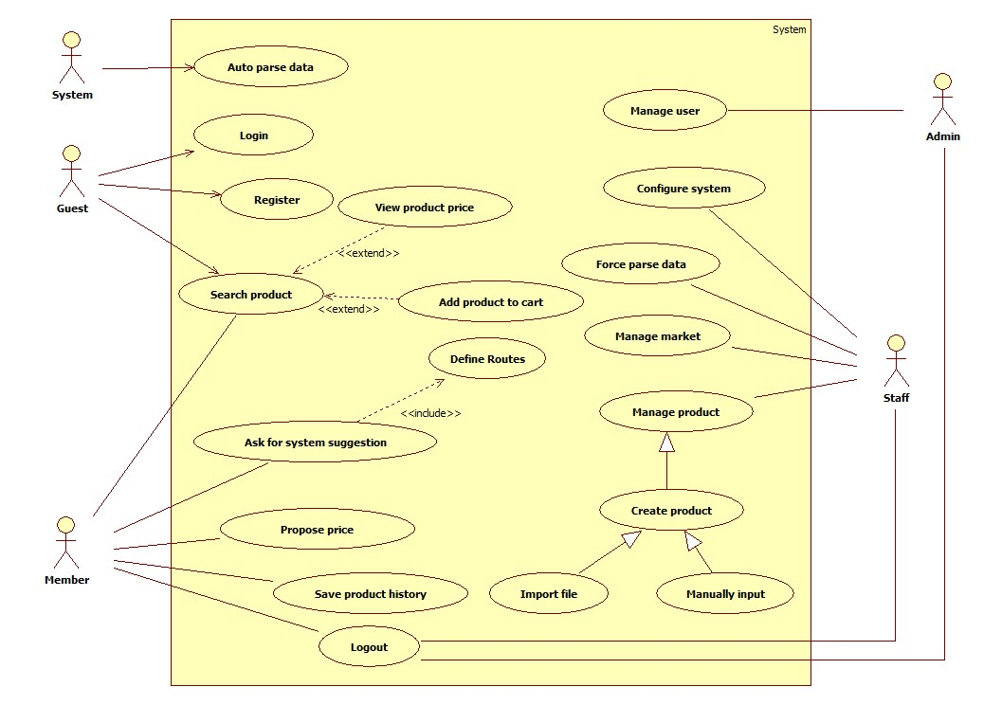

Figure 2: System Overview Use Case

### List of Use Case

#### <Admin>Overview Use Case

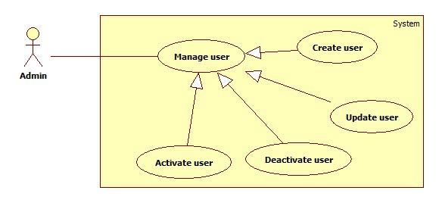

Figure 3: <Admin> Overview Use Case

##### <Admin> Create User

Use Case Diagram



Figure 5: <Admin> Create User

Use Case Specification

|  |  |  |  |
| --- | --- | --- | --- |
| **USE CASE – SB002** | | | |
| **Use Case No.** | SB002 | **Use Case Version** | 2.0 |
| **Use Case Name** | Create user | | |
| **Author** | Doan Ho Anh Triet | | |
| **Date** | 15/02/2014 | **Priority** | Normal |
| **Actor:**   * Admin   **Summary:**   * This user case allows admin to create new user account for the system.   **Goal:**   * New user account will be added to the system.   **Triggers:**   * Admin wants to create new user account. * From the sidebar:   + Choose “Quản lý tài khoản” menu.   + Choose “Tạo tài khoản” sub-menu   **Preconditions:**   * User must log in the system with admin role.   **Post Conditions:**   * **Success:** New user account will be added to the database. * **Fail:** Nothing is added to the database.   **Main Success Scenario:**   |  |  |  | | --- | --- | --- | | Step | Actor Action | System Response | | 1 | Admin clicks “Tạo tài khoản” link. | Navigate to “Tạo tài khoản” page which contains:   * Tên đăng nhập: textbox, min length: 6, max length: 30, required. * Mật khẩu: textbox, password type, min length: 6, max length: 20, required. * Vai trò: drop down list, required. * Tạo tài khoản: button. * Xóa trắng: button. | | 2 | Admin fills data to the form. |  | | 3 | Admin clicks “Tạo tài khoản” button. [Alternative 1], [Exception 1, 2, 3, 4] | Insert new user account to the database and redirect to “Quản lý tài khoản” page. |   **Alternative Scenario:**   |  |  |  | | --- | --- | --- | | No | Actor Action | System Response | | 1 | Admin clicks “Xóa trắng button”. | Clear all input data. |   **Exceptions:**   |  |  |  | | --- | --- | --- | | No | Actor Action | System Response | | 1 | Length of username is not in range. | Show error message: “Độ dài username phải từ 6-30 ký tự!” | | 2 | Length of password is not in range. | Show error message: “Độ dài password phải từ 6-20 ký tự!” | | 3 | Role is not specified. | Show error message: “Phải phân quyền cho user!” | | 4 | Username’s existed already. | Show error message: “Trùng tên đăng nhập! Vui lòng chọn tên khác!” |   **Relationships:** Manage user  **Business Rules:**   * Each created account must be in active state when insert to database. | | | |

Table 12: <Admin> Create User

##### <Admin> Update User

Use Case Diagram



Figure 6: <Admin> Update User

Use Case Specification

|  |  |  |  |
| --- | --- | --- | --- |
| **USE CASE – SB003** | | | |
| **Use Case No.** | SB003 | **Use Case Version** | 2.0 |
| **Use Case Name** | Update user | | |
| **Author** | Doan Ho Anh Triet | | |
| **Date** | 16/02/2014 | **Priority** | Normal |
| **Actor:**   * Admin   **Summary:**   * This use case allows admin to update information for user accounts.   **Goal:**   * New information will be updated to the database.   **Triggers:**   * Admin wants to change some information of members or staffs.   **Preconditions:**   * User must log in system with admin role.   **Post Conditions:**   * **Success:** New information will be updated to the database. * **Fail:** Nothing is updated.   **Main Success Scenario:**   |  |  |  | | --- | --- | --- | | Step | Actor Action | System Response | | 1 | Click menu item “Danh sách tài khoản”. | Navigate to “Danh sách tài khoản” page which contains:   * A table with 4 columns:   + Số thứ tự.   + Tên đăng nhập.   + Trạng thái.   + Hành động. * Tạo tài khoản: button. | | 2 | Click at username. | Navigate to “Thông tin tài khoản” page, which contains:   * Tên đăng nhập: textbox, min length: 6, max length: 30, disabled. * Mật khẩu: textbox, password type, min length: 6, max length: 20, required. * Vai trò: drop down list, required. * Cập nhật: button. | | 3 | Admin updates information. |  | | 4 | Click “Cập nhật” button. | New information will be updated to the database. |   **Alternative Scenario:** N/A  **Exceptions:**   |  |  |  | | --- | --- | --- | | No | Actor Action | System Response | | 1 | Length of password is not in range. | Show error message: “Độ dài password phải từ 6-20 ký tự!” | | 2 | Role is not specified. | Show error message: “Phải phân quyền cho user!” |   **Relationships:** Manage User  **Business Rules:**   * Editing username is forbidden. | | | |

Table 13: <Admin> Update User

##### <Admin> Activate User

Use Case Diagram

Figure 7: <Admin> Activate User

Use Case Specification

|  |  |  |  |
| --- | --- | --- | --- |
| **USE CASE – SB004** | | | |
| **Use Case No.** | SB004 | **Use Case Version** | 2.0 |
| **Use Case Name** | Activate User | | |
| **Author** | Doan Ho Anh Triet | | |
| **Date** | 16/02/2014 | **Priority** | Normal |
| **Actor:**   * Admin   **Summary:**   * This user case allows admin to activate a user account.   **Goal:**   * Deactivated accounts will be activated again.   **Triggers:**   * Admin wants to activate an account so that it can be used to log in the system again.   **Preconditions:**   * User must log in the system with admin role.   **Post Conditions:**   * **Success:** The selected account will be activated. * **Fail:** No account is activated.   **Main Success Scenario:**   |  |  |  | | --- | --- | --- | | Step | Actor Action | System Response | | 1 | Click menu item “Danh sách tài khoản”. | Navigate to “Danh sách tài khoản” page which contains:   * A table with 4 column:   + Số thứ tự.   + Tên đăng nhập.   + Trạng thái. * Tạo tài khoản: button. | | 2 | Check the checkbox in “Trạng thái” cell of a deactivated account. | Selected account is activated again. [Exception 1] |   **Alternative Scenario:** N/A  **Exceptions:**   |  |  |  | | --- | --- | --- | | No | Actor Action | System Response | | 1 | Cannot activate the account due to database connection. | Show error message: “Không thể kích hoạt! Vui lòng thử lại sau.” |   **Relationships:** Manage User  **Business Rules:**   * Admins can’t activate/deactivate account of themselves or other admins. | | | |

Table 14: <Admin> Activate User

##### <Admin> Deactivate User

Use Case Diagram



Figure 8: <Admin> Deactivate User

Use Case Specification

|  |  |  |  |
| --- | --- | --- | --- |
| **USE CASE – SB005** | | | |
| **Use Case No.** | SB005 | **Use Case Version** | 2.0 |
| **Use Case Name** | Deactivate User | | |
| **Author** | Doan Ho Anh Triet | | |
| **Date** | 16/02/2014 | **Priority** | Normal |
| **Actor:**   * Admin   **Summary:**   * This user case allows admin to deactivate an account.   **Goal:**   * An active account will be deactivated.   **Triggers:**   * In our system, when we do not want a user to login, we deactivate his/her account. That account can be activated later.   **Preconditions:**   * User must log in the system with admin role.   **Post Conditions:**   * **Success:** The selected account will be deactivated. * **Fail:** No account is deactivated.   **Main Success Scenario:**   |  |  |  | | --- | --- | --- | | Step | Actor Action | System Response | | 1 | Click menu item “Danh sách tài khoản”. | Navigate to “Quản lý tài khoản” page which contains:   * A table with 4 column:   + Số thứ tự.   + Tên đăng nhập.   + Trạng thái. * Tạo tài khoản: button. | | 2 | Uncheck the checkbox in “Trạng thái” cell of an active account. | The selected account will be deactivated.  [Exception 1] |   **Alternative Scenario:** N/A  **Exceptions:**   |  |  |  | | --- | --- | --- | | No | Actor Action | System Response | | 1 | Cannot deactivate the account due to database connection. | Show error message: “Không thể kích hoạt! Vui lòng thử lại sau.” |   **Relationships:** Manage Account  **Business Rules:**   * Admins can’t activate/deactivate account of themselves or other admins. | | | |

Table 15: <Admin> Deactivate User

#### <System> Overview Use Case



Figure 9: <System> Overview Use Case

##### <System> Auto Parse Data

Use Case Diagram



Figure 10: <System> Auto Parse Data

Use Case Specification

|  |  |  |  |
| --- | --- | --- | --- |
| **USE CASE – SB006** | | | |
| **Use Case No.** | SB006 | **Use Case Version** | 2.0 |
| **Use Case Name** | Auto Parse Data | | |
| **Author** | Doan Ho Anh Triet | | |
| **Date** | 16/02/2014 | **Priority** | High |
| **Actor:**   * System.   **Summary:**   * System can parse data automatically from many websites at specified time.   **Goal:**   * Get data from many websites.   **Triggers:**   * The time hits configured time.   **Preconditions:**   * Parse time has been configured.   **Post Conditions:**   * **Success:** New data is inserted to database. Log file is generated. * **Fail:** Nothing is changed in the database. Log file is generated.   **Main Success Scenario:**   |  |  |  | | --- | --- | --- | | Step | Actor Action | System Response | | 1 | Server checks the current time. If it hits configured time, parse process starts. | * Send request to the parsed link. * Fetch data from the response based on the inputted XPaths. * Validate data [Exception 1]. * If data is valid, insert to database [Alternative 1]. * Generate log file. |   **Alternative Scenario:**   |  |  |  | | --- | --- | --- | | Step | Actor Action | System Response | | 1 | Server checks the current time. If it hits configured time, parse process starts. | * If fetched product is already in the database, update its information. * Generate log file. |   **Exceptions:**   |  |  |  | | --- | --- | --- | | No | Actor Action | System Response | | 1 | Data is invalid. | * Don’t insert to database. * Generate log file. |   **Relationships:** N/A  **Business Rules:**   * If price is negative or not a number, consider it invalid. * Log file structure:   SMART BUY LOG FILE  Tạo file lúc: {Created date}, {Created time}   |  |  |  |  |  |  |  | | --- | --- | --- | --- | --- | --- | --- | | STT | Link | Thời gian parse | Dạng dữ liệu | Tổng sản phẩm | Insert thành công | Insert thất bại | |  |  |  |  |  |  |  | |  |  |  |  |  |  |  |   Tổng thời gian parse dạng {Data type}: {Elapsed time}  Tổng thời gian parse: {Total elapsed time}  Tổng sản phẩm parse được: {Total parsed product} | | | |

Table 16: <System> Auto Parse Data

#### <Staff >Overview Use Case

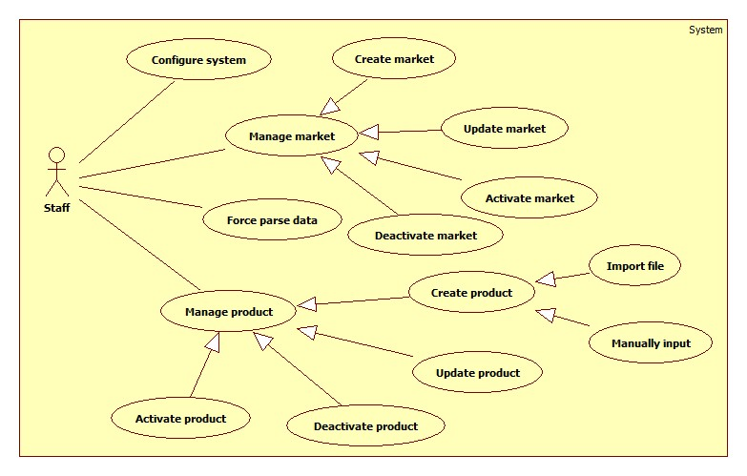

Figure 11: <Staff> Overview Use Case

##### <Staff> Configure System

Use Case Diagram



Figure 12: <Staff> Configure System

Use Case Specification

|  |  |  |  |
| --- | --- | --- | --- |
| **USE CASE – SB007** | | | |
| **Use Case No.** | SB007 | **Use Case Version** | 2.0 |
| **Use Case Name** | Configure system | | |
| **Author** | Doan Ho Anh Triet | | |
| **Date** | 15/02/2014 | **Priority** | High |
| **Actor:**   * Staff.   **Summary:**   * This use case allows staff to configure the system.   **Goal:**   * System parameters will be configured by admin.   **Triggers:**   * Staff wants to change system parameter, such as epsilon number or parse time. * From the sidebar:   + Choose “Hệ thống” menu.   + Choose “Cấu hình hệ thống” sub-menu.   **Preconditions:**   * User must log in the system with Staff role.   **Post Conditions:**   * **Success:** New parameter will be saved to configuration file. * **Fail:** Nothing is saved to configuration file.   **Main Success Scenario:**   |  |  |  | | --- | --- | --- | | Step | Actor Action | System Response | | 1 | Click at “Cấu hình hệ thống” link in sub-menu. | Show “Cấu hình hệ thống” page which contains:   * Epsilon: textbox, min length: 1, max length: 3, type: integer number, min value: 1, max value: 100, decimal number only, required. * Thời gian parse: time picker, min value: 0:00, max value: 23:59, required. * Giá 1 lít xăng: textbox, min length: 1, max length: 3, min value: 1, max value: 100, integer number only, required. * Lưu: button. | | 2 | Admin changes system parameters. |  | | 3 | Click on “Lưu” button.  [Exception 1, 2, 3] | * Save data to configuration file. * Show success message. |   **Alternative Scenario:** N/A  **Exceptions:**   |  |  |  | | --- | --- | --- | | No | Actor Action | System Response | | 1 | Epsilon value is out of range. | Show error message: “Epsilon phải lớn hơn 0 và nhỏ hơn hoặc bằng 100!” | | 2 | Epsilon is not a number. | Show error message: “Epsilon phải là số!” | | 3 | “Thời gian parse” format is not correct. | Show error message: “Thời gian phải đúng định dạng!” | | 4 | “Giá 1 lít xăng” value is out of range. | Show error message: “Giá 1 liets xăng phải lớn hơn 0 và nhỏ hơn hoặc bằng 100!” | | 5 | “Giá 1 lít xăng” is not a number. | Show error message: “Giá 1 lít xăng phải là số!”. |   **Relationships:** N/A  **Business Rules:** N/A | | | |

Table 17: <Staff> Configure System

##### <Staff> Force Parse Data

Use Case Diagram



Figure 13: <Staff> Force Parse Data

Use Case Specification

|  |  |  |  |
| --- | --- | --- | --- |
| **USE CASE – SB008** | | | |
| **Use Case No.** | SB008 | **Use Case Version** | 2.0 |
| **Use Case Name** | Force Parse Data | | |
| **Author** | Doan Ho Anh Triet | | |
| **Date** | 16/02/2014 | **Priority** | High |
| **Actor:**   * Staff.   **Summary:**   * Staff can force system to parse data at any time.   **Goal:**   * Get data from many websites.   **Triggers:**   * Staff wants to run the parser at that time. * Staff clicks “Parse” button.   **Preconditions:**   * User logged in with “Staff” role.   **Post Conditions:**   * **Success:** New data is inserted to database. Log file is generated. * **Fail:** Nothing is changed in the database. Log file is generated.   **Main Success Scenario:**   |  |  |  | | --- | --- | --- | | Step | Actor Action | System Response | | 1 | Staff clicks “Parse” button. | * Disable “Parse” button. Change its text into “Parsing…” * Send request to the parsed link. * Fetch data from the response based on the inputted XPaths. * Validate data [Exception 1]. * If data is valid, insert to database [Alternative 1]. * Generate log file. * Enable “Parse” button. Change its text into “Parse”. |   **Alternative Scenario:**   |  |  |  | | --- | --- | --- | | Step | Actor Action | System Response | | 1 | Staff clicks “Parse” button. | * If fetched product is already in the database, update its information. * Generate log file. |   **Exceptions:**   |  |  |  | | --- | --- | --- | | No | Actor Action | System Response | | 1 | Data is not valid. | * Don’t insert to database. * Generate log file. |   **Relationships:** N/A  **Business Rules:**   * Refer to “Auto Parse Data” use case. | | | |

Table 30: <Staff> Force Parse Data

##### <Staff> Create Market

Use Case Diagram



Figure 14: <Staff> Create Market

Use Case Specification

|  |  |  |  |
| --- | --- | --- | --- |
| **USE CASE – SB009** | | | |
| **Use Case No.** | SB009 | **Use Case Version** | 2.0 |
| **Use Case Name** | Create Market | | |
| **Author** | Doan Ho Anh Triet | | |
| **Date** | 19/02/2014 | **Priority** | Normal |
| **Actor:**   * Staff.   **Summary:**   * This use case allows staff to create a new market.   **Goal:**   * A new market added to the database.   **Triggers:**   * Staff wants to create a new market. * To create new market, staff must do the following steps:   + Click “Quản lý chợ” on the sidebar menu.   + Click “Tạo chợ mới” sub-menu.   **Preconditions:**   * User must log in the system with staff role.   **Post Conditions:**   * **Success**: New market will be added to the database. * **Fail:** Nothing is added to the database. Show error message.   **Main Success Scenario:**   |  |  |  | | --- | --- | --- | | Step | Actor Action | System Response | | 1 | Click “Tạo chợ mới” link. | Navigate to “Tạo chợ mới” page, which contains:   * Tên chợ: textbox, min length: 6, max length: 50, required. * Địa chỉ: textbox, min length: 6, max length: 100. * Map: to show market address. * Tạo mới: button * Xóa trắng: button | | 2 | Input market information, click “Tạo mới” button. [Alternative 1] | Add new market to the database. Redirect to “Quản lý chợ” page.  [Exception 1, 2, 3, 4, 5, 6, 7, 8, 9] |   **Alternative Scenario:**   |  |  |  | | --- | --- | --- | | Step | Actor Action | System Response | | 1 | Click “Xóa trắng” button | Clear all input fields. |   **Exceptions:**   |  |  |  | | --- | --- | --- | | No | Actor Action | System Response | | 1 | Duplicate “Tên chợ”. | Show error message: “Tên này đã có trong hệ thống. Vui lòng chọn tên khác!” | | 2 | Length of “Tên chợ” is not in range. | Show error message: “Tên chợ phải từ 6 đến 50 ký tự!” | | 3 | Length of “Địa chỉ” is not in range. | Show error message: “Địa chỉ phải từ 6 đến 100 ký tự!” |   **Relationships:** Manage market.  **Business Rules:**   * We should apply Google Map auto complete to “Địa chỉ” textbox. * Whenever “Địa chỉ” is chosen, navigate map to that position and put a marker at it. | | | |

Table 31: <Staff> Create Market

##### <Staff> Update Market

Use Case Diagram



Figure 15: <Staff> Update Market

Use Case Specification

|  |  |  |  |
| --- | --- | --- | --- |
| **USE CASE – SB010** | | | |
| **Use Case No.** | SB010 | **Use Case Version** | 2.0 |
| **Use Case Name** | Update Market | | |
| **Author** | Doan Ho Anh Triet | | |
| **Date** | 19/02/2014 | **Priority** | Normal |
| **Actor:**   * Staff.   **Summary:**   * This use case allows staff to update market information.   **Goal:**   * Update new information to the market.   **Triggers:**   * Staff wants to update information of markets. * To update information of markets, staff must do the following steps:   + Click “Quản lý chợ” in the sidebar menu.   + Click at the name of the market which staff wants to change information.   **Preconditions:**   * User must log in the system with staff role.   **Post Conditions:**   * **Success**: Market information will be updated. * **Fail:** Nothing is updated. Show error message.   **Main Success Scenario:**   |  |  |  | | --- | --- | --- | | Step | Actor Action | System Response | | 1 | Click “Quản lý chợ” in sidebar menu. | Navigate to “Quản lý chợ” page which contains:   * A table has 4 columns:   + Số thứ tự   + Tên chợ   + Địa chỉ   + Trạng thái | | 2 | Click at the market name. | Navigate to “Thông tin chợ” page, which contains:   * Tên chợ: textbox, min length: 6, max length: 50, required. * Địa chỉ: textbox, min length: 6, max length: 100. * Map: to show market position. * Cập nhật: button | | 3 | Edit market information, click “Cập nhật” button. | The system will update new market information to the database. Redirect to “Quản lý chợ” page.  [Exception 1, 2, 3, 4, 5, 6, 7, 8, 9] |   **Alternative Scenario:** N/A  **Exceptions:**   |  |  |  | | --- | --- | --- | | No | Actor Action | System Response | | 1 | Duplicate “Tên chợ”. | Show error message: “Tên này đã có trong hệ thống. Vui lòng chọn tên khác!” | | 2 | Length of “Tên chợ” is not in range. | Show error message: “Tên chợ phải từ 6 đến 50 ký tự!” | | 3 | Length of “Địa chỉ” is not in range. | Show error message: “Địa chỉ phải từ 6 đến 100 ký tự!” |   **Relationships:** Manage market.  **Business Rules:**   * We should apply Google Map auto complete to “Địa chỉ” textbox. * Whenever “Địa chỉ” is chosen, navigate map to that position and put a marker at it. | | | |

Table 32: <Staff> Update Market

##### <Staff> Deactivate Market

Use Case Diagram



Figure 16: <Staff> Deactivate Market

Use Case Specification

|  |  |  |  |
| --- | --- | --- | --- |
| **USE CASE – SB011** | | | |
| **Use Case No.** | SB011 | **Use Case Version** | 2.0 |
| **Use Case Name** | Deactivate Market | | |
| **Author** | Doan Ho Anh Triet | | |
| **Date** | 20/02/2014 | **Priority** | Normal |
| **Actor:**   * Staff.   **Summary:**   * This use case allows staff to deactivate market in the system.   **Goal:**   * Markets will be deactivated.   **Triggers:**   * Staff wants to deactivate a market so that it is no longer available in the system. * To deactivate a market, staff must do the following steps:   + Click “Quản lý chợ” item in the menu.   + Uncheck the status checkbox of each active market.   **Preconditions:**   * User must log in the system with staff role.   **Post Conditions:**   * **Success**: The selected market will be deactivated. * **Fail:** Nothing is changed. Show error message.   **Main Success Scenario:**   |  |  |  | | --- | --- | --- | | Step | Actor Action | System Response | | 1 | Click “Quản lý chợ” in menu bar. | Navigate to “Quản lý chợ” page which contains:   * A table has 4 columns:   + Số thứ tự   + Tên chợ   + Địa chỉ   + Trạng thái | | 2 | Uncheck the checkbox in “Trạng thái” cell of an active market. | The selected market will be deactivated. [Exception 1]  Show success message: “Thao tác thành công!” |   **Alternative Scenario:** N/A  **Exceptions:**   |  |  |  | | --- | --- | --- | | Step | Actor Action | System Response | | 1 | Cannot deactivate the market due to database connection problem. | Show error message: “Thao tác không thể thực hiện. Vui lòng thử lại sau!” |   **Relationships:** Manage Market.  **Business Rules:**   * Cannot deactivate virtual market. | | | |

Table 33: <Staff> Deactivate Market

##### <Staff> Activate Market

Use Case Diagram



Figure 17: <Staff> Activate Market

Use Case Specification

|  |  |  |  |
| --- | --- | --- | --- |
| **USE CASE – SB012** | | | |
| **Use Case No.** | SB012 | **Use Case Version** | 2.0 |
| **Use Case Name** | Activate Market | | |
| **Author** | Doan Ho Anh Triet | | |
| **Date** | 20/02/2014 | **Priority** | Normal |
| **Actor:**   * Staff.   **Summary:**   * This use case allows staff to activate the market.   **Goal:**   * Selected market will be activated.   **Triggers:**   * Staff wants to activate a market so that it can be accessed from the system again. * To activate the market, staff must do the following steps:   + Click “Quản lý chợ” item in the menu.   + Check the status checkbox of each deactivated market   **Preconditions:**   * User must log in the system with staff role.   **Post Conditions:**   * **Success**: Market will be activated again. * **Fail:** Nothing is changed. Show error message.   **Main Success Scenario:**   |  |  |  | | --- | --- | --- | | Step | Actor Action | System Response | | 1 | Click “Quản lý chợ” in menu bar. | Navigate to “Quản lý chợ” page which contains:   * A table has 4 columns:   + Số thứ tự   + Tên chợ   + Địa chỉ   + Trạng thái | | 2 | Check the checkbox in “Trạng thái” cell of a deactivated market. | The selected market will be activated. [Exception 1]  Show success message: “Thao tác thành công!” |   **Alternative Scenario:** N/A  **Exceptions:**   |  |  |  | | --- | --- | --- | | Step | Actor Action | System Response | | 1 | Cannot activate the market due to database connection problem. | Show error message: “Thao tác không thể thực hiện. Vui lòng thử lại sau!” |   **Relationships:** Manage Market.  **Business Rules:** N/A | | | |

Table 34: <Staff> Activate Market

##### <Staff> Import File

Use Case Diagram

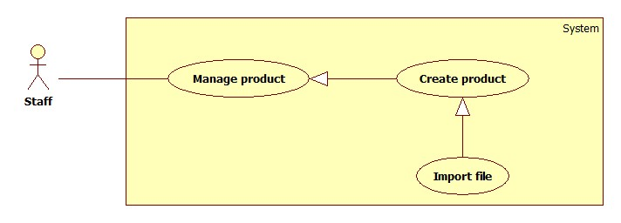

Figure 18: <Staff> Import File

Use Case Specification

|  |  |  |  |
| --- | --- | --- | --- |
| **USE CASE – SB013** | | | |
| **Use Case No.** | SB013 | **Use Case Version** | 2.0 |
| **Use Case Name** | Import File | | |
| **Author** | Tran Trung Dung | | |
| **Date** | 20/02/2014 | **Priority** | High |
| **Actor:**   * Staff   **Summary:**   * This use case allows staff to import data from excel files.   **Goal:**   * Create many products from imported files.   **Triggers:**   * Staff wants to create many products by importing excel files. * To import a file, staff must do the following steps:   + Click “Nhập từ excel” menu.   + Choose the file, click “Tải lên” button.   **Preconditions:**   * User must log in the system with staff role.   **Post Conditions:**   * **Success**: Products will be added to the database. Show success message. * **Fail:** Nothing is saved to the database. Show error list.   **Main Success Scenario:**   |  |  |  | | --- | --- | --- | | Step | Actor Action | System Response | | 1 | From the staff’s page, staff clicks “Nhập từ Excel” link. | Show “Nhập từ excel” page with 2 buttons:   * “Chọn file” button. * “Tải lên” button. | | 2 | From “Nhập từ excel” page, staff clicks “Chọn file” button, then clicks “Mở”. | System will get file path and show on text box. | | 3 | Staff clicks “Tải lên” button | File is uploaded to server, then redirect back to “Nhập từ excel” page, contains:   * A 4-columns table show detail of product in excel file. Column header includes:   + “STT” label.   + “Tên sản phẩm” label.   + “Tên chợ” label.   + “Giá (Ngàn đồng)” label. * “Lưu” button. * “Hủy” button.   [Exception 1, 2, 3, 4] | | 5 | Staff clicks “Lưu” button to save product. [Alternative 1] | Save products to database. [Exception 5] |   **Alternative Scenario:**   |  |  |  | | --- | --- | --- | | Step | Actor Action | System Response | | 1 | Click on “Hủy” button to finish. | No product is added. System will return back to “Nhập từ excel” page. |   **Exceptions:**   |  |  |  | | --- | --- | --- | | Step | Actor Action | System Response | | 1 | Product input is wrong format | Display error message: “File không đúng định dạng”. | | 2 | Product name is not in range [5, 20]. | Display error message: “Tên sản phẩm phải từ 5 đến 20 ký tự”. | | 3 | Market name is not in range [5, 20]. | Display error message: “Tên chợ phải từ 5 đến 20 ký tự”. | | 4 | Price is not in range [1, 10000]. | Display error message: “Giá sản phẩm phải từ 1 đến 10000”. | | 5 | Fail to insert to database. | Display error message: “Có lỗi xảy ra. Vui lòng thử lại sau”. |   **Relationships:** Manage Product, Create Product.  **Business Rules:**   * Valid file format :      * Format file is excel (.xlsx) * File has less than 5 errors. * File has more than 5 errors. Display list error rows. | | | |

Table 18: <Staff> Import File

##### <Staff> Manually Input Data

Use Case Diagram



Figure 19: <Staff> Manually Input Data

Use Case Specification

|  |  |  |  |
| --- | --- | --- | --- |
| **USE CASE – SB014** | | | |
| **Use Case No.** | SB014 | **Use Case Version** | 2.0 |
| **Use Case Name** | Manually Input | | |
| **Author** | Tran Trung Dung | | |
| **Date** | 20/02/2014 | **Priority** | High |
| **Actor:**   * Staff.   **Summary:**   * This use case allows staff to input product manually.   **Goal:**   * New product will be added to the database.   **Triggers:**   * Staff wants to input new product manually. * To input product manually, staff must do the following steps:   + Click “Quản lý sản phẩm” in the menu.   + Click “Tạo sản phẩm” button.   **Preconditions:**   * User must log in the system with staff role.   **Post Conditions:**   * **Success**: New product will be added to the database. * **Fail:** Nothing is added to the database. Show error message.   **Main Success Scenario:**   |  |  |  | | --- | --- | --- | | Step | Actor Action | System Response | | 1 | Click “Tạo sản phẩm” button. | Navigate to “Tạo sản phẩm” page which contains:   * Tên sản phẩm: textbox (min length: 5, max length: 20), required. * Tên chợ: drop down list, list of available markets in the system, required. * Giá: textbox (min value: 1, max value: 10000, integer number only, min length: 1, max length: 5), required. * “Thêm sản phẩm” button. * “Hủy” button. | | 2 | Enter information into text fields.  Click “Thêm sản phẩm” button to finish. [Alternative 1] | System will add product to database.  A new product will be displayed in list product page. Then, redirect to list product page. [Exception 1, 2, 3] |   **Alternative Scenario:**   |  |  |  | | --- | --- | --- | | Step | Actor Action | System Response | | 1 | Click on “Hủy” button to finish. | No product is added. System will return back to list product page. |   **Exceptions:**   |  |  |  | | --- | --- | --- | | Step | Actor Action | System Response | | 1 | “Tên sản phẩm” is not in range [5, 20]. | Display error message: “Tên sản phẩm phải từ 5 đến 20 ký tự”. | | 2 | “Tên chợ” is not selected. | Display error message: “Phải chọn chợ”. | | 3 | “Giá” is not in range [1, 10000]. | Display error message: “Giá sản phẩm phải từ 1 đến 10000”. |   **Relationships:** Manage Product, Create Product.  **Business Rules:**   * When staff enters product name, system will search all product name in the database. * Staff can choose existed product and update the price of this product. | | | |

Table 19: <Staff> Manually Input Data

##### <Staff> Update Product

Use Case Diagram



Figure 20: <Staff> Update Product

Use Case Specification

|  |  |  |  |
| --- | --- | --- | --- |
| **USE CASE – SB015** | | | |
| **Use Case No.** | SB015 | **Use Case Version** | 2.0 |
| **Use Case Name** | Update Product | | |
| **Author** | Doan Ho Anh Triet | | |
| **Date** | 20/02/2014 | **Priority** | Normal |
| **Actor:**   * Staff.   **Summary:**   * This use case allows staff to update product information.   **Goal:**   * New information will be updated to selected product.   **Triggers:**   * Staff wants to change product information. * To change product information, staff must do the following steps:   + Choose “Quản lý sản phẩm” in sidebar menu.   + Click “Danh sách sản phẩm” sub-menu.   + Click at product name.   + Change information.   + Click “Cập nhật” button to save new data to database.   **Preconditions:**   * User must log in the system with staff role. * There is at least one product in the database.   **Post Conditions:**   * **Success**: New information will be updated to selected product. * **Fail:** Nothing is updated. Show error message.   **Main Success Scenario:**   |  |  |  | | --- | --- | --- | | Step | Actor Action | System Response | | 1 | Click “Danh sách sản phẩm” sub-menu. | Navigate to “Danh sách sản phẩm” page which contains:   * A table has 5 columns:   + Số thứ tự.   + Tên sản phẩm.   + Khoảng giá.   + Thời gian cập nhật.   + Trạng thái | | 2 | Click at any product name. | Navigate to “Thông tin sản phẩm” page which contains:   * Tên sản phẩm: textbox, min length: 5, max length: 20, required. * Tên chợ: drop down list, list of available markets in the system, required. * Giá: textbox, integer number only, min value: 1, max value: 10000, min length: 1, max length: 5, required. * Cập nhật: button. | | 3 | Update new data. Click “Cập nhật” button. | Save new data to the database. Redirect to “Quản lý sản phẩm” page. |   **Alternative Scenario:** N/A  **Exceptions:**   |  |  |  | | --- | --- | --- | | Step | Actor Action | System Response | | 1 | “Tên sản phẩm” is not in range [5, 20]. | Display error message: “Tên sản phẩm phải từ 5 đến 20 ký tự”. | | 2 | “Tên chợ” is not selected. | Display error message: “Phải chọn chợ”. | | 3 | “Giá” is not in range [1, 10000]. | Display error message: “Giá sản phẩm phải từ 1 đến 10000”. |   **Relationships:** Manage Product.  **Business Rules:** N/A | | | |

Table 20: <Staff> Update Product

##### <Staff> Deactivate Product

Use Case Diagram



Figure 30: <Staff> Deactivate Product

Use Case Specification

|  |  |  |  |
| --- | --- | --- | --- |
| **USE CASE – SB016** | | | |
| **Use Case No.** | SB016 | **Use Case Version** | 2.0 |
| **Use Case Name** | Deactivate Product | | |
| **Author** | Doan Ho Anh Triet | | |
| **Date** | 20/02/2014 | **Priority** | Normal |
| **Actor:**   * Staff.   **Summary:**   * This use case allows staff to deactivate product.   **Goal:**   * Selected product will be deactivated.   **Triggers:**   * Staff wants to deactivate a product in the system. * To deactivate a product, staff must do the following steps:   + Choose “Quản lý sản phẩm” in sidebar menu.   + Click “Danh sách sản phẩm” sub-menu.   + Uncheck any active product.   **Preconditions:**   * User must log in the system with staff role.   **Post Conditions:**   * **Success**: Selected product will be deactivated. * **Fail:** Nothing is changed. Show error message.   **Main Success Scenario:**   |  |  |  | | --- | --- | --- | | Step | Actor Action | System Response | | 1 | Click “Danh sách sản phẩm” sub-menu. | Navigate to “Danh sách sản phẩm” page which contains:   * A table has 5 columns:   + Số thứ tự.   + Tên sản phẩm.   + Khoảng giá.   + Thời gian cập nhật.   + Trạng thái | | 2 | Uncheck any active product. | Deactivate selected product. Show success message.  [Exception 1] |   **Alternative Scenario:** N/A  **Exceptions:**   |  |  |  | | --- | --- | --- | | No | Actor Action | System Response | | 1 | Cannot deactivate product due to database connection problem | Show error message: “Thao tác thất bại. Vui lòng thử lại sau!” |   **Relationships:** Manage Product.  **Business Rules:** N/A | | | |

Table 21: <Staff> Deactivate Product

##### <Staff> Activate Product

Use Case Diagram



Figure 31: <Staff> Activate Product

Use Case Specification

|  |  |  |  |
| --- | --- | --- | --- |
| **USE CASE – SB017** | | | |
| **Use Case No.** | SB017 | **Use Case Version** | 2.0 |
| **Use Case Name** | Activate Product | | |
| **Author** | Doan Ho Anh Triet | | |
| **Date** | 20/02/2014 | **Priority** | Normal |
| **Actor:**   * Staff.   **Summary:**   * This use case allows staff to activate product.   **Goal:**   * Selected product will be activated.   **Triggers:**   * Staff wants to activate a product in the system. * To deactivate a product, staff must do the following steps:   + Choose “Quản lý sản phẩm” in sidebar menu.   + Click “Danh sách sản phẩm” sub-menu.   + Check any deactived product.   **Preconditions:**   * User must log in the system with staff role.   **Post Conditions:**   * **Success**: Selected product will be activated. * **Fail:** Nothing is changed. Show error message.   **Main Success Scenario:**   |  |  |  | | --- | --- | --- | | Step | Actor Action | System Response | | 1 | Click “Danh sách sản phẩm” sub-menu. | Navigate to “Danh sách sản phẩm” page which contains:   * A table has 5 columns:   + Số thứ tự.   + Tên sản phẩm.   + Khoảng giá.   + Thời gian cập nhật.   + Trạng thái | | 2 | Check any deactived product. | Activate selected product. Show success message.  [Exception 1] |   **Alternative Scenario:** N/A  **Exceptions:**   |  |  |  | | --- | --- | --- | | No | Actor Action | System Response | | 1 | Cannot activate product due to database connection problem | Show error message: “Thao tác thất bại. Vui lòng thử lại sau!” |   **Relationships:** Manage Product.  **Business Rules:** N/A | | | |

Table 22: <Staff> Activate Product

#### <Member>Overview Use Case

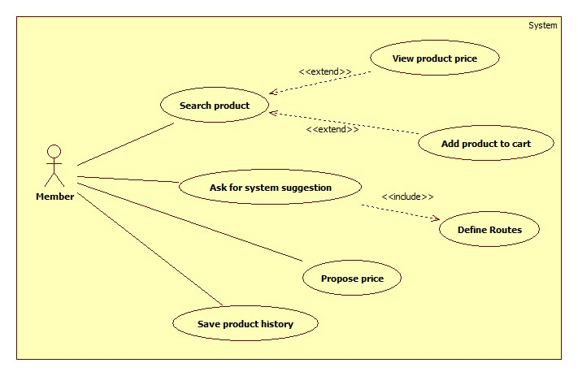

Figure 21: <Member> Overview Use Case

##### <Member> Search Product and View Product Price

Use Case Diagram



Figure 22: <Member> Search Product and View Product Price

Use Case Specification

|  |  |  |  |
| --- | --- | --- | --- |
| **USE CASE – SB018** | | | |
| **Use Case No.** | SB018 | **Use Case Version** | 2.0 |
| **Use Case Name** | Search Product and View Product Price | | |
| **Author** | Huynh Thanh Viet | | |
| **Date** | 20/02/2014 | **Priority** | High |
| **Actor:**   * Member. * Guest.   **Summary:**   * This use case allows user to search and view product information.   **Goal:**   * A list of products will be shown to user.   **Triggers:**   * User can search product to get product’s information: name, range of price. * In search screen, user inputs name of product then they search all products with relative name which they inputted. The searching results will show a list of product which follow product name. * User inputs to a blank textbox then clicks “Tìm” button.   **Preconditions:**   * For mobile application:   + Mobile connected to a wireless network or active data connection (2G, 3G).   + In case the internet connection isn’t satisfy, the application must be synchronized data at daily checkpoint.   **Post Conditions:**   * **Success**: Show search results which include a list of product with name, range of price. * **Fail:** Show an error message.   **Main Success Scenario:**   |  |  |  | | --- | --- | --- | | Step | Actor Action | System Response | | 1 | User inputs the product’s name into textbox. |  | | 2 | User clicks “Tìm” button. | * System will show a list of product as a grid and order by product name. [Alternative 1] * A product will show in a line as a record with these information:   + First column is order number.   + Second column is product name.   + Third column is range of product price.   + The final column has 2 buttons: “Thêm vào giỏ” and “Đề xuất giá”. |   **Alternative Scenario:**   |  |  |  | | --- | --- | --- | | Step | Actor Action | System Response | | 1 | Search not found | System will show a message: “Không tìm thấy”. |   **Exceptions:** N/A  **Relationships:** N/A  **Business Rules:**   * Search by product name, using full text search. * Result list will be ordered by matching percent. | | | |

Table 23: <Member> Search Product and View Product Price

##### <Member> Add Product To Cart

Use Case Diagram



Figure 23: <Member> Add Product To Cart

Use Case Specification

|  |  |  |  |
| --- | --- | --- | --- |
| **USE CASE – SB019** | | | |
| **Use Case No.** | SB019 | **Use Case Version** | 2.0 |
| **Use Case Name** | Add Product To Cart | | |
| **Author** | Dang Huu Hoang | | |
| **Date** | 20/02/2014 | **Priority** | Normal |
| **Actor:**   * Member. * Guest.   **Summary:**   * This use case allows guest/member to add product to cart.   **Goal:**   * A product will be added to guest/member’s cart.   **Triggers:**   * Guest/Member can add product to cart after search product. * Guest/Member clicks on “Thêm vào giỏ” button on each result row.   **Preconditions:** N/A  **Post Conditions:**   * **Success**: The product will be added to cart. * **Fail:** Product will not be added to cart. Show error message.   **Main Success Scenario:**   |  |  |  | | --- | --- | --- | | Step | Actor Action | System Response | | 1 | Click “Thêm vào giỏ” button on result row. | * Check for the existence of the cart object in session [Exception 1]. * Add clicked product to cart [Alternative 1]. * Notify user. |   **Alternative Scenario:**   |  |  |  | | --- | --- | --- | | Step | Actor Action | System Response | | 1 | The product has existed in cart. | Update quantity of the product. |   **Exceptions:**   |  |  |  | | --- | --- | --- | | Step | Actor Action | System Response | | 1 | Session time out. | * Create new cart object in session. * Add clicked product to cart. * Notify user. |   **Relationships:** Search Product  **Business Rules:**   * Maximum quantity of each product is 10. * Maximum size of cart is 20. | | | |

Table 24: <Member> Add Product To Cart

##### <Member> Propose Price

Use Case Diagram



Figure 24: <Member> Propose Price

Use Case Specification

|  |  |  |  |
| --- | --- | --- | --- |
| **USE CASE – SB020** | | | |
| **Use Case No.** | SB020 | **Use Case Version** | 2.0 |
| **Use Case Name** | Propose Price | | |
| **Author** | Dang Huu Hoang | | |
| **Date** | 20/02/2014 | **Priority** | Normal |
| **Actor:**   * Member.   **Summary:**   * This use case allows member to propose product price.   **Goal:**   * Insert new product price to the database.   **Triggers:**   * Member wants to propose new product price. * Member clicks on “Đề xuất giá” button on each search result row.   **Preconditions:**   * User has logged in to the system with the role is “member”. * User used search function to find product.   **Post Conditions:**   * **Success**: Propose product price will be inserted to database. Show success message. * **Fail:** Nothing is inserted to the database. Show error message.   **Main Success Scenario:**   |  |  |  | | --- | --- | --- | | Step | Actor Action | System Response | | 1 | Click on “Đề xuất giá” button on each search result row. | Pop up a window with:   * Giá đề xuất: text box (integer number only, min length: 1, max length: 4), required. * Lưu lại: button | | 2 | Input proposed product price, click “Lưu lại” button. | Updates new product price to the database and show message “Cảm ơn sự đóng góp của bạn”. [Alternative 1; Exception 1, 2] |   **Alternative Scenario:**   |  |  |  | | --- | --- | --- | | No | Actor Action | System Response | | 1 | Price is out of range. | Show message “Cảm ơn sự đóng góp của bạn”. |   **Exceptions:**   |  |  |  | | --- | --- | --- | | No | Actor Action | System Response | | 1 | Price is not a positive number. | Show error “Giá không phù hợp”. | | 2 | Price’s length is not in range. | Show error “Giá không phù hợp”. |   **Relationships:** Search Product  **Business Rules:**   * Average price (avgPrice) = $\frac{minPrice+maxPrice}{2}$* Epsilon $(ε)$ is a number set by staff. $Range ∈[minPrice-ε×avgPrice, maxPrice+ε×avgPrice]$ | | | |

Table 25: <Member> Propose Price

##### <Member> Save Product History

Use Case Diagram



Figure 25: <Member> Save Product History

Use Case Specification

|  |  |  |  |
| --- | --- | --- | --- |
| **USE CASE – SB021** | | | |
| **Use Case No.** | SB021 | **Use Case Version** | 2.0 |
| **Use Case Name** | Save Product History | | |
| **Author** | Dang Huu Hoang | | |
| **Date** | 20/02/2014 | **Priority** | Normal |
| **Actor:**   * Member.   **Summary:**   * This use case allows member to save their cart.   **Goal:**   * The cart will be saved as member’s history.   **Triggers:**   * Members want to save their cart. * Member clicks “Lưu lại” button.   **Preconditions:**   * User has logged in to the system with the role is “member”. * There is at least one product which was added to cart.   **Post Conditions:**   * **Success**: Information of cart will be added to database. Show success message. * **Fail:** Nothing is added to the database. Show error message.   **Main Success Scenario:**   |  |  |  | | --- | --- | --- | | Step | Actor Action | System Response | | 1 | The member clicks “Lưu lại” button on View cart page. | * Add new cart to database. * Show message “Giỏ hàng đã được lưu thành công” [Alternative 1], [Exception 1]. |   **Alternative Scenario:**   |  |  |  | | --- | --- | --- | | No | Actor Action | System Response | | 1 | The cart has existed in database. | * Update cart to database. * Show message “Giỏ hàng đã được lưu thành công”. |   **Exceptions:**   |  |  |  | | --- | --- | --- | | No | Actor Action | System Response | | 1 | Fail to insert to database. | Show message “Có lỗi xảy ra. Vui lòng thử lại sau”. |   **Relationships:** Add Product To Cart  **Business Rules:**   * The insert time of the cart is current time. * Save product name and current price range. | | | |

Table 26: <Member> Save Product History

##### <Member> Define Route

Use Case Diagram

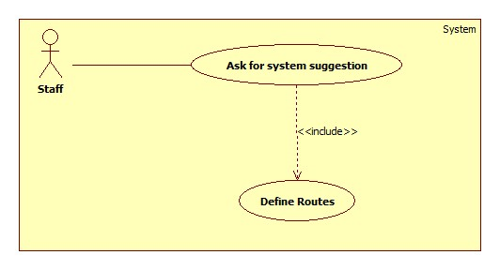

Figure 26: <Member> Define Routes

Use Case Specification

|  |  |  |  |
| --- | --- | --- | --- |
| **USE CASE – SB022** | | | |
| **Use Case No.** | SB022 | **Use Case Version** | 2.0 |
| **Use Case Name** | Define Routes | | |
| **Author** | Doan Ho Anh Triet | | |
| **Date** | 20/03/2014 | **Priority** | Normal |
| **Actor:**   * Member.   **Summary:**   * This use case allows user to define their favourite routes.   **Goal:**   * User can define 3 their favourite routes to use in suggestion.   **Triggers:**   * User wants to define their routes to use “suggest” function. * User accesses their account detail page and chooses routes.   **Preconditions:**   * User has logged in to the system with member role.   **Post Conditions:**   * **Success**: User’s favourite routes will be store in the database. * **Fail:** Show error message.   **Main Success Scenario:**   |  |  |  | | --- | --- | --- | | Step | Actor Action | System Response | | 1 | Click “Thông tin cá nhân” menu. | Show “Thông tin cá nhân” page which includes:   * First column: * Tên đăng nhập: textbox, disabled, value is current username. * Mật khẩu cũ: textbox, password type, min length: 6, max length: 20. * Mật khẩu mới: textbox, password type, min length: 6, max length: 20. * Cập nhật: button. * Second column: * Tên đường đi: textbox, min length: 3, max length: 20. * Điểm xuất phát: textbox, min length: 10, max length: 100. * Điểm kết thúc: textbox, min length: 10, max length: 100. * Chọn: button. * Those controls above are repeated 3 times to define 3 favourite routes. * Xác nhận: button. * Google map. | | 2 | User enters “Điểm bắt đầu” and “Điểm kết thúc” value, then click “Chọn”. | System renders the route from “Điểm bắt đầu” point to “Điểm kết thúc” point. If there are any market around that route, set marker at that position. | | 3 | User click “Xác nhận” button. | Save user’s defined routes and show success message. |   **Alternative Scenario:** N/A  **Exceptions:** N/A  **Relationships:** Ask for system suggestion  **Business Rules:**   * All “Điểm xuất phát” and “Điểm kết thúc” textbox should have Google Map Place auto-complete. * Nearby market should be 500 meters away from the defined route. | | | |

Table 27: <Member> Define Route

##### <Member> Ask For System Suggestion

Use Case Diagram



Figure 27: <Member> Ask for system suggestion

Use Case Specification

|  |  |  |  |
| --- | --- | --- | --- |
| **USE CASE – SB023** | | | |
| **Use Case No.** | SB023 | **Use Case Version** | 2.0 |
| **Use Case Name** | Ask For System Suggestion | | |
| **Author** | Doan Ho Anh Triet | | |
| **Date** | 24/03/2014 | **Priority** | High |
| **Actor:**   * Member.   **Summary:**   * Member can ask for system suggestion about how to buy a list of products.   **Goal:**   * Suggest user where to buy what.   **Triggers:**   * After user has a list of product in their cart, user can ask for system suggestion about how to buy all that things. * User clicks “Gợi ý” menu.   **Preconditions:**   * User must log in the system with member role. * User has defined at least a route.   **Post Conditions:**   * **Success**: System shows the solution and the map. * **Fail:** Show error message.   **Main Success Scenario:**   |  |  |  | | --- | --- | --- | | Step | Actor Action | System Response | | 1 | User clicks “Gợi ý” menu. | Show “Gợi ý” page which include:   * Drop down list contains all defined routes name. * Chọn: button. | | 2 | User chooses a route name and click “Chọn”. | Calculate and return the result which has the following format [Alternative 1]:   * A table has 4 columns:   + Số thứ tự.   + Tên sản phẩm.   + Tên chợ.   + Giá. * A Google Map to render the solution. |   **Alternative Scenario:**   |  |  |  | | --- | --- | --- | | Step | Actor Action | System Response | | 1 | Search not found. | System will show a message: “Không tìm thấy”. |   **Exceptions:** N/A  **Relationships:** Add to cart, Define route  **Business Rules:**   * If user haven’t defined at least a route, show error message. * If there is a product which user cannot buy when travelling on selected row, the value of “Tên chợ” column should be “Không tìm thấy” and the value of “Giá” column is the range of price of that product. | | | |

Table 28: <Member> Ask For System Suggestion

##### <Member> Logout

Use Case Diagram



Figure 28: <Member> Logout

Use Case Specification

|  |  |  |  |
| --- | --- | --- | --- |
| **USE CASE – SB024** | | | |
| **Use Case No.** | SB024 | **Use Case Version** | 2.0 |
| **Use Case Name** | Logout | | |
| **Author** | Doan Ho Anh Triet | | |
| **Date** | 20/02/2014 | **Priority** | Normal |
| **Actor:**   * Member. * Staff. * Admin.   **Summary:**   * This use case allows user to log out of the system.   **Goal:**   * User logs out of the system. User’s current session is destroyed.   **Triggers:**   * User wants to log out. * User clicks “Đăng xuất” link.   **Preconditions:**   * User has logged in to the system.   **Post Conditions:**   * **Success**: User’s current session is destroyed. Redirect to homepage. * **Fail:** Show error message.   **Main Success Scenario:**   |  |  |  | | --- | --- | --- | | Step | Actor Action | System Response | | 1 | User clicks “Thoát” link. | Destroy user’s session. Redirect to homepage. [Exception 1] |   **Alternative Scenario:** N/A  **Exceptions:**   |  |  |  | | --- | --- | --- | | No | Actor Action | System Response | | 1 | Fail to destroy user’s session | Redirect to error page. |   **Relationships:** Login  **Business Rules:** N/A | | | |

Table 29: <Member> Logout

#### <Guest>Overview Use Case

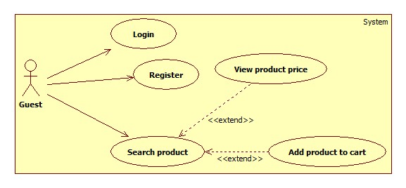

Figure 29: <Guest> Overview Use Case

##### <Guest> Login



Figure 30: <Guest> Login

|  |  |  |  |
| --- | --- | --- | --- |
| **USE CASE – SB025** | | | |
| **Use Case No.** | SB025 | **Use Case Version** | 2.0 |
| **Use Case Name** | Login | | |
| **Author** | Doan Ho Anh Triet | | |
| **Date** | 20/02/2014 | **Priority** | Normal |
| **Actor:**   * Guest.   **Summary:**   * This use case allows guest to login to the system.   **Goal:**   * Allow authentication and authorization of the system.   **Triggers:**   * Guest want to login into system. * To login: Guests go to the login page, enter username and password, and click “Đăng nhập” button to login.   **Preconditions:** N/A.  **Post Conditions:**   * **Success:** Guest is authorized, redirect to corresponding page. * **Fail:** System will show error on current page.   **Main Success Scenario:**   |  |  |  | | --- | --- | --- | | Step | Actor Action | System Response | | 1 | Guest goes to login page. | System show a login form, includes:   * Username: textbox, min length: 6, max length: 30, required. * Password: textbox, password box, min length: 6, max length: 20, required. * Đăng nhập: button. | | 2 | Guess enter username and password into textboxes.  Press “Đăng nhập” button. | Guest is logged into system, authorized with corresponding role. Redirect to corresponding page.  [Exception 1,2] |   **Alternative Scenario:** N/A  **Exceptions:**   |  |  |  | | --- | --- | --- | | No | Actor Action | System Response | | 1 | No input in “Username” or “Password” textboxes | Show error message: “Vui lòng điền đủ username và password!” | | 2 | Username/Password not in range [5,30] | Show error message: “Thông tin không hợp lệ. Vui lòng thử lại!” | | 3 | Input invalid “Username” and “Password” | Show error message: “Thông tin không hợp lệ. Vui lòng thử lại!” |   **Relationships:** N/A  **Business Rules:**   * Each member, staff, admin has an account. * Only active account can log in. * Only member’s account can login from mobile application. | | | |

Table 30: <Guest> Login

##### <Guest> Register



Figure 31: <Guest> Register

|  |  |  |  |
| --- | --- | --- | --- |
| **USE CASE – SB026** | | | |
| **Use Case No.** | SB026 | **Use Case Version** | 2.0 |
| **Use Case Name** | Register | | |
| **Author** | Doan Ho Anh Triet | | |
| **Date** | 20/02/2014 | **Priority** | Normal |
| **Actor:**   * Guest.   **Summary:**   * This use case allows guest to register.   **Goal:**   * User can register new account to become a member of the system.   **Triggers:**   * Guest wants to be a member of the system. * To register, click “Đăng ký” in menu bar.   **Preconditions:** N/A.  **Post Conditions:**   * **Success:** New member account is created. * **Fail:** Show error message.   **Main Success Scenario:**   |  |  |  | | --- | --- | --- | | Step | Actor Action | System Response | | 1 | Guest clicks “Đăng ký” link. | System show a register form which includes:   * Username: textbox, min length: 6, max length: 30, required. * Password: textbox, password box, min length: 6, max length: 20, required. * Đăng ký: button. * Xóa trắng: button. | | 2 | Guess enters required information, then clicks “Đăng ký” button. [Alternative 1] | Create new member account. Show success message.  [Exception 1,2, 3] |   **Alternative Scenario:**   |  |  |  | | --- | --- | --- | | No | Actor Action | System Response | | 1 | Guest clicks “Xóa trắng” button. | Clear all input fields. |   **Exceptions:**   |  |  |  | | --- | --- | --- | | No | Actor Action | System Response | | 1 | Length of username is not in range. | Show error message: “Độ dài username phải từ 6-30 ký tự!” | | 2 | Length of password is not in range. | Show error message: “Độ dài password phải từ 6-20 ký tự!” | | 3 | Username’s existed already. | Show error message: “Trùng tên đăng nhập! Vui lòng chọn tên khác!” |   **Relationships:** N/A  **Business Rules:**   * The role of new created account is “member”. | | | |

Table 31: <Guest> Register

##### <Guest> Search Product and View Product Price

* Reference use case SB018.

##### <Guest> Add Product To Cart

* Reference use case SB019.

## Software System Attribute

### Usability

#### Graphic User Interface

* All the texts, labels and should be written in Vietnamese.

#### Usability

* Admin, staff should need less than one week of training to be productive with the system.
* Guest and member can use the system easily without training.

#### Installation

* The system must be easy to deploy. Customer can deploy successfully and learn to configure, maintain the system within one day of training.
* The mobile app must be easy to install. Compatible with almost Android Phone.
* The attached manual guide must be clear. User can read and do themselves without developer’s help.

### Reliability

* The price should be updated every day.
* If the price is out of date, system must notify user about it.

### Availability

* In case network is not available, user still can search product, propose price, add to cart, and save buying history.

### Security

* Privacy: Each role of user has a specific permission to interact with system.
* System always checks authorization and authentication before doing anything.
* Only admin can grant permission to staff.

### Maintainability

* The system is divided into separated modules.
* The code is easy to maintain and upgrade.

### Portability

* N/A

### Performance

* Parsing speed should be 5ms per product.
* The speed of suggestion algorithm is less than 2 seconds.

## Conceptual Diagram

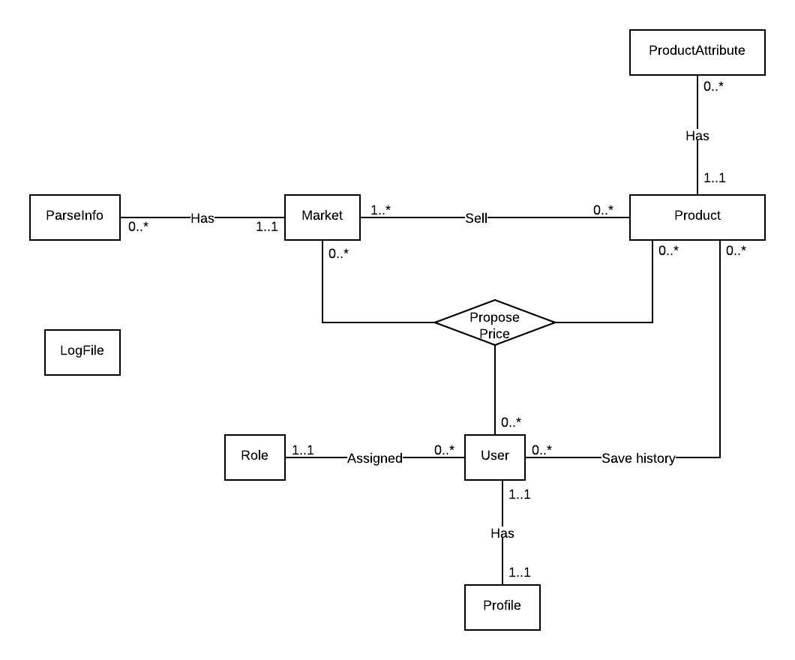

Figure 32: Conceptual Diagram

### Data Dictionary

|  |  |
| --- | --- |
| Entity Name | Description |
| Market | Describe all markets in the system. Market may exist in real life or just virtual. |
| Parse Info | Describe all needed data to parse a website. |
| Product | Describe all products in the system. |
| Product Attribute | Describe attributes of each product. |
| Log File | Describe all log files of the system. Log file is generated after parsers finish running. |
| User | Describe all accounts in the system. |
| Role | Describe all roles in the system. |
| Profile | Describe all user profiles in the system. Each user has only one profile. |

Table 32: Entity Data dictionary - Describe content of all entities

# Software Design Description

## Design Overview

* This document describes the technical and user interface design of Smart Buy System using mobile device. It includes the architectural design, the detailed design of common functions and business functions and the design of database model.
* The architectural design describes the overall architecture of the system and the architecture of each main component and subsystem.
* The detailed design describes static and dynamic structure for each component and functions. It includes class diagrams, class explanations and sequence diagrams for each use cases.
* The database design describes the relationships between entities and details of each entity.
* Document overview:
* Section 2: gives an overall description of the system architecture design.
* Section 3: gives component diagrams that describe the connection and integration of the system.
* Section 4: gives the detail design description which includes class diagram, class explanation, and sequence diagram to details the application functions.
* Section 5: describe an ERD with logical diagram.

## System Architectural Design

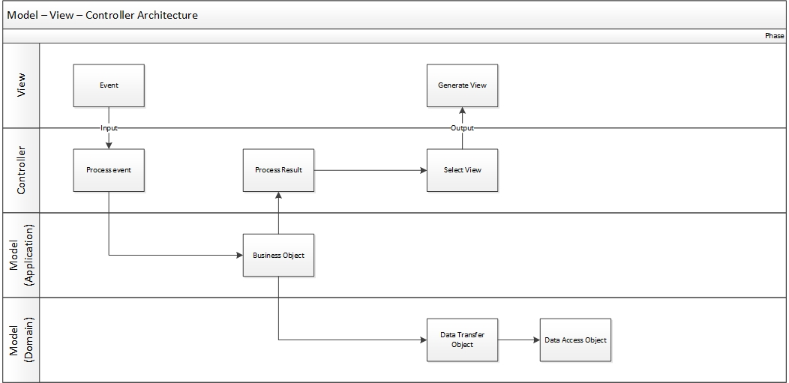

Figure 33: MVC Architecture

* **Model** is the part of the application that handles the logic for the application data. Often model objects retrieve data (and store data) from a database.
* **View** is the parts of the application that handles the display of the data. Most often the views are created from the model data.
* **Controller** is the part of the application that handles user interaction. Typically controllers read data from a view, control user input, and send input data to the model.

## Component Diagram

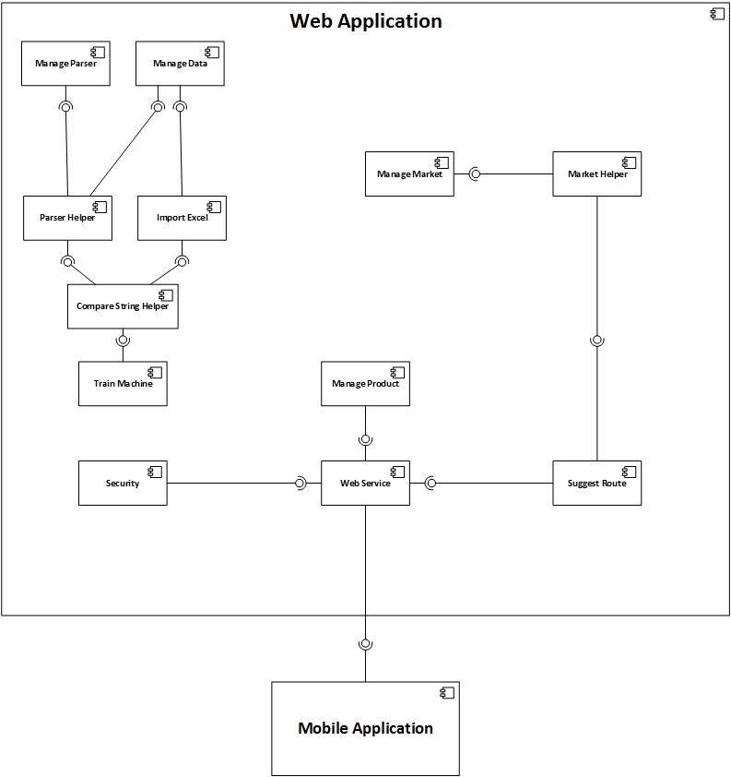

Figure 34: Component Diagram

## Detailed Description of Components

### Class Diagram

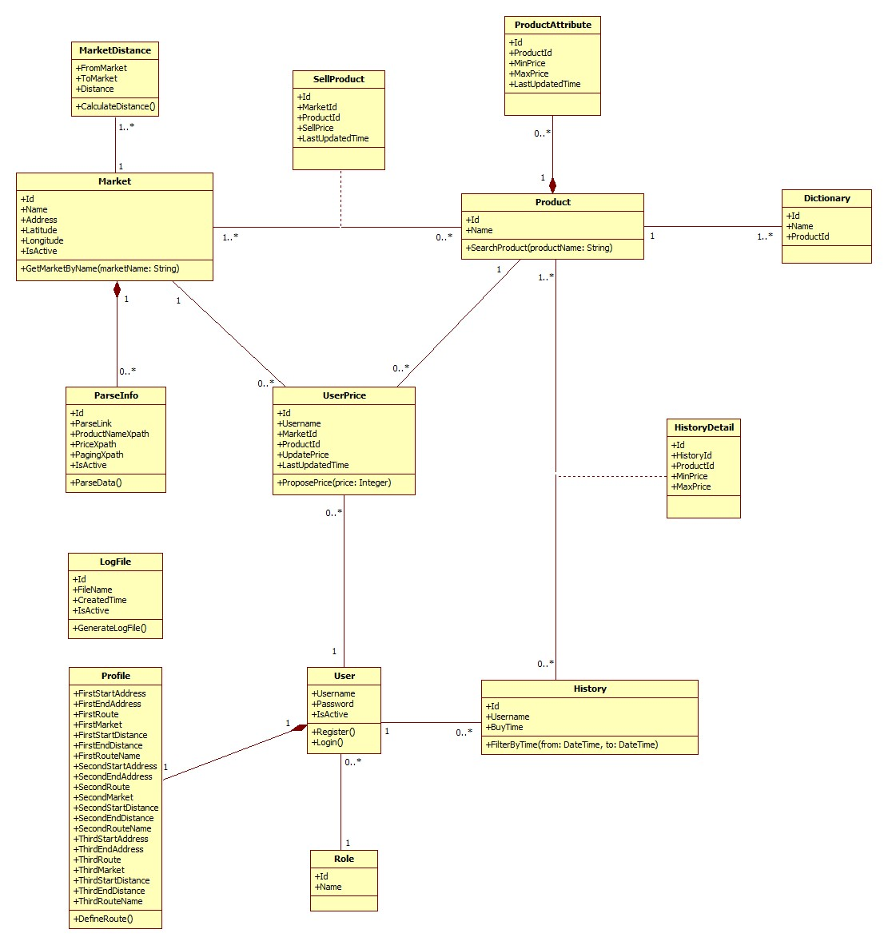

Figure 35: Class Diagram

### Class Diagram Explanation

#### Market

Attribute

|  |  |  |  |
| --- | --- | --- | --- |
| **Attribute** | **Type** | **Visibility** | **Description** |
| Id | Integer | Public | Unique identifier of each market |
| Name | String | Public | Name of market |
| Address | String | Public | Address of market |
| Longitude | Double | Public | Longitude of market |
| IsActive | Boolean | Public | Status of market |

Method

|  |  |  |  |
| --- | --- | --- | --- |
| **Method** | **Return type** | **Visibility** | **Description** |
| GetMarketByName | List of markets | Public | Find market by its name |

#### Parse Info

Attribute

|  |  |  |  |
| --- | --- | --- | --- |
| **Attribute** | **Type** | **Visibility** | **Description** |
| Id | Integer | Public | Unique identifier of each item |
| ParseLink | String | Public | Link used to parse |
| ProductNameXpath | String | Public | Xpath to get the name of products |
| PriceXpath | String | Public | Xpath to get the price of products |
| PagingXpath | String | Public | Xpath to get the pagination part |
| IsActive | Boolean | Public | Status of info |

Method

|  |  |  |  |
| --- | --- | --- | --- |
| **Method** | **Return type** | **Visibility** | **Description** |
| ParseData | Void | Public | Run parser to get data |

#### Sell Product

Attribute

|  |  |  |  |
| --- | --- | --- | --- |
| **Attribute** | **Type** | **Visibility** | **Description** |
| Id | Integer | Public | Unique identifier of each item |
| MarketId | Integer | Public | Id of market |
| ProductId | Integer | Public | Id of product |
| SellPrice | Integer | Public | That market sells that product at this price |
| LastUpdatedTime | DateTime | Public | The time when the price is updated. |

#### Product

Attribute

|  |  |  |  |
| --- | --- | --- | --- |
| **Attribute** | **Type** | **Visibility** | **Description** |
| Id | Integer | Public | Unique identifier of each product |
| Name | Integer | Public | Product name |

Method

|  |  |  |  |
| --- | --- | --- | --- |
| **Method** | **Return type** | **Visibility** | **Description** |
| SearchProduct | List of products | Public | Search product by its name |

#### Product Attribute

Attribute

|  |  |  |  |
| --- | --- | --- | --- |
| **Attribute** | **Type** | **Visibility** | **Description** |
| Id | Integer | Public | Unique identifier of each item |
| ProductId | Integer | Public | Id of product |
| MinPrice | Integer | Public | Min price of this product |
| MaxPrice | Integer | Public | Max price of this product |
| LastUpdatedTime | DateTime | Public | The time when this information is updated. |

#### User Price

Attribute

|  |  |  |  |
| --- | --- | --- | --- |
| **Attribute** | **Type** | **Visibility** | **Description** |
| Id | Integer | Public | Unique identifier of each item |
| Username | String | Public | Username of member who propose price |
| MarketId | Integer | Public | Id of market |
| ProductId | Integer | Public | Id of product |
| UpdatePrice | Integer | Public | Proposed price |
| LastUpdatedTime | DateTime | Public | The time when the price is proposed. |

Method

|  |  |  |  |
| --- | --- | --- | --- |
| **Method** | **Return type** | **Visibility** | **Description** |
| ProposePrice | Void | Public | Propose price for the system |

#### User

Attribute

|  |  |  |  |
| --- | --- | --- | --- |
| **Attribute** | **Type** | **Visibility** | **Description** |
| Username | String | Public | Username for each user |
| Password | String | Public | User’s password |
| IsActive | Boolean | Public | Status of this account |

Method

|  |  |  |  |
| --- | --- | --- | --- |
| **Method** | **Return type** | **Visibility** | **Description** |
| Register | Void | Public | For new user to register |
| Login | Boolean | Public | Used to log in the system |

#### History

Attribute

|  |  |  |  |
| --- | --- | --- | --- |
| **Attribute** | **Type** | **Visibility** | **Description** |
| Id | Integer | Public | Unique identifier of each history |
| Username | String | Public | Owner of this history |
| BuyTime | DateTime | Public | The time when owner create this history |

Method

|  |  |  |  |
| --- | --- | --- | --- |
| **Method** | **Return type** | **Visibility** | **Description** |
| FilterByTime | List of history | Public | Filter history list by the range of time |

#### History Detail

Attribute

|  |  |  |  |
| --- | --- | --- | --- |
| **Attribute** | **Type** | **Visibility** | **Description** |
| Id | Integer | Public | Unique identifier of each item |
| HistoryId | Integer | Public | Id of history |
| ProductId | Integer | Public | Id of product |
| MinPrice | Integer | Public | Min price of that product at that time |

#### Role

Attribute

|  |  |  |  |
| --- | --- | --- | --- |
| **Attribute** | **Type** | **Visibility** | **Description** |
| Id | Integer | Public | Unique identifier of each role |
| Name | String | Public | Role name |

#### Log File

Attribute

|  |  |  |  |
| --- | --- | --- | --- |
| **Attribute** | **Type** | **Visibility** | **Description** |
| Id | Integer | Public | Unique identifier of each file |
| FileName | String | Public | File name |
| CreatedTime | DateTime | Public | The time when this file is created |
| IsActive | Boolean | Public | Status of this file |

Method

|  |  |  |  |
| --- | --- | --- | --- |
| **Method** | **Return type** | **Visibility** | **Description** |
| GenerateLogFile | Boolean | Public | Generate log file for each time system runs the parser |

#### Dictionary

Attribute

|  |  |  |  |
| --- | --- | --- | --- |
| **Attribute** | **Type** | **Visibility** | **Description** |
| Id | Integer | Public | Unique id of each item |
| Name | String | Public | The name of the product |
| ProductId | Integer | Public | The identifier of that product |

#### Market Distance

Attribute

|  |  |  |  |
| --- | --- | --- | --- |
| **Attribute** | **Type** | **Visibility** | **Description** |
| FromMarket | Integer | Public | Unique id of a market |
| ToMarket | Integer | Public | Unique id of a market |
| Distance | Integer | Public | Distance between 2 markets |

Method

|  |  |  |  |
| --- | --- | --- | --- |
| **Method** | **Return Type** | **Visibility** | **Description** |
| CalculateDistance | Integer | Public | Calculate distance between 2 markets |

#### Profile

Attribute

|  |  |  |  |
| --- | --- | --- | --- |
| **Attribute** | **Type** | **Visibility** | **Description** |
| FirstStartAddress | String | Public | Start address of the first route |
| FirstEndAddress | String | Public | End address of the first route |
| FirstRoute | String | Public | First favourite route |
| FirstMarket | String | Public | List of nearby market id separated by comma |
| FirstStartDistance | String | Public | List of distance from the first start point to all nearby markets, separated by comma |
| FirstEndDistance | String | Public | List of distance from the first end point to all nearby markets, separated by comma |
| FirstRouteName | String | Public | Name of the first route |
| SecondStartAddress | String | Public | Start address of the second route |
| SecondEndAddress | String | Public | End address of the Second route |
| SecondRoute | String | Public | Second favourite route |
| SecondMarket | String | Public | List of nearby market id separated by comma |
| SecondStartDistance | String | Public | List of distance from the second start point to all nearby markets, separated by comma |
| SecondEndDistance | String | Public | List of distance from the second end point to all nearby markets, separated by comma |
| SecondRouteName | String | Public | Name of the second route |
| ThirdStartAddress | String | Public | Start address of the third route |
| ThirdEndAddress | String | Public | End address of the third route |
| ThirdRoute | String | Public | Third favourite route |
| ThirdMarket | String | Public | List of nearby market id separated by comma |
| ThirdStartDistance | String | Public | List of distance from the third start point to all nearby markets, separated by comma |
| ThirdEndDistance | String | Public | List of distance from the third end point to all nearby markets, separated by comma |
| ThirdRouteName | String | Public | Name of the third route |

Method

|  |  |  |  |
| --- | --- | --- | --- |
| **Method** | **Return Type** | **Visibility** | **Description** |
| DefineRoute | Void | Public | Define favourite routes |

### Sequence Diagram

#### Force Parse Data

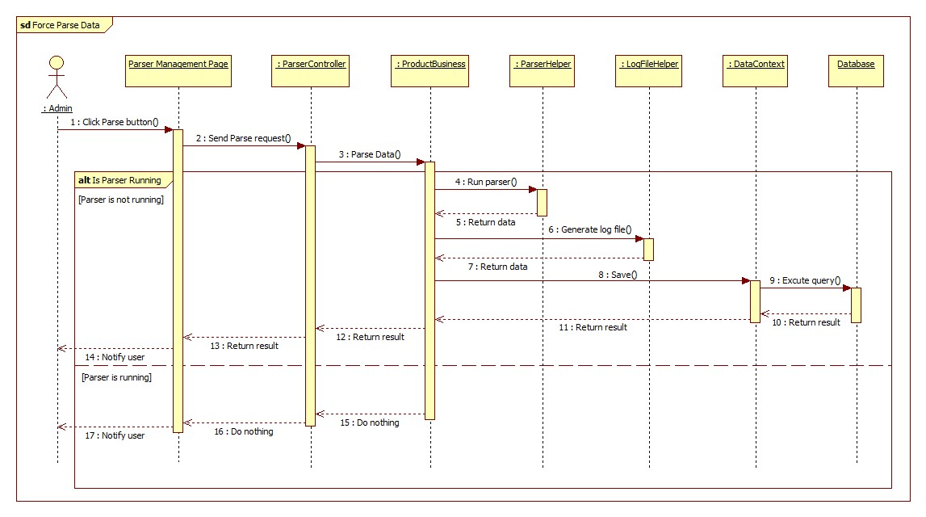

Figure 36: Force Parse Data Sequence Diagram

#### Import Excel

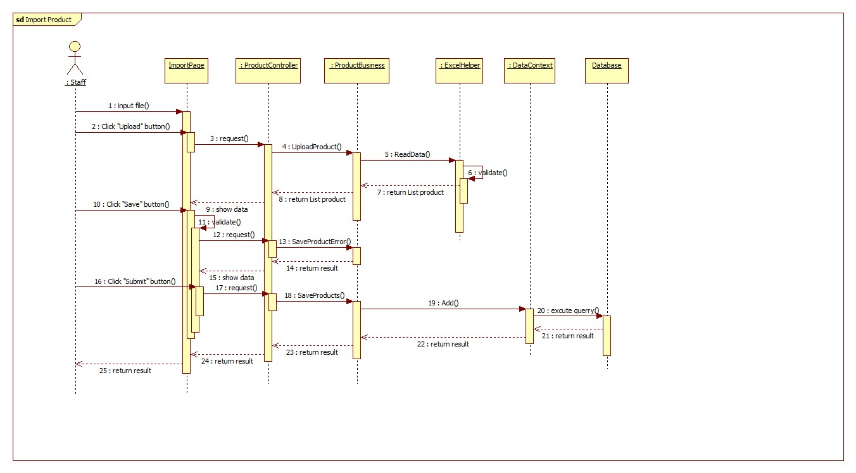

Figure 37: Import Excel Sequence Diagram

#### Propose Price



Figure 38: Propose Price Sequence Diagram

#### Save Product History



Figure 39: Save Product History Sequence Diagram

#### View Product History



Figure 40: View Product History Sequence Diagram

#### View History Detail



Figure 41: View History Detail Sequence Diagram

#### Search Product

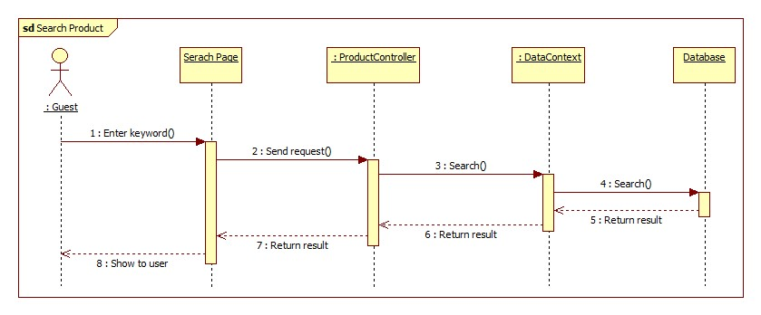

Figure 42: Search Product Sequence Diagram

#### Configure System

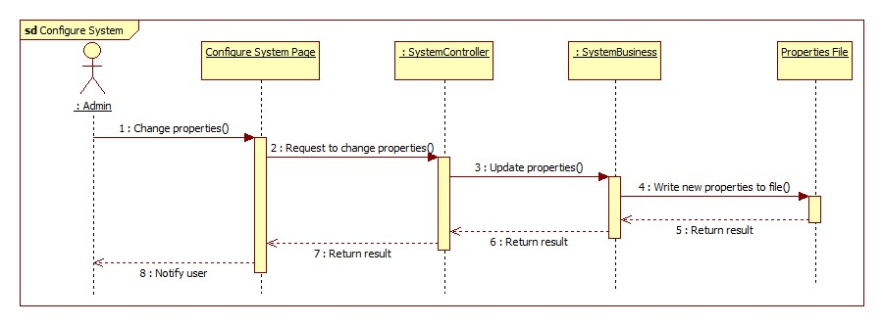

Figure 43: Configure System Sequence Diagram

#### Ask For System Suggestion

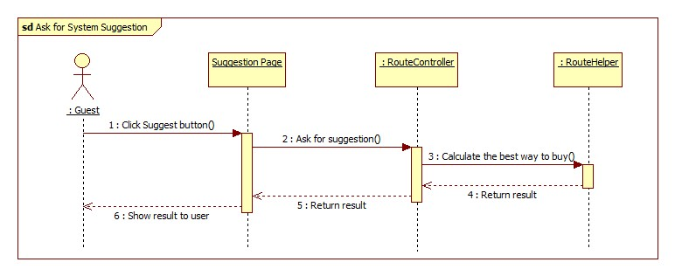

Figure 44: Ask For System Suggestion Sequence Diagram

## User Interface Design

### Guest, Member Design

#### Guest Home Page



Figure 45: Guest Home Page

**Fields**

|  |  |  |  |  |  |  |  |
| --- | --- | --- | --- | --- | --- | --- | --- |
| **No** | **Field Name** | **Description** | **Read only** | **Mandatory** | **Control Type** | **Data Type** | **Length** |
| 6 | Slide | Slide about website | No | No | Slide | N/A | N/A |

**Buttons/ Hyperlinks**

|  |  |  |  |  |
| --- | --- | --- | --- | --- |
| **No** | **Function** | **Description** | **Validation** | **Outcome** |
| 1 | Home page | Click to transfer to home page | No | Transfer to Home page |
| 2 | Search product | Click to transfer to search page | No | Transfer to Search page |
| 3 | View cart | Click to view cart | No | Transfer to Cart page |
| 4 | View Statistic | Click to transfer to statistic page | No | Transfer to Statistic page |
| 5 | Login page | Click to transfer to Login page | No | Transfer to Login page |

#### Login



Figure 46: Login

**Fields**

|  |  |  |  |  |  |  |  |
| --- | --- | --- | --- | --- | --- | --- | --- |
| **No** | **Field Name** | **Description** | **Read only** | **Mandatory** | **Control Type** | **Data Type** | **Length** |
| 1 | Account name | Fill account name | No | Yes | Textbox | String | N/A |
| 2 | Password | Fill password | No | Yes | Password | String | N/A |

**Buttons/Hyperlinks**

|  |  |  |  |  |
| --- | --- | --- | --- | --- |
| **No** | **Function** | **Description** | **Validation** | **Outcome** |
| 3 | Remember | Click to remember username and password | N/A | N/A |
| 4 | Login | Log-in into the system | N/A | Transfer to home page |
| 5 | Register | Click to register account | N/A | Transfer to register page |

#### Register Page



Figure 47: Register Page

**Fields**

|  |  |  |  |  |  |  |  |
| --- | --- | --- | --- | --- | --- | --- | --- |
| **No** | **Field Name** | **Description** | **Read only** | **Mandatory** | **Control Type** | **Data Type** | **Length** |
| 1 | Account name | Fill account name | No | Yes | Textbox | String | N/A |
| 2 | Password | Fill password | No | Yes | Password | String | N/A |
| 3 | Confirm password | Fill password | No | Yes | Password | String | N/A |

**Buttons/Hyperlinks**

|  |  |  |  |  |
| --- | --- | --- | --- | --- |
| **No** | **Function** | **Description** | **Validation** | **Outcome** |
| 4 | Register | Register new account | N/A | Transfer to home page |
| 5 | Login | Click to log-in into the system | N/A | Transfer to login page |

#### Member Home Page



Figure 48: Member Home Page

**Buttons/ Hyperlinks**

|  |  |  |  |  |
| --- | --- | --- | --- | --- |
| **No** | **Function** | **Description** | **Validation** | **Outcome** |
| 1 | Home page | Click to transfer to home page | No | Transfer to Home page |
| 2 | Search product | Click to transfer to search page | No | Transfer to Search page |
| 3 | View cart | Click to view cart | No | Transfer to Cart page |
| 4 | View Statistic | Click to transfer to statistic page | No | Transfer to Statistic page |
| 5 | Suggest route | Click to transfer to Suggest route | No | Transfer to Suggest page |
| 6 | Account Detail | Click to transfer to account detail page | No | Transfer to Account detail page |

#### Search Page



Figure 49: Search Page

**Fields**

|  |  |  |  |  |  |  |  |
| --- | --- | --- | --- | --- | --- | --- | --- |
| **No** | **Field Name** | **Description** | **Read only** | **Mandatory** | **Control Type** | **Data Type** | **Length** |
| 2 | Product name | Fill product name | No | No | Textbox | String | N/A |
| 3 | Product list | Show list product | Yes | Yes | Table list view | N/A | N/A |

**Button/ Hyperlink**

|  |  |  |  |  |
| --- | --- | --- | --- | --- |
| **No** | **Function** | **Description** | **Validation** | **Outcome** |
| 1 | Search | Click to search | N/A | N/A |
| 4 | Add to cart | Add product to cart | N/A | N/A |
| 5 | Propose price | Click to propose price | N/A | Show pop-up propose product price |

**Product List includes**

|  |  |  |  |  |  |
| --- | --- | --- | --- | --- | --- |
| **Field Name** | **Description** | **Read only** | **Control Type** | **Data Type** | **Length** |
| Product name | Show product name | Yes | Textview | String | N/A |
| Price | Show product price | Yes | Textview | Integer | N/A |
| Action | Action for product | N/A | Button | N/A | N/A |

#### Propose Price



Figure 50: Propose Price

**Fields**

|  |  |  |  |  |  |  |  |
| --- | --- | --- | --- | --- | --- | --- | --- |
| **No** | **Field Name** | **Description** | **Read only** | **Mandatory** | **Control Type** | **Data Type** | **Length** |
| 1 | Propose Product price | Fill propose product price. | N/A | N/A | Label | String | N/A |
| 2 | Propose Product price | Fill product name | Yes | N/A | Textbox | String | N/A |
| 3 | Propose product price | Fill product price | No | Yes | Textbox | Integer | 1-10000 |
| 4 | Market name | Select market name | No | Yes | Dropdown list | String | N/A |

**Button/ Hyperlink**

|  |  |  |  |  |
| --- | --- | --- | --- | --- |
| **No** | **Function** | **Description** | **Validation** | **Outcome** |
| 5 | Propose price | Click to propose price | N/A | Close propose product price pop-up |

#### View Cart



Figure 51: View Cart

**Fields**

|  |  |  |  |  |  |  |  |
| --- | --- | --- | --- | --- | --- | --- | --- |
| **No** | **Field Name** | **Description** | **Read only** | **Mandatory** | **Control Type** | **Data Type** | **Length** |
| 1 | Quantity product | Fill product quantity | No | N/A | Textbox | Integer | [1-10] |

**Button/ Hyperlink**

|  |  |  |  |  |
| --- | --- | --- | --- | --- |
| **No** | **Function** | **Description** | **Validation** | **Outcome** |
| 2 | Delete | Click to remove product | N/A | N/A |
| 3 | Save | Save cart to history | N/A | Transfer to buying history |

**Product List includes**

|  |  |  |  |  |  |
| --- | --- | --- | --- | --- | --- |
| **Field Name** | **Description** | **Read only** | **Control Type** | **Data Type** | **Length** |
| Row number | Number of row | Yes | Textview | String | N/A |
| Product name | Show product name | Yes | Textview | String | N/A |
| Price | Show product price | Yes | Textview | Integer | N/A |
| Quantity | Show quantity of product | No | Textview | Integer | N/A |
| Action | Action for product | No | Button | N/A | N/A |

#### Buying History



Figure 52: Buying History

**Fields**

|  |  |  |  |  |  |  |  |
| --- | --- | --- | --- | --- | --- | --- | --- |
| **No** | **Field Name** | **Description** | **Read only** | **Mandatory** | **Control Type** | **Data Type** | **Length** |
| 1 | Buying history | Show list of buying history | No | No | Table list view | N/A | N/A |

**Button/ Hyperlink**

|  |  |  |  |  |
| --- | --- | --- | --- | --- |
| **No** | **Function** | **Description** | **Validation** | **Outcome** |
| 2 | Detail | Click to view history detail | N/A | Transfer to order detail page |

**Order History List includes**

|  |  |  |  |  |  |
| --- | --- | --- | --- | --- | --- |
| **Field Name** | **Description** | **Read only** | **Control Type** | **Data Type** | **Length** |
| Date | Show date order | Yes | Textview | String | N/A |
| Action | View order detail | N/A | Button | N/A | N/A |

#### History Details



Figure 53: History Details

**Fields**

|  |  |  |  |  |  |  |  |
| --- | --- | --- | --- | --- | --- | --- | --- |
| **No** | **Field Name** | **Description** | **Read only** | **Mandatory** | **Control Type** | **Data Type** | **Length** |
| 1 | Order history | Show list product | No | No | Table list view | N/A | N/A |

**Button/ Hyperlink**

|  |  |  |  |  |
| --- | --- | --- | --- | --- |
| **No** | **Function** | **Description** | **Validation** | **Outcome** |
| 2 | Back | Back to order history page | N/A | Transfer to order history page |

**Order Product List includes**

|  |  |  |  |  |  |
| --- | --- | --- | --- | --- | --- |
| **Field Name** | **Description** | **Read only** | **Control Type** | **Data Type** | **Length** |
| Product name | Show product name | Yes | Textview | String | N/A |
| Product price | Show product price | Yes | Textview | Integer | N/A |
| Product current price | Show current price | Yes | Textview | Integer | N/A |

#### Suggest Route



Figure 54: Suggest Route

**Fields**

|  |  |  |  |  |  |  |  |
| --- | --- | --- | --- | --- | --- | --- | --- |
| **No** | **Field Name** | **Description** | **Read only** | **Mandatory** | **Control Type** | **Data Type** | **Length** |
| 1 | Route | Address name | Yes | No | Dropdown list | String | N/A |
| 3 | Order detail | Show list product | Yes | No | Table list view | N/A | N/A |
| 4 | Map | Show map suggest | Yes | No | Google map | N/A | N/A |

**Button/ Hyperlink**

|  |  |  |  |  |
| --- | --- | --- | --- | --- |
| **No** | **Function** | **Description** | **Validation** | **Outcome** |
| 2 | Suggest route | Click to view map | N/A | Show map |

**Order Detail includes**

|  |  |  |  |  |  |
| --- | --- | --- | --- | --- | --- |
| **Field Name** | **Description** | **Read only** | **Control Type** | **Data Type** | **Length** |
| STT | Number row | Yes | Textview | Integer | N/A |
| Product name | Show product name | Yes | Textview | String | N/A |
| Market name | Show market name | Yes | Textview | String | N/A |
| Product price | Show current price | Yes | Textview | Integer | N/A |

#### Account Detail



Figure 55: Account Detail

**Fields**

|  |  |  |  |  |  |  |  |
| --- | --- | --- | --- | --- | --- | --- | --- |
| **No** | **Field Name** | **Description** | **Read only** | **Mandatory** | **Control Type** | **Data Type** | **Length** |
| 1 | Route name | Route’s name | No | Yes | Textbox | String | N/A |
| 2 | Start route | Address of start route | No | Yes | Textbox | String | N/A |
| 3 | End route | Address of end route | No | Yes | Textbox | String | N/A |
| 8 | Map | Show route on map | Yes | No | Google map | N/A | N/A |

**Button/ Hyperlink**

|  |  |  |  |  |
| --- | --- | --- | --- | --- |
| **No** | **Function** | **Description** | **Validation** | **Outcome** |
| 4 | Choose | Show route on map | Yes | N/A |
| 5 | Route second | Show info detail of route second | N/A | N/A |
| 6 | Route three | Show info detail of route three | N/A | N/A |
| 7 | Save | Save info detail of address | Yes | N/A |

#### Change Password



Figure 56: Change Password

**Fields**

|  |  |  |  |  |  |  |  |
| --- | --- | --- | --- | --- | --- | --- | --- |
| **No** | **Field Name** | **Description** | **Read only** | **Mandatory** | **Control Type** | **Data Type** | **Length** |
| 1 | User name | Fill account name | No | Yes | Textbox | String | N/A |
| 2 | Old password | Fill old password | No | Yes | Textbox | String | N/A |
| 3 | New password | Fill new password | No | Yes | Textbox | String | N/A |

**Button/ Hyperlink**

|  |  |  |  |  |
| --- | --- | --- | --- | --- |
| **No** | **Function** | **Description** | **Validation** | **Outcome** |
| 4 | Save | Change old password | Yes | Transfer to Account detail |

### Admin Interface Design

#### Login Page

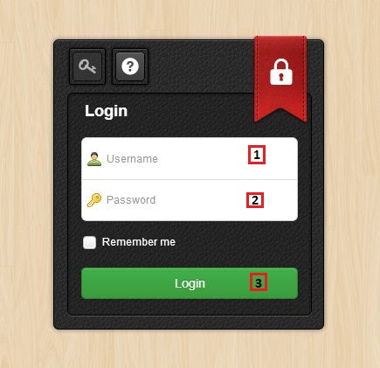

Figure 57: Admin/Staff Login Page

**Fields**

|  |  |  |  |  |  |  |  |
| --- | --- | --- | --- | --- | --- | --- | --- |
| **No** | **Field name** | **Description** | **Read only** | **Mandatory** | **Control type** | **Data type** | **Length** |
| 1 | Username | Fill username | No | Yes | Textbox | String | [6-20] |
| 2 | Password | Fill password | No | Yes | Password | String | [6-20]] |

**Button/Hyperlink**

|  |  |  |  |  |
| --- | --- | --- | --- | --- |
| **No** | **Function** | **Description** | **Validation** | **Outcome** |
| 2 | Login | Click to login into the system | Yes | Transfer to Admin/Staff Home page |

#### User List Page

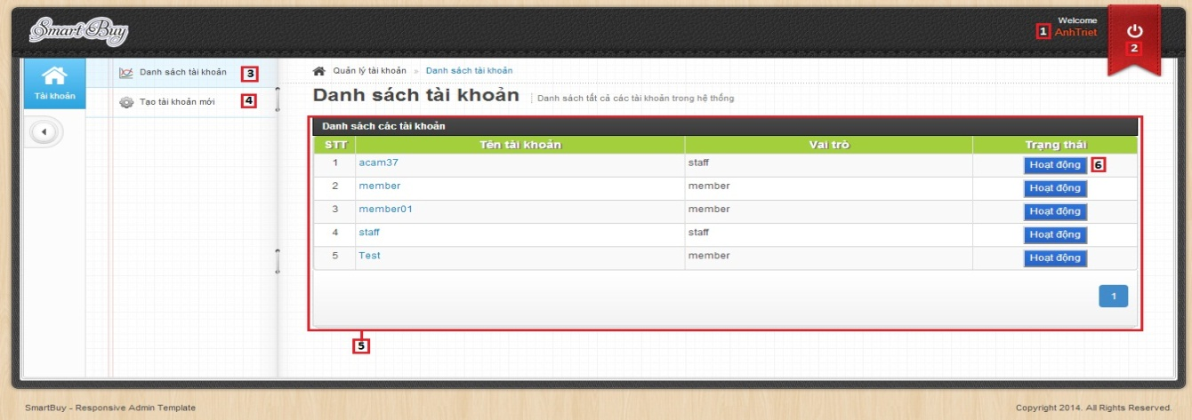

Figure 58: User List Page

**Fields**

|  |  |  |  |  |  |  |  |
| --- | --- | --- | --- | --- | --- | --- | --- |
| **No** | **Field name** | **Description** | **Read only** | **Mandatory** | **Control type** | **Data type** | **Length** |
| 1 | Account info | Username of admin | N/A | N/A | Label | N/A | N/A |
| 5 | User list | Table showing | Yes | Yes | Table | N/A | N/A |

**Button/ Hyperlink**

|  |  |  |  |  |
| --- | --- | --- | --- | --- |
| **No** | **Function** | **Description** | **Validation** | **Outcome** |
| 2 | Logout | Click to logout account | No | Transfer to Admin/Staff Login page |
| 3 | Manage user account | Click to go to manage user page | No | Transfer to Manage user page |
| 4 | Create new account | Click to go to create new user page | No | Transfer to Create new user page |
| 6 | Enable/Disable account | Click to Enable/Disable the user | No | Message completed |

**Table User List includes**

|  |  |  |  |  |  |
| --- | --- | --- | --- | --- | --- |
| **Field name** | **Description** | **Read only** | **Control type** | **Data type** | **Length** |
| No. | Number | N/A | Label | Integer | N/A |
| Username | Username | N/A | Label | String | N/A |
| Role | Role of user | N/A | Label | String | N/A |
| Status | Enable/Disable account | No | Button | N/A | N/A |

#### Create New User Page

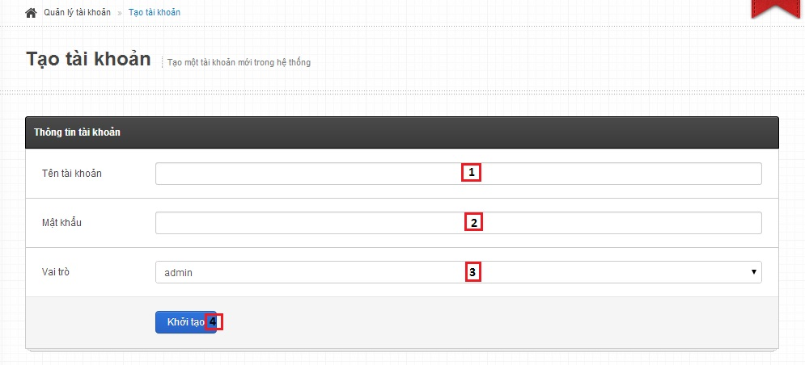

Figure 59: Create New User Page

**Fields**

|  |  |  |  |  |  |  |  |
| --- | --- | --- | --- | --- | --- | --- | --- |
| **No** | **Field name** | **Description** | **Read only** | **Mandatory** | **Control type** | **Data type** | **Length** |
| 1 | Username | Fill username of user | No | Yes | Textbox | String | [6-20] |
| 2 | Password | Fill password | No | Yes | Password | String | [6-20] |
| 3 | Role | Select role of user | No | Yes | Drop down list | N/A | N/A |

**Button/ Hyperlink**

|  |  |  |  |  |
| --- | --- | --- | --- | --- |
| **No** | **Function** | **Description** | **Validation** | **Outcome** |
| 4 | Create new user | Create new user | Yes | Transfer to Manage user page |

### Staff Interface Design

#### Train Machine Page

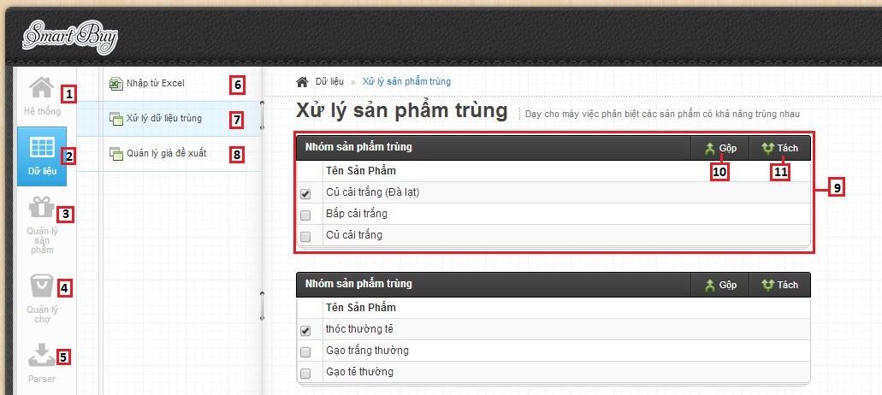

Figure 60: Train Machine Page

**Fields**

|  |  |  |  |  |  |  |  |
| --- | --- | --- | --- | --- | --- | --- | --- |
| **No** | **Field name** | **Description** | **Read only** | **Mandatory** | **Control type** | **Data type** | **Length** |
| 1 | Home page | Home page | N/A | Yes | Label | N/A | N/A |
| 2 | Data | Data | N/A | Yes | Label | N/A | N/A |
| 3 | Manage product | Manage product | N/A | Yes | Label | N/A | N/A |
| 4 | Manage market | Manage market | N/A | Yes | Label | N/A | N/A |
| 5 | Parser | Manage parse data | N/A | Yes | Label | N/A | N/A |
| 9 | Data training list | Table showing | No | Yes | Table | N/A | N/A |

**Button/ Hyperlink**

|  |  |  |  |  |
| --- | --- | --- | --- | --- |
| **No** | **Function** | **Description** | **Validation** | **Outcome** |
| 6 | Import excel | Click to go to import excel page | No | Transfer to Import excel page |
| 7 | Training match | Click to go to training match page | No | Transfer to Training match page |
| 8 | Manage propose price | Click to go to manage propose price page | No | Transfer to Manage propose price page |
| 10 | Merge | Click to merge product | Yes | N/A |
| 11 | Split | Click to split product | Yes | N/A |

**Table data training List includes**

|  |  |  |  |  |  |
| --- | --- | --- | --- | --- | --- |
| **Field name** | **Description** | **Read only** | **Control type** | **Data type** | **Length** |
| Checkbox field | Select product | No | Checkbox | N/A | N/A |
| Product name | Product name | N/A | Label | String | N/A |

#### Import Excel Page

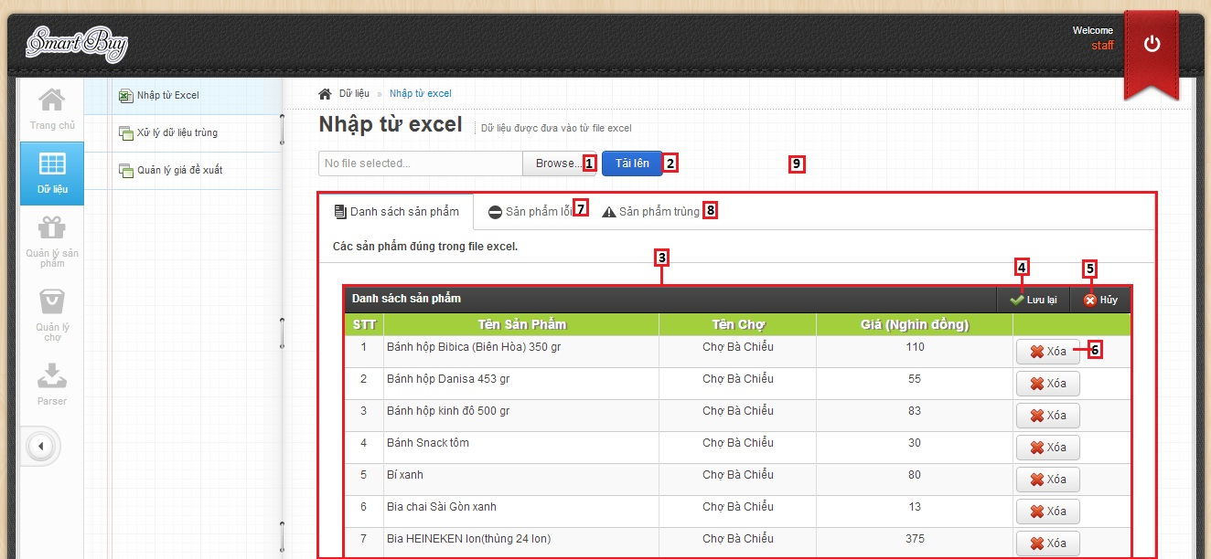

Figure 61: Import Excel – Correct Data List

**Fields**

|  |  |  |  |  |  |  |  |
| --- | --- | --- | --- | --- | --- | --- | --- |
| **No** | **Field Name** | **Description** | **Read only** | **Mandatory** | **Control Type** | **Data Type** | **Length** |
| 3 | Product list | Show list product | No | N/A | Table list view | N/A | N/A |
| 9 | Tab content | Tab content | No | N/A | Tab view | N/A | N/A |

**Button/ Hyperlink**

|  |  |  |  |  |
| --- | --- | --- | --- | --- |
| **No** | **Function** | **Description** | **Validation** | **Outcome** |
| 1 | Select excel file | Click to select excel file | N/A | N/A |
| 2 | Upload excel file | Get data in excel file | N/A | N/A |
| 4 | Save product | Click to save product into database | N/A | Show message result. |
| 5 | Cancel import | Click to cancel import product | N/A | N/A |
| 6 | Remove product | Click to remove product | N/A | N/A |
| 7 | Error product list | Click to transfer to error product list | N/A | Transfer to error product tab |
| 8 | Duplicate product list | Click to transfer to duplicate product list | N/A | Transfer to duplicate product tab |

**Product List includes**

|  |  |  |  |  |  |
| --- | --- | --- | --- | --- | --- |
| **Field Name** | **Description** | **Read only** | **Control Type** | **Data Type** | **Length** |
| Number row | Number of row | N/A | Label | String | N/A |
| Product name | Show product name | N/A | Label | String | N/A |
| Market name | Show market name | N/A | Label | String | N/A |
| Price | Show product price | N/A | Label | Integer | N/A |
| Action | Action for product | No | Button | N/A | N/A |

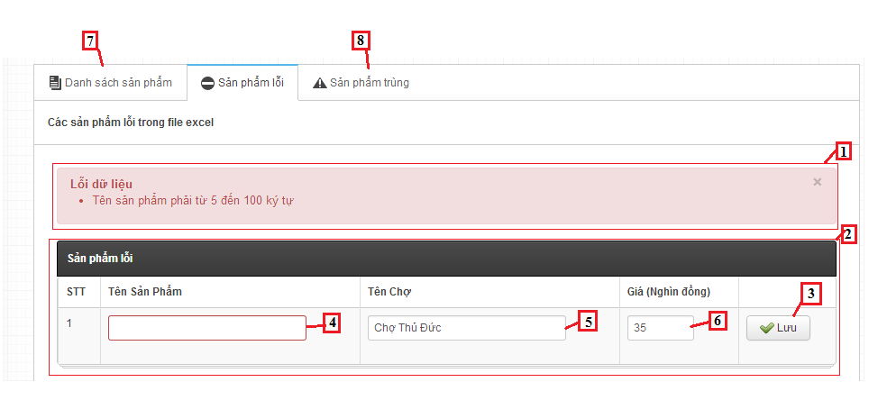

Figure 62: Import Excel – Error Data List

**Fields**

|  |  |  |  |  |  |  |  |
| --- | --- | --- | --- | --- | --- | --- | --- |
| **No** | **Field Name** | **Description** | **Read only** | **Mandatory** | **Control Type** | **Data Type** | **Length** |
| 1 | Message | Show error message | N/A | N/A | Label | String | N/A |
| 2 | Error Product list | Show list product | No | N/A | Table list view | N/A | N/A |
| 4 | Product name | Fill name of product | No | Yes | Textbox | String | [6-100] |
| 5 | Market name | Fill name of market | No | Yes | Textbox | String | [6-100] |
| 6 | Price | Fill price of product | No | Yes | Textbox | String | [1-10000] |

**Button/ Hyperlink**

|  |  |  |  |  |
| --- | --- | --- | --- | --- |
| **No** | **Function** | **Description** | **Validation** | **Outcome** |
| 3 | Save product | Click to save product | N/A | N/A |
| 7 | Correct product list | Click to transfer to correct product list | N/A | Transfer to correct product tab |
| 8 | Duplicate product list | Click to transfer to duplicate product list | N/A | Transfer to duplicate product tab |

**Error Product List includes**

|  |  |  |  |  |  |
| --- | --- | --- | --- | --- | --- |
| **Field Name** | **Description** | **Read only** | **Control Type** | **Data Type** | **Length** |
| Number row | Number of row | N/A | Label | String | N/A |
| Product name | Show product name | N/A | Label | String | N/A |
| Market name | Show market name | N/A | Label | String | N/A |
| Price | Show product price | N/A | Label | Integer | N/A |
| Action | Action for product | No | Button | N/A | N/A |

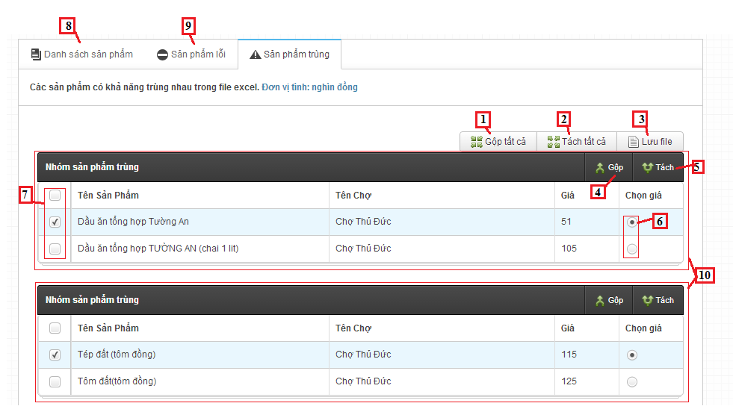

Figure 63: Import Excel - Name Conflict

**Fields**

|  |  |  |  |  |  |  |  |
| --- | --- | --- | --- | --- | --- | --- | --- |
| **No** | **Field Name** | **Description** | **Read only** | **Mandatory** | **Control Type** | **Data Type** | **Length** |
| 10 | Duplicate product table | Show duplicate product | N/A | N/A | Table list view | N/A | N/A |

**Button/ Hyperlink**

|  |  |  |  |  |
| --- | --- | --- | --- | --- |
| **No** | **Function** | **Description** | **Validation** | **Outcome** |
| 1 | Join all product | Click to join products in each table | N/A | N/A |
| 2 | Divide all product | Click to divide product in each table | N/A | N/A |
| 3 | Save log file | Click to save duplicate product to text file | N/A | Show message result |
| 4 | Join product | Click to join products in current table | N/A | N/A |
| 5 | Divide product | Click to divide product in current table | N/A | N/A |
| 6 | Price | Select price of product | N/A | N/A |
| 7 | Checkbox product | Click to select product | N/A | N/A |
| 8 | Correct product list | Click to transfer to correct product list | N/A | Transfer to correct product tab |
| 9 | Duplicate product list | Click to transfer to duplicate product list | N/A | Transfer to duplicate product tab |

**Duplicate Product List includes**

|  |  |  |  |  |  |
| --- | --- | --- | --- | --- | --- |
| **Field Name** | **Description** | **Read only** | **Control Type** | **Data Type** | **Length** |
| Checkbox | Checkbox of product | N/A | Checkbox | Checkbox | N/A |
| Product name | Show product name | N/A | Label | String | N/A |
| Market name | Show market name | N/A | Label | String | N/A |
| Price | Show product price | N/A | Label | Integer | N/A |
| Select price | Action for product | No | Radio | radio | N/A |

#### Manage Proposed Price Page

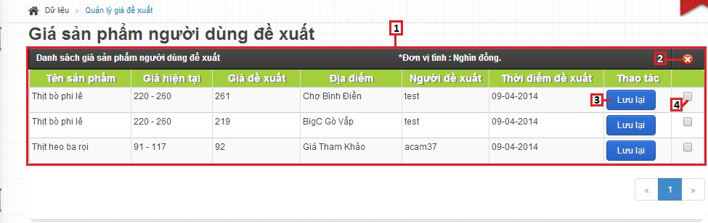

Figure 64: Manage Proposed Price Page

**Fields**

|  |  |  |  |  |  |  |  |
| --- | --- | --- | --- | --- | --- | --- | --- |
| **No** | **Field name** | **Description** | **Read only** | **Mandatory** | **Control type** | **Data type** | **Length** |
| 1 | User price list | Table showing | No | Yes | Table | N/A | N/A |
| 4 | Select product | Select user price to delete | No | N/A | Check box | N/A | N/A |

**Button/ Hyperlink**

|  |  |  |  |  |
| --- | --- | --- | --- | --- |
| **No** | **Function** | **Description** | **Validation** | **Outcome** |
| 2 | Delete user price | Click to delete the user price that selected | No | Message completed |
| 3 | Save user price | Click to update product price | No | Message completed |

**Table User price List includes**

|  |  |  |  |  |  |
| --- | --- | --- | --- | --- | --- |
| **Field name** | **Description** | **Read only** | **Control type** | **Data type** | **Length** |
| Product name | Product name | N/A | Label | String | N/A |
| Current price | Product price | N/A | Label | Integer | N/A |
| Propose price | Propose price | N/A | Label | Integer | N/A |
| Market name | Market name | N/A | Label | String | N/A |
| Username | Name of user proposed | N/A | Label | String | N/A |
| Time proposed | Time proposed | N/A | Label | DateTime | N/A |
| Action | Action of staff | No | Button, Checkbox | N/A | N/A |

#### Configure System

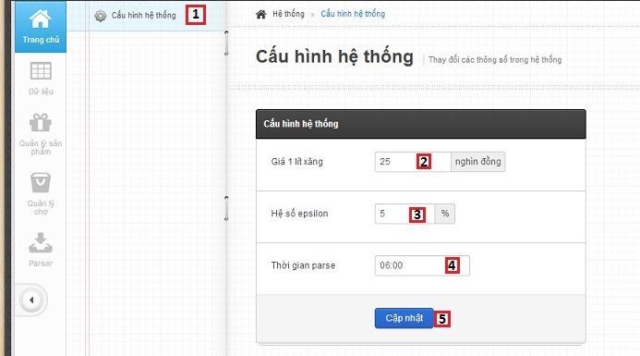

Figure 65: Configure System

**Fields**

|  |  |  |  |  |  |  |  |
| --- | --- | --- | --- | --- | --- | --- | --- |
| **No** | **Field name** | **Description** | **Read only** | **Mandatory** | **Control type** | **Data type** | **Length** |
| 2 | Petrol price | Fill petrol price | No | Yes | Textbox | Integer | N/A |
| 3 | Epsilon | Fill epsilon | No | Yes | Textbox | Integer | [0-100] |
| 4 | Time parse | Fill time parse | No | Yes | Time picker | Date Time | N/A |

**Button/Hyperlink**

|  |  |  |  |  |
| --- | --- | --- | --- | --- |
| **No** | **Function** | **Description** | **Validation** | **Outcome** |
| 1 | Configure system | Click to go to configure system page | No | Transfer to configure system page |
| 5 | Update configuration | Click to update configuration system | Yes | Message completed |

#### Manage Product

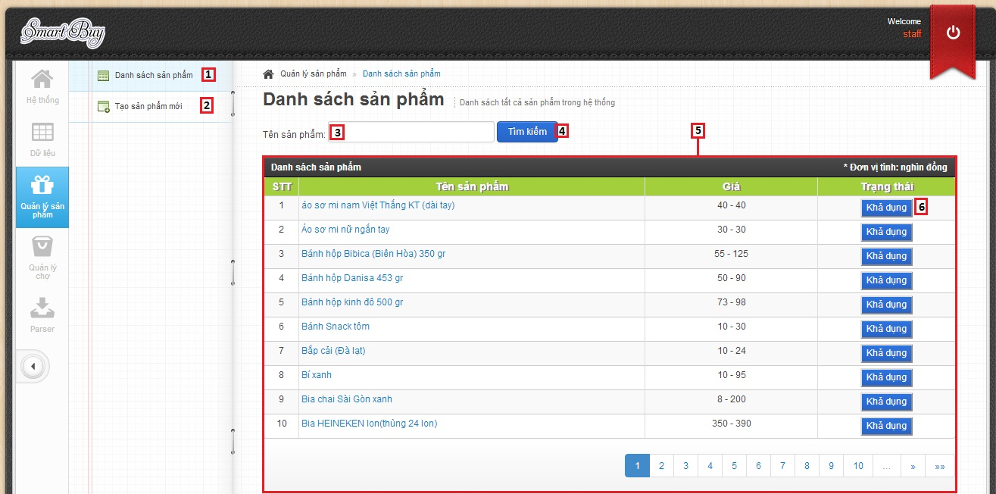

Figure 66: Manage Product

**Fields**

|  |  |  |  |  |  |  |  |
| --- | --- | --- | --- | --- | --- | --- | --- |
| **No** | **Field Name** | **Description** | **Read only** | **Mandatory** | **Control Type** | **Data Type** | **Length** |
| 3 | Search text box | Fill key to search product | No | Yes | Textbox | String | N/A |
| 5 | Product table | Show product | No | N/A | Table list view | N/A | N/A |

**Button/ Hyperlink**

|  |  |  |  |  |
| --- | --- | --- | --- | --- |
| **No** | **Function** | **Description** | **Validation** | **Outcome** |
| 1 | Manage Product | Click to go to manage product page | N/A | Transfer to manage product page |
| 2 | Create new Product | Click to go to create new product page | N/A | Transfer to create new product page |
| 4 | Search product | Click to search product | N/A | Show search result list |
| 6 | Enable/Disable product | Click to Enable/Disable product | N/A | Message completed |

**Product List includes**

|  |  |  |  |  |  |
| --- | --- | --- | --- | --- | --- |
| **Field Name** | **Description** | **Read only** | **Control Type** | **Data Type** | **Length** |
| Number row | Number of row | N/A | Label | String | N/A |
| Product name | Show product name | N/A | Link | N/A | N/A |
| Market name | Show market name | N/A | Label | String | N/A |
| Price | Show product price | N/A | Label | Integer | N/A |
| Status | Enable/Disable product | No | Button | N/A | N/A |

#### Create New Product

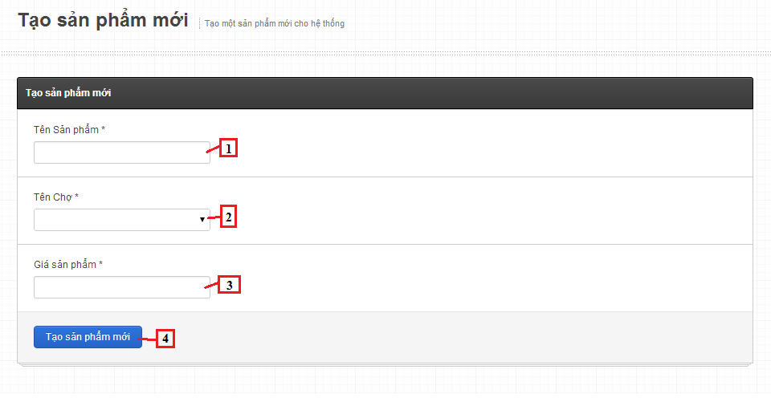

Figure 67: Create New Product

**Fields**

|  |  |  |  |  |  |  |  |
| --- | --- | --- | --- | --- | --- | --- | --- |
| **No** | **Field Name** | **Description** | **Read only** | **Mandatory** | **Control Type** | **Data Type** | **Length** |
| 1 | Product name | Fill name of product | No | Yes | Textbox | String | [6-100] |
| 2 | Market name | Fill name of market | No | Yes | Dropdown list | String | N/A |
| 3 | Price | Fill price of product | No | Yes | Textbox | Integer | [1-10000] |

**Button/ Hyperlink**

|  |  |  |  |  |
| --- | --- | --- | --- | --- |
| **No** | **Function** | **Description** | **Validation** | **Outcome** |
| 4 | Save product | Click to save product into database | Yes | Transfer to manage product pages. |

#### Manage Market

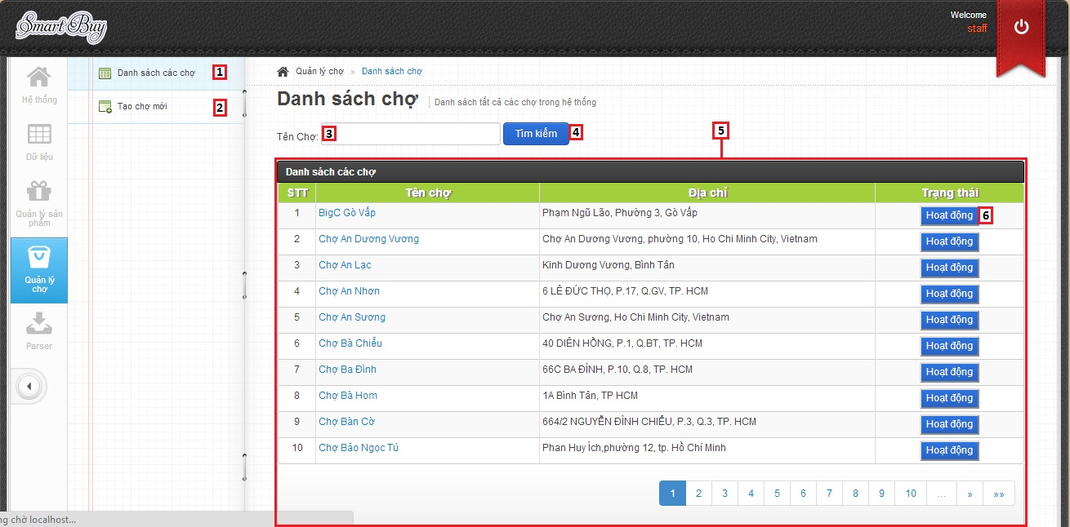

Figure 68: Manage Market

**Fields**

|  |  |  |  |  |  |  |  |
| --- | --- | --- | --- | --- | --- | --- | --- |
| **No** | **Field name** | **Description** | **Read only** | **Mandatory** | **Control type** | **Data type** | **Length** |
| 3 | Search text box | Fill key to search market | No | Yes | Textbox | String | N/A |
| 5 | Markets list | Table showing | No | Yes | Table | N/A | N/A |

**Button/Hyperlink**

|  |  |  |  |  |
| --- | --- | --- | --- | --- |
| **No** | **Function** | **Description** | **Validation** | **Outcome** |
| 1 | Manage market | Click to go to manage market page | No | Transfer to manage market page |
| 2 | Create new market | Click to go to create new market page | No | Transfer to create new market page |
| 4 | Search market | Click to search market | N/A | Show search result list |
| 6 | Enable/Disable market | Click to Enable/Disable market | N/A | Message completed |

**Table Markets List includes**

|  |  |  |  |  |  |
| --- | --- | --- | --- | --- | --- |
| **Field name** | **Description** | **Read only** | **Control type** | **Data type** | **Length** |
| No. | Number | N/A | Label | Integer | N/A |
| Market name | Market name | N/A | Link | N/A | N/A |
| Market address | Market address | N/A | Label | String | N/A |
| Status | Enable/Disable market | No | Button | N/A | N/A |

#### Create New Market

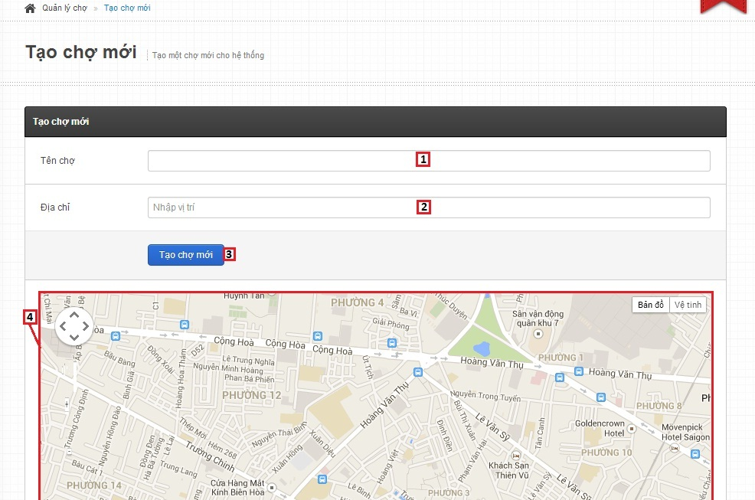

Figure 69: Create New Market

**Fields**

|  |  |  |  |  |  |  |  |
| --- | --- | --- | --- | --- | --- | --- | --- |
| **No** | **Field name** | **Description** | **Read only** | **Mandatory** | **Control type** | **Data type** | **Length** |
| 1 | Market name | Fill market name | No | Yes | Textbox | String | N/A |
| 2 | Market address | Fill market address | No | Yes | Autocomplete Textbox | String | N/A |
| 4 | Maps | Show market address on maps | N/A | N/A | Google map | N/A | N/A |

**Button/Hyperlink**

|  |  |  |  |  |
| --- | --- | --- | --- | --- |
| **No** | **Function** | **Description** | **Validation** | **Outcome** |
| 3 | Create new market | Create new market | Yes | Transfer to manage market page |

#### Manage Parser

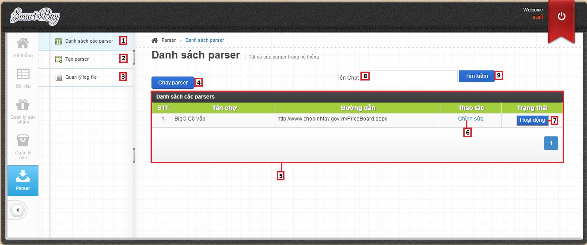

Figure 70: Manage Parser

**Fields**

|  |  |  |  |  |  |  |  |
| --- | --- | --- | --- | --- | --- | --- | --- |
| **No** | **Field name** | **Description** | **Read only** | **Mandatory** | **Control type** | **Data type** | **Length** |
| 5 | Parsers list | Table showing | No | Yes | Table | N/A | N/A |
| 8 | Search text box | Fill key to search market | No | Yes | Textbox | String | N/A |

**Button/Hyperlink**

|  |  |  |  |  |
| --- | --- | --- | --- | --- |
| **No** | **Function** | **Description** | **Validation** | **Outcome** |
| 1 | Manage parsers | Click to go to manage parsers page | No | Transfer to manage parsers page |
| 2 | Create parser | Click to go to create parser page | No | Transfer to create parser page |
| 3 | Manage log file | Click to go to manage log file page | No | Transfer to log file page |
| 4 | Run parser | Click to run parser | No | Write log file |
| 6 | Edit parser | Click to edit parser | No | Transfer to edit parser page |
| 7 | Enable/Disable parser | Click to Enable/Disable parser | N/A | Message completed |
| 9 | Search market | Click to search market | N/A | Show search result list |

**Table Markets List includes**

|  |  |  |  |  |  |
| --- | --- | --- | --- | --- | --- |
| **Field name** | **Description** | **Read only** | **Control type** | **Data type** | **Length** |
| No. | Number | N/A | Label | Integer | N/A |
| Market name | Market name | N/A | Label | String | N/A |
| Link | Link to parse | N/A | Label | String | N/A |
| Action | Click to edit parser | No | Link | N/A | N/A |
| Status | Enable/Disable parser | No | Button | N/A | N/A |

#### Create Parser

##### Step 1

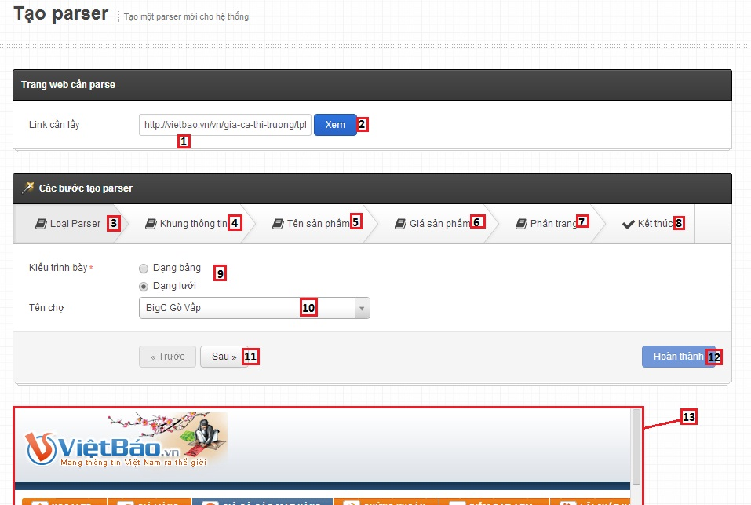

Figure 71: Create Parser - Step 1

**Fields**

|  |  |  |  |  |  |  |  |
| --- | --- | --- | --- | --- | --- | --- | --- |
| **No** | **Field name** | **Description** | **Read only** | **Mandatory** | **Control type** | **Data type** | **Length** |
| 1 | Link | Link to parse | No | Yes | Textbox | String | N/A |
| 9 | Type | Type View | No | Yes | Radio button | N/A | N/A |
| 10 | Market name | Market name | No | Yes | Drop down list | N/A | N/A |
| 11 | Web view | Web view | No | N/A | Web view | N/A | N/A |

**Button/Hyperlink**

|  |  |  |  |  |
| --- | --- | --- | --- | --- |
| **No** | **Function** | **Description** | **Validation** | **Outcome** |
| 2 | View web | View web from link | No | Display web view |
| 3 | Type of parser | Click to go to step 1 – type of parser | No | Transfer to step 1 |
| 4 | Tile xpath | Click to go to step 2 – Tile xpath | No | Transfer to step 2 |
| 5 | Product name xpath | Click to go to step 3 – Product name xpath | No | Transfer to step 3 |
| 6 | Product price xpath | Click to go to step 4 – Product price xpath | No | Transfer to manage parser page |
| 7 | Paging xPath | Click to go to step 5 – Paging xpath | No | Transfer to step 5 |
| 8 | Finish step | Click to go to step 6 – Finish parser | No | Transfer to step 6 |
| 11 | Next/Previous step | Next/Previous step | No | Transfer to next/previous step |
| 12 | Create parser | Click to create parser | Yes | Transfer to edit parser page |

##### Step 2

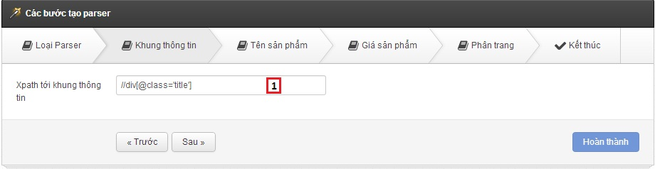

Figure 72: Create Parser - Step 2

**Fields**

|  |  |  |  |  |  |  |  |
| --- | --- | --- | --- | --- | --- | --- | --- |
| **No** | **Field name** | **Description** | **Read only** | **Mandatory** | **Control type** | **Data type** | **Length** |
| 1 | Tile xpath | Tile xpath | No | Yes | Textbox | String | N/A |

##### Step 3

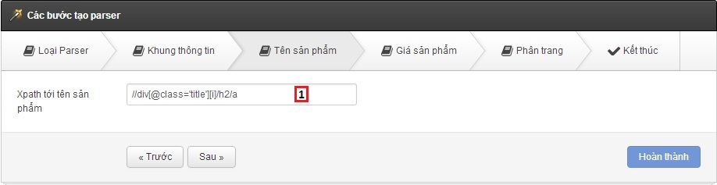

Figure 73: Create Parser - Step 3

**Fields**

|  |  |  |  |  |  |  |  |
| --- | --- | --- | --- | --- | --- | --- | --- |
| **No** | **Field name** | **Description** | **Read only** | **Mandatory** | **Control type** | **Data type** | **Length** |
| 1 | Product name xpath | Product name xpath | No | Yes | Textbox | String | N/A |

##### Step 4

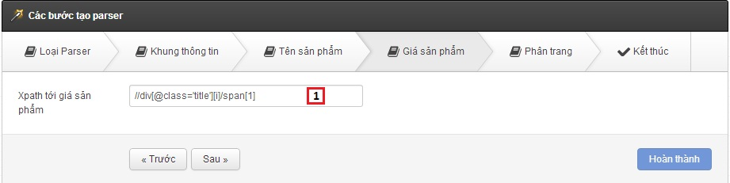

Figure 74: Create Parser - Step 4

**Fields**

|  |  |  |  |  |  |  |  |
| --- | --- | --- | --- | --- | --- | --- | --- |
| **No** | **Field name** | **Description** | **Read only** | **Mandatory** | **Control type** | **Data type** | **Length** |
| 1 | Product price xpath | Product price xpath | No | Yes | Textbox | String | N/A |

##### Step 5

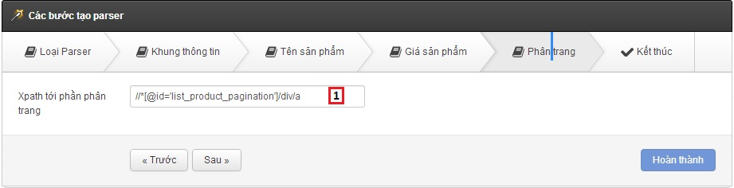

Figure 75: Create Parser - Step 5

**Fields**

|  |  |  |  |  |  |  |  |
| --- | --- | --- | --- | --- | --- | --- | --- |
| **No** | **Field name** | **Description** | **Read only** | **Mandatory** | **Control type** | **Data type** | **Length** |
| 1 | Paging xpath | Paging xpath | No | Yes | Textbox | String | N/A |

##### Step 6

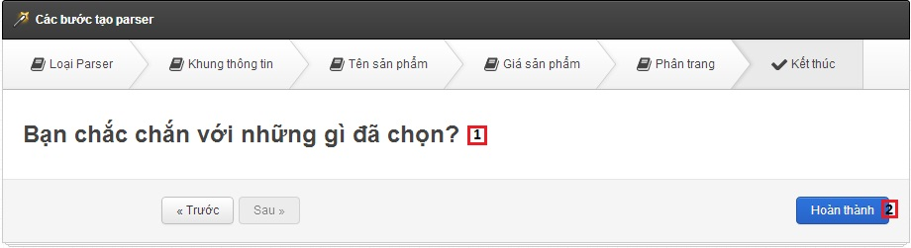

Figure 76: Create Parser - Step 6

**Fields**

|  |  |  |  |  |  |  |  |
| --- | --- | --- | --- | --- | --- | --- | --- |
| **No** | **Field name** | **Description** | **Read only** | **Mandatory** | **Control type** | **Data type** | **Length** |
| 1 | Message confirm | Message confirm | N/A | Yes | Label | String | N/A |

**Button/Hyperlink**

|  |  |  |  |  |
| --- | --- | --- | --- | --- |
| **No** | **Function** | **Description** | **Validation** | **Outcome** |
| 2 | Create parser | Click to create parser | Yes | Transfer to edit parser page |

#### Manage Log File

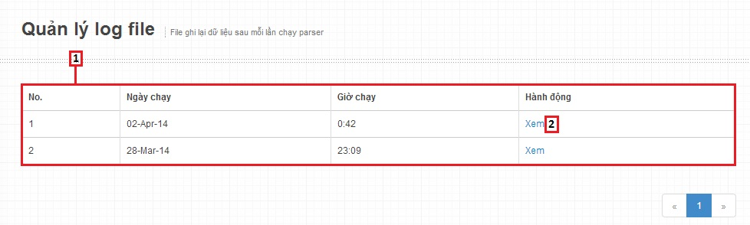

Figure 77: Manage Log File

**Fields**

|  |  |  |  |  |  |  |  |
| --- | --- | --- | --- | --- | --- | --- | --- |
| **No** | **Field name** | **Description** | **Read only** | **Mandatory** | **Control type** | **Data type** | **Length** |
| 1 | Log file list | Table showing | No | Yes | Table | N/A | N/A |

**Button/Hyperlink**

|  |  |  |  |  |
| --- | --- | --- | --- | --- |
| **No** | **Function** | **Description** | **Validation** | **Outcome** |
| 1 | View log file | Click to view log file | No | Transfer to log file detail |

**Table Log file List includes**

|  |  |  |  |  |  |
| --- | --- | --- | --- | --- | --- |
| **Field name** | **Description** | **Read only** | **Control type** | **Data type** | **Length** |
| No. | Number | N/A | Label | Integer | N/A |
| Date start | Date start | N/A | Label | String | N/A |
| Time start | Time start | N/A | Label | String | N/A |
| Action | Action of staff | No | Link | N/A | N/A |

### Mobile Interface Design

#### Login



Figure 78: <Mobile> Login

**Fields**

|  |  |  |  |  |  |  |  |
| --- | --- | --- | --- | --- | --- | --- | --- |
| **No** | **Field Name** | **Description** | **Read only** | **Mandatory** | **Control Type** | **Data Type** | **Length** |
| 1 | Username | Fill account name | No | Yes | Textbox | String | N/A |
| 2 | Password | Fill password | No | Yes | Password | String | N/A |

**Button/ Hyperlink**

|  |  |  |  |  |
| --- | --- | --- | --- | --- |
| **No** | **Function** | **Description** | **Validation** | **Outcome** |
| 3 | Login | Log-in into the system | N/A | Transfer to Favourite product screen |

#### Favourite Products

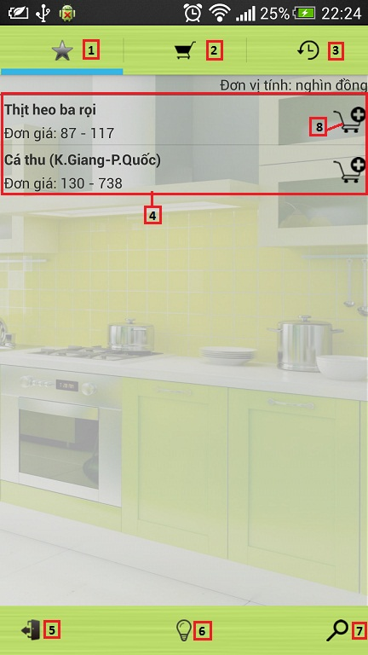

Figure 79: <Mobile> Favourite Products

**Fields**

|  |  |  |  |  |  |  |  |
| --- | --- | --- | --- | --- | --- | --- | --- |
| **No** | **Field Name** | **Description** | **Read only** | **Mandatory** | **Control Type** | **Data Type** | **Length** |
| 4 | Favourite product list | Table showing | No | Yes | Table | N/A | N/A |

**Button/ Hyperlink**

|  |  |  |  |  |
| --- | --- | --- | --- | --- |
| **No** | **Function** | **Description** | **Validation** | **Outcome** |
| 1 | Favourite product | Click to go to Favourite product screen | N/A | Transfer to Favourite product screen |
| 2 | View cart | Click to go to View cart screen | N/A | Transfer to View cart screen |
| 3 | History | Click to go to History screen | N/A | Transfer to History screen |
| 5 | Log out | Click to logout account | N/A | Transfer to Login screen |
| 6 | Suggest route | Click to go to Suggest route screen | N/A | Transfer to Suggest route screen |
| 7 | Search product | Click to go to Search product screen | N/A | Transfer to Search product screen |
| 8 | Add product to cart | Click to add product to cart | N/A | N/A |

**Table Favourite product List includes**

|  |  |  |  |  |  |
| --- | --- | --- | --- | --- | --- |
| **Field name** | **Description** | **Read only** | **Control type** | **Data type** | **Length** |
| Product name | Product name | N/A | Label | String | N/A |
| Product price | Product price | N/A | Label | Integer | N/A |

#### View Cart

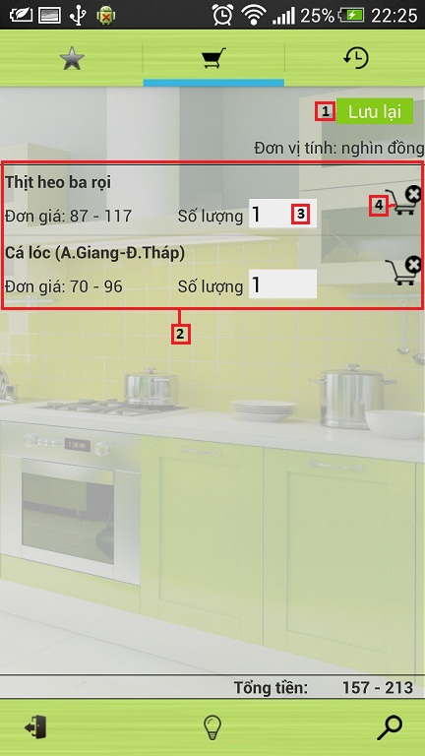

Figure 80: <Mobile> View Cart

**Fields**

|  |  |  |  |  |  |  |  |
| --- | --- | --- | --- | --- | --- | --- | --- |
| **No** | **Field Name** | **Description** | **Read only** | **Mandatory** | **Control Type** | **Data Type** | **Length** |
| 2 | Cart items list | Table showing | No | Yes | Table | N/A | N/A |
| 3 | Quantity of product | Fill product quantity | No | N/A | Textbox | Integer | [1-10] |

**Button/ Hyperlink**

|  |  |  |  |  |
| --- | --- | --- | --- | --- |
| **No** | **Function** | **Description** | **Validation** | **Outcome** |
| 1 | Save cart | Click to save cart to history | N/A | Transfer to History screen |
| 4 | Remove item in cart | Click to remove product in cart | N/A | N/A |

**Table Cart items List includes**

|  |  |  |  |  |  |
| --- | --- | --- | --- | --- | --- |
| **Field name** | **Description** | **Read only** | **Control type** | **Data type** | **Length** |
| Product name | Product name | N/A | Label | String | N/A |
| Product price | Product price | N/A | Label | Integer | N/A |

#### View History

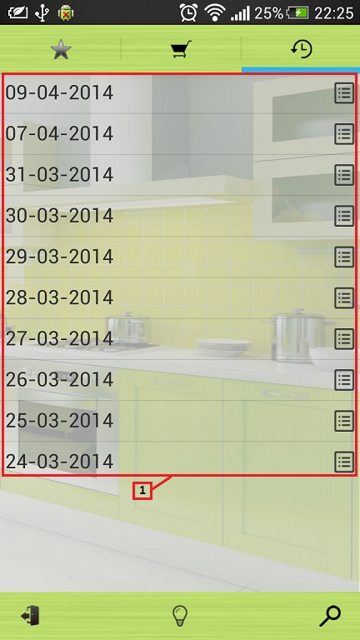

Figure 81: <Mobile> View History

**Fields**

|  |  |  |  |  |  |  |  |
| --- | --- | --- | --- | --- | --- | --- | --- |
| **No** | **Field Name** | **Description** | **Read only** | **Mandatory** | **Control Type** | **Data Type** | **Length** |
| 1 | Histories list | Table showing | No | Yes | Table | N/A | N/A |

**Table Histories List includes**

|  |  |  |  |  |  |
| --- | --- | --- | --- | --- | --- |
| **Field name** | **Description** | **Read only** | **Control type** | **Data type** | **Length** |
| Date | Date save cart | N/A | Label | String | N/A |

#### View History Details

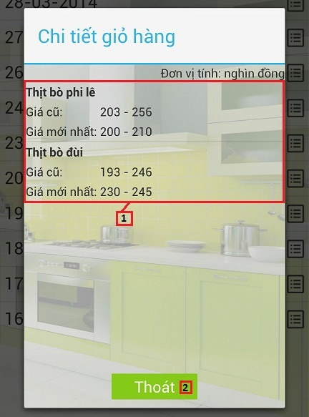

Figure 82: <Mobile> View History Details

**Fields**

|  |  |  |  |  |  |  |  |
| --- | --- | --- | --- | --- | --- | --- | --- |
| **No** | **Field Name** | **Description** | **Read only** | **Mandatory** | **Control Type** | **Data Type** | **Length** |
| 1 | History details list | Table showing | No | Yes | Table | N/A | N/A |

**Button/ Hyperlink**

|  |  |  |  |  |
| --- | --- | --- | --- | --- |
| **No** | **Function** | **Description** | **Validation** | **Outcome** |
| 2 | Cancel | Click to history detail close pop-up | N/A | Close history detail pop-up |

**Table History details List includes**

|  |  |  |  |  |  |
| --- | --- | --- | --- | --- | --- |
| **Field name** | **Description** | **Read only** | **Control type** | **Data type** | **Length** |
| Product name | Product name | N/A | Label | String | N/A |
| Old price | Old product price | N/A | Label | Integer | N/A |
| New price | New product price | N/A | Label | Integer | N/A |

#### Search Product

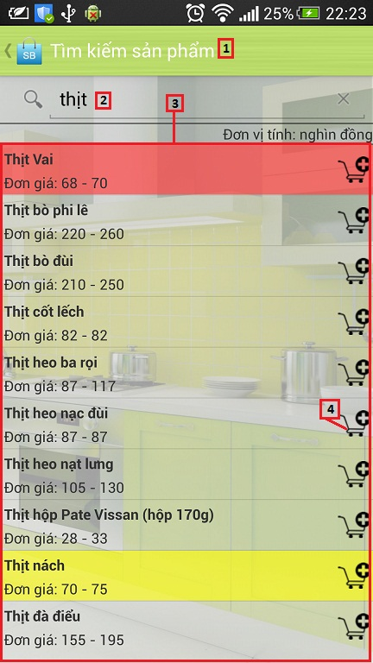

Figure 83: <Mobile> Search Product

**Fields**

|  |  |  |  |  |  |  |  |
| --- | --- | --- | --- | --- | --- | --- | --- |
| **No** | **Field Name** | **Description** | **Read only** | **Mandatory** | **Control Type** | **Data Type** | **Length** |
| 2 | Search text box | Fill key to search product | No | Yes | Textbox | String | N/A |
| 3 | Search result list | Table showing | Yes | Yes | Table | N/A | N/A |

**Button/ Hyperlink**

|  |  |  |  |  |
| --- | --- | --- | --- | --- |
| **No** | **Function** | **Description** | **Validation** | **Outcome** |
| 1 | Back | Back to cart view screen | N/A | Transfer to Cart view screen |
| 4 | Add product to cart | Click to add product to cart | N/A | N/A |

**Table Search result List includes**

|  |  |  |  |  |  |
| --- | --- | --- | --- | --- | --- |
| **Field name** | **Description** | **Read only** | **Control type** | **Data type** | **Length** |
| Product name | Product name | N/A | Label | String | N/A |
| Product price | Product price | N/A | Label | Integer | N/A |

#### Propose Price

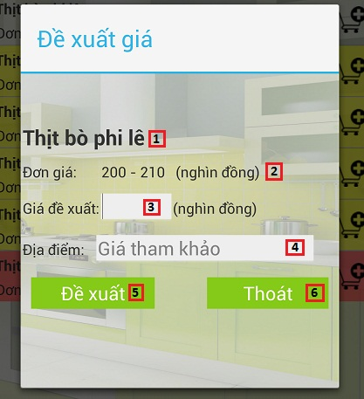

Figure 84: <Mobile> Propose Price

**Fields**

|  |  |  |  |  |  |  |  |
| --- | --- | --- | --- | --- | --- | --- | --- |
| **No** | **Field Name** | **Description** | **Read only** | **Mandatory** | **Control Type** | **Data Type** | **Length** |
| 1 | Product name | Product name | N/A | Yes | Label | String | N/A |
| 2 | Product price | Product price | N/A | Yes | Label | Integer | N/A |
| 3 | Propose product price | Fill propose product price | No | Yes | Textbox | Integer | [1-10000] |
| 4 | Market name | Fill market name | No | Yes | Autocomplete textbox | String | N/A |

**Button/ Hyperlink**

|  |  |  |  |  |
| --- | --- | --- | --- | --- |
| **No** | **Function** | **Description** | **Validation** | **Outcome** |
| 5 | Propose price | Click to propose price | Yes | Show success message pop-up |
| 6 | Cancel | Click to close propose product price pop-up | No | Close propose product price pop-up |

#### Suggest Route

##### List View

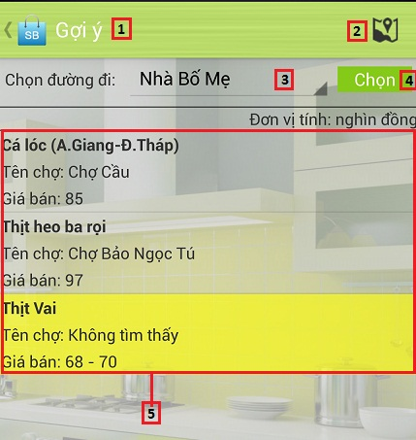

Figure 85: <Mobile> Suggest Route List View

**Fields**

|  |  |  |  |  |  |  |  |
| --- | --- | --- | --- | --- | --- | --- | --- |
| **No** | **Field Name** | **Description** | **Read only** | **Mandatory** | **Control Type** | **Data Type** | **Length** |
| 3 | Route | Route name | No | N/A | Drop down list | N/A | N/A |
| 5 | Order details list | Table showing | Yes | Yes | Table | N/A | N/A |

**Button/ Hyperlink**

|  |  |  |  |  |
| --- | --- | --- | --- | --- |
| **No** | **Function** | **Description** | **Validation** | **Outcome** |
| 1 | Back | Back to cart view screen | N/A | Transfer to Cart view screen |
| 2 | Maps | Click to go to maps screen | N/A | Transfer to Maps screen |
| 4 | Suggest route | Click to view table order details list | N/A | Show table order details list |

**Table Order details List includes**

|  |  |  |  |  |  |
| --- | --- | --- | --- | --- | --- |
| **Field name** | **Description** | **Read only** | **Control type** | **Data type** | **Length** |
| Product name | Product name | N/A | Label | String | N/A |
| Market name | Market name | N/A | Label | String | N/A |
| Product price | Product price | N/A | Label | Integer | N/A |

##### Map View

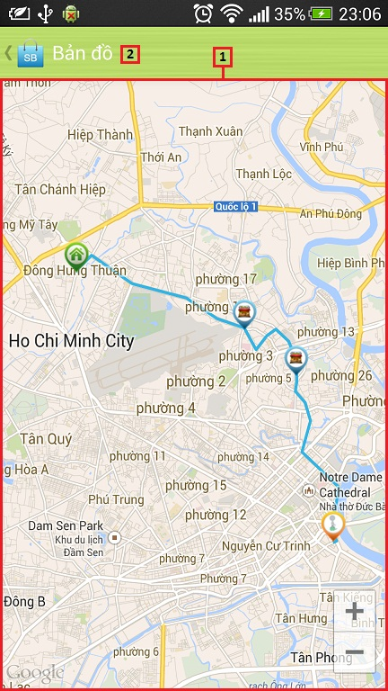

Figure 86: <Mobile> Suggest Route Map View

**Fields**

|  |  |  |  |  |  |  |  |
| --- | --- | --- | --- | --- | --- | --- | --- |
| **No** | **Field Name** | **Description** | **Read only** | **Mandatory** | **Control Type** | **Data Type** | **Length** |
| 1 | Maps | Show maps suggest | N/A | Yes | Google map | N/A | N/A |

**Button/ Hyperlink**

|  |  |  |  |  |
| --- | --- | --- | --- | --- |
| **No** | **Function** | **Description** | **Validation** | **Outcome** |
| 2 | Back | Back to Suggest route screen | N/A | Transfer to Suggest route screen |

## Database Design

### Entity Relationship Diagram

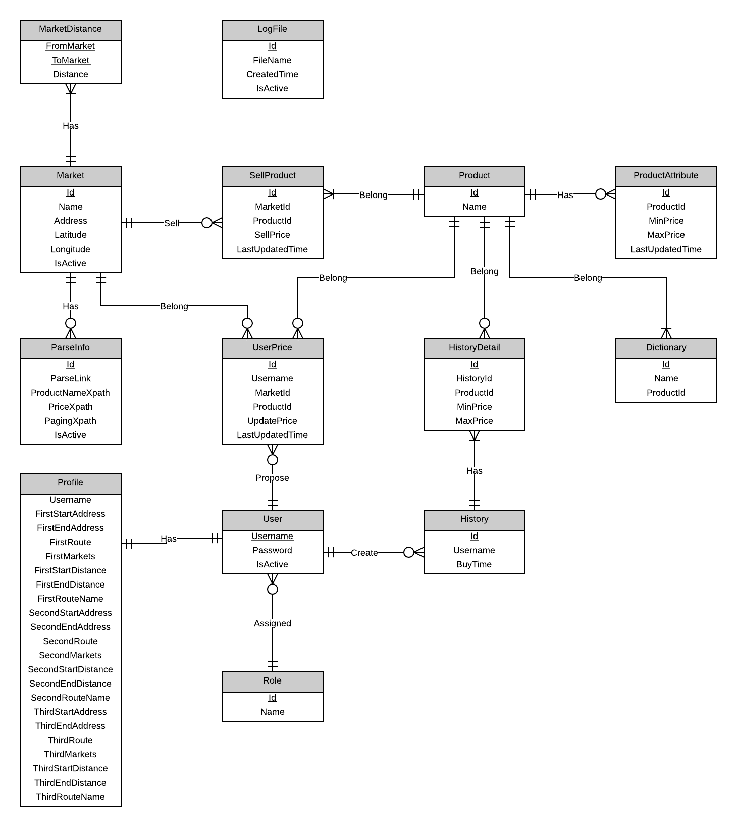

Figure 87: Entity Relationship Diagram

### Data Dictionary

|  |  |
| --- | --- |
| **Entity Data dictionary: describe content of all entities** | |
| Entity Name | Description |
| Market | Describe all markets in the system. Market may exist in real life or just virtual. |
| Parse Info | Describe all needed data to parse a website. |
| Product | Describe all products in the system. |
| Product Attribute | Describe attributes of each product. |
| Log File | Describe all log files of the system. Log file is generated after parsers finish running. |
| User | Describe all accounts in the system. |
| Role | Describe all roles in the system. |
| Profile | Describe all user profiles in the system. Each user has only one profile. |
| Market Distance | Describe distance between two markets. |
| History | Describe all users’ buying history. |
| History Detail | Describe all details of each history. |
| Dictionary | Describe all possible product names in the system. |
| Sell Product | Describe product price at each market. |
| User Price | Describe all users’ proposed price. |

Table 33: Entity Data Dictionary

|  |  |  |  |  |
| --- | --- | --- | --- | --- |
| **Entity name** | **Attributes** | **Description** | **Domain** | **Nulls** |
| Market | Id {PK} | Unique identifier of a market, auto increment. | int | No |
| Name | Market name. | nvarchar(50) | No |
| Address | Market address. | nvarchar(100) | Yes |
| Latitude | Market latitude. | varchar(20) | Yes |
| Longitude | Market longitude. | varchar(20) | Yes |
| IsActive | Market status. | bit | No |
| Parse Info | Id {PK} | Unique identifier of a parser, auto increment. | int | No |
| MarketId {FK} | Foreign key, market identifier. | int | No |
| ParseLink | Link to parse. | nvarchar(300) | No |
| ProductNameXpath | Xpath to get product name. | nvarchar(100) | No |
| PriceXpath | Xpath to get price. | nvarchar(100) | No |
| PagingXpath | Xpath to get paging part. | nvarchar(100) | No |
| IsActive | Parser status. | bit | No |
| Product | Id {PK} | Unique identifier of a parser, auto increment. | int | No |
| Name | Product name. | nvarchar(100) | No |
| IsActive | Product status. | bit | No |
| Product Attribute | Id {PK} | Unique identifier, auto increment. | int | No |
| ProductId {FK} | Foreign key, product identifier. | int | No |
| MinPrice | Product min price. | int | No |
| MaxPrice | Product max price. | int | No |
| LastUpdatedTime | The time this record is inserted. | datetime | No |
| Log File | Id {PK} | Unique identifier of a log file, auto increment. | int | No |
| FileName | The file name. | varchar(100) | No |
| CreatedTime | The time that file is created. | datetime | No |
| IsActive | The file status. | bit | No |
| User | Username {PK} | The name chosen by user. | varchar(50) | No |
| Password | Password of an account. | varchar(20) | No |
| RoleId {FK} | Foreign key, role identifier. | int | No |
| IsActive | Account status. | bit | No |
| Role | Id {PK} | Unique identifier a role, auto increment. | int | No |
| Name | Role name. | nvarchar(50) | No |
| Profile | Username {PK, FK} | Owner of this profile. | varchar(50) | No |
| FirstStartAddress | Start address of the first route. | nvarchar(100) | Yes |
| FirstEndAddress | End address of the first route. | nvarchar(100) | Yes |
| FirstRoute | First favourite route. | nvarchar(200) | Yes |
| FirstMarkets | Nearby market on the first route. | nvarchar(100) | Yes |
| FirstStartDistance | All distance from first start point to all nearby markets. | varchar(150) | Yes |
| FirstEndDistance | All distance from first end point to all nearby markets. | varchar(150) | Yes |
| FirstRouteName | Name of the first route. | nvarchar(50) | Yes |
| SecondStartAddress | Start address of the second route. | nvarchar(100) | Yes |
| SecondEndAddress | End address of the second route. | nvarchar(100) | Yes |
| SecondRoute | Second favourite route. | nvarchar(200) | Yes |
| SecondMarkets | Nearby market on the second route. | nvarchar(100) | Yes |
| SecondStartDistance | All distance from second start point to all nearby markets. | varchar(150) | Yes |
| SecondEndDistance | All distance from second end point to all nearby markets. | varchar(150) | Yes |
| SecondRouteName | Name of the second route. | nvarchar(50) | Yes |
| ThirdStartAddress | Start address of the third route. | nvarchar(100) | Yes |
| ThirdEndAddress | End address of the third route. | nvarchar(100) | Yes |
| ThirdRoute | Third favourite route. | nvarchar(200) | Yes |
| ThirdMarkets | Nearby market on the third route. | nvarchar(100) | Yes |
| ThirdStartDistance | All distance from third start point to all nearby markets. | varchar(150) | Yes |
| ThirdEndDistance | All distance from third end point to all nearby markets. | varchar(150) | Yes |
| ThirdRouteName | Name of the third route. | nvarchar(50) | Yes |
| Market Distance | FromMarket {PK, FK} | Unique identifier of a market. | int | No |
| ToMarket {PK, FK} | Unique identifier of a market. | int | No |
| Distance | Distance between two markets. | float | No |
| History | Id {PK } | Unique identifier of a history. | int | No |
| Username {FK} | Foreign key, owner of this history. | varchar(50) | No |
| BuyTime | The time this history is created. | datetime | No |
| History Detail | Id {PK} | Uniquely identifier, auto increment. | int | No |
| HistoryId {FK} | Foreign key, history identifier. | int | No |
| ProductId {FK} | Foreign key, product identifier. | int | No |
| MinPrice | Product min price at the time it was bought. | int | No |
| MaxPrice | Product max price at the time it was bought. | int | No |
| Dictionary | Id {PK} | Unique identifier of a word, auto increment. | Int | No |
| Name | Possible name of a product. | nvarchar(100) | No |
| ProductId {FK} | Foreign key, product identifier. | int | No |
| Sell Product | Id {PK } | Unique identifier, auto increment. | int | No |
| MarketId {FK} | Foreign key, market identifier. | int | No |
| ProductId {FK} | Foreign key, product identifier. | int | No |
| SellPrice | The price at which the product is sold. | int | No |
| LastUpdatedTime | The time data was last updated. | datetime | No |
| User Price | Id {FK} | Unique identifier, auto increment. | int | No |
| Username {FK} | Foreign key, user who proposed the price. | varchar(50) | No |
| MarketId {FK} | Foreign key, market identifier. | int | No |
| ProductId {FK} | Foreign key, product identifier. | int | No |
| UpdatedPrice | The price user proposed. | int | No |
| LastUpdatedTime | The time user proposed price. | datetime | No |

Table 34: Attribute Data Dictionary

## Algorithms

### Dynamic Programming

#### Definition

In [mathematics](http://en.wikipedia.org/wiki/Mathematics), [computer science](http://en.wikipedia.org/wiki/Computer_science), [economics](http://en.wikipedia.org/wiki/Economics), and [bioinformatics](http://en.wikipedia.org/wiki/Bioinformatics), dynamic programming is a method for solving complex problems by breaking them down into simpler sub-problems. It is applicable to problems exhibiting the properties of [overlapping sub-problems](http://en.wikipedia.org/wiki/Overlapping_subproblem) and [optimal substructure](http://en.wikipedia.org/wiki/Optimal_substructure). When applicable, the method takes far less time than naive methods that don't take advantage of the sub-problem overlap (like [depth-first search](http://en.wikipedia.org/wiki/Depth-first_search)).

References: <http://en.wikipedia.org/wiki/Dynamic_programming>

#### Define Problem

In our system, there is a function called “Ask for System Suggestion”. This function gives users the best way to buy their list of products based on their cart and the markets around their defined route. Here we can describe this problem as below:

**Given a two-dimensional array named Price, size $M×N \left(0<M≤20;0<N≤10\right).$ $Price\left[i,j\right](0<i≤M;0<j≤N)$ means market $j$ sells product $i$ at $Price[i,j]$ price. Find a way to buy all products at the minimum cost.**

**The output should be in this format**:

* **Buy <product name> at <market name>.**
* **Buy <product name> at <market name>.**
* **Buy <product name> at <market name>.**
* **…**

#### Solution

To solve this problem, we should follow these steps:

* Call **M** is the number of total products; **N** is the number of total markets.
* Create a two-dimensional array named **Total** size $M×N$. $Total\left[i,j\right]$ is the sum of money user have to pay when the buying process is at item $i$ in market $j$.
* Create a two-dimensional array named **Distance** size $N×N$. $Distance[i,j]$ is the distance from market *i* to market *j*.
* Create a one-dimensional array named **TraceY**, size **N**. $TraceY[i]$ means we buy the product before product *i* at market $TraceY[i]$.
* Create a one-dimensional array named **DistanceA**, size **N**. $DistanceA[i]$ is the distance from start point to market *i*.
* Create a one-dimensional array named **DistanceB**, size **N**. $DistanceB[i]$ is the distance from end point to market *i*.
* Initialize all elements in **Total** with a very big number.
* Set the first row of **Total**: $Total\left[1,i\right]=Price\left[1,i\right]+DistanceA[i]$
* Use this regression formula to calculate the rest of **Total**:
$$Total\left[i,j\right]=Min\left(Total\left[i-1,k\right]+Price\left[i,j\right]+Distance\left[k,j\right]\right)$$

$$2≤i≤M;1≤j≤N;1≤k≤N$$

* Set $Total\left[M,i\right]=Total\left[M,i\right]+DistanceB[i]$
* The minimum value at the final row of **Total** is the answer.
* Trace back to find the complete answer.

#### Complexity

* To traverse through all elements in **Total** array, we go through $M×N$ steps.
* With each element, we traverse its previous row. Each row has $N$ elements.
* In total, the complexity of this algorithm is $Ο\left(M×N×N\right).$

#### Flowchart



### String Comparison

#### Define Problem

Given 2 strings. Calculate their matching percent.

#### Requirement

* A robustness to changes of word order: two strings which contain the same words, but in a different order, should be recognised as being similar.
* Language Independence - the algorithm should work not only in English, but in many different languages.

#### Solution

* If a string contains many words, break it into a list of words.
* For each word, we find out how many adjacent character pairs are contained in it.
* Create a function *pairs(s)* which returns a list of adjacent character pairs of string *s*.
* Then, we use below formula to calculate matching percent.

$$similarity\left(s1,s2\right)=\frac{2×\left|pairs(s1)∩pairs(s2)\right|}{\left|pairs\left(s1\right)\right|+\left|pairs(s2)\right|}$$

#### Example

Calculate the matching percent of 2 strings: France and French.

* Upper case 2 strings:
  + France $→$ FRANCE.
  + French $→$ FRENCH.
* Break string into list of adjacent character pairs:
  + FRANCE $→\left\{FR,RA,AN,NC,CE\right\}$
  + FRENCH $→\left\{FR,RE,EN,NC,CH\right\}$
* Calculate its matching percent.

$$similarity\left(FRANCE,FRENCH\right)=\frac{2×\left|\left\{FR,NC\right\}\right|}{\left|\left\{FR,RA,AN,NC,CE\right\}\right|+\left|\left\{FR,RE,EN,NC,CH\right\}\right|}$$

$$=\frac{2×2}{5+5}=\frac{4}{10}=0.4$$

# System Implementation & Test

## Introduction

### System Overview

This section provides in detail all necessary information about test plans, test cases, test result, test environments, pass/fail criteria and risks estimations as well as a checklist to cover all possible cases of SmartB.

### Test Approach

- Goal: To test the whole system based on the core workflow.

- Method: System Testing, Black-box Testing.

## Database Relationship Diagram

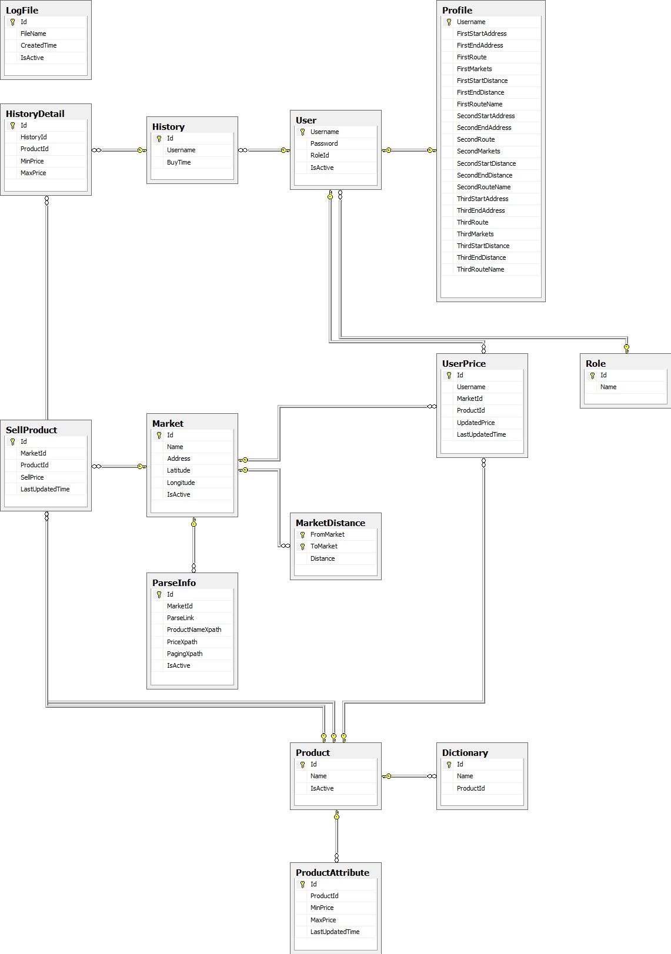

Figure 88: Database Relationship Diagram

## Performance Measures

### Parser Performance

* Parsing speed is 5ms per product.

### Suggestion Algorithm Performance

* The speed of suggestion algorithm is less than 2 seconds.

## Test Plan

The purpose of this section is to verify and ensure that SmartB meets its design specification and other requirements from user. The following part will describe which features to be tested and which will not.

### Features to be tested

We will test the entire system based on the following core workflow (Reference: **Figure 71, 72: Core Workflow**).

Based on the workflow, all following features will be tested, which can include one or more functions. These features will be focused and tested thoroughly during the test phase.

* Guest: search product, add to cart, and view report.
* Member: propose price, define route, ask for suggestion, and save product history.
* System: run parsers.
* Staff: create parser, run parser, train system, and import excel.

### Features not to be tested

* Login, Logout.
* Change Password.
* Manage market.
* Manage product.
* Manage user.
* Configure System.

## System Testing Test Case

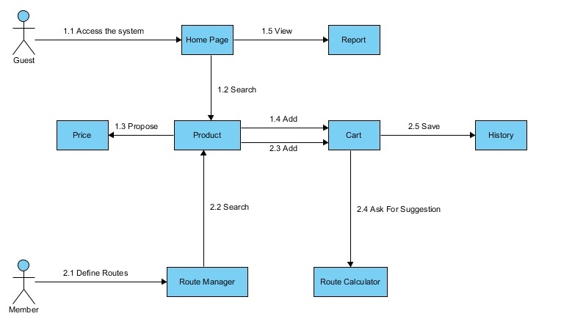

Figure 89: Guest, Member Core Flow



Figure 90: Staff, System Core Flow

### Guest Test Case

#### Search Product

|  |  |  |  |  |  |  |  |
| --- | --- | --- | --- | --- | --- | --- | --- |
| **ID** | **Test Case Description** | **Test Case Procedure** | **Expected output** | **Inter-test Case Dependence** | **Result** | **Test Date** | **Note** |
| SP01 | Guest searches product | 1 – On the home page, click on “**Tìm kiếm**” on menu bar.  2 – Input name of product on search textbox  3 – Click “**Search**” button or press enter key | - After step 1, go to search page  - After step 3, show search result with product name, range of price |  | Passed | 28/03/2014 |  |
| SP02 | Member searches product [Web] | 1 – On the home page, click on “**Tìm kiếm**” on menu bar.  2 – Input name of product on search textbox  3 – Click “**Search**” button or press enter key | - After step 1, go to search page  - After step 3, show search result with product name, range of price |  | Passed | 28/03/2014 |  |
| SP03 | Member searches product [Mobile] | 1 – On the home screen, click on “**Search**” button.  2 – Input name of product on search textbox  3 – Click “**Search**” button or press enter key | - After step 1, go to search screen  - After step 3, show search result with product name, range of price |  | Passed | 28/03/2014 |  |

Table 35: Search Product Test Case

#### Add To Cart

|  |  |  |  |  |  |  |  |
| --- | --- | --- | --- | --- | --- | --- | --- |
| **ID** | **Test Case Description** | **Test Case Procedure** | **Expected output** | **Inter-test Case Dependence** | **Result** | **Test Date** | **Note** |
| AC01 | Guest adds product to cart | 1 – On the search page, click on “**Thêm vào giỏ**” button on search result row. | - After step 1, added product to cart. | SP01 | Passed | 28/03/2014 |  |
| AC02 | Guest adds product to cart when the product has existed in cart | 1 – On the search page, click on “**Thêm vào giỏ**” button on search result row. | - After step 1, update quantity of the product in cart. | SP01, AC01 | Passed | 28/03/2014 |  |
| AC03 | Member adds product to cart [Web] | 1 – On the search page, click on “**Thêm vào giỏ**” button on search result row. | - After step 1, added product to cart. | SP02 | Passed | 28/03/2014 |  |
| AC04 | Member adds product to cart when the product has existed in cart [Web] | 1 – On the search page, click on “**Thêm vào giỏ**” button on search result row. | - After step 1, update quantity of the product in cart. | SP02, AC03 | Passed | 28/03/2014 |  |
| AC05 | Member adds product to cart [Mobile] | 1 – On the search/favourites product screen, click on “**Thêm vào giỏ**” button on search result row. | - After step 1, added product to cart. | SP03 | Passed | 28/03/2014 |  |
| AC06 | Member adds product to cart when the product has existed in cart [Mobile] | 1 – On the search/favourites product screen, click on “**Thêm vào giỏ**” button on search result row. | - After step 1, update quantity of the product in cart. | SP03, AC05 | Passed | 28/03/2014 |  |
| AC07 | Guest adds product to cart when the cart has 20 items | 1 – On the search page, click on “**Thêm vào giỏ**” button on search result row. | - After step 1, display dialog message “**Giỏ của bạn không quá 20 sản phẩm**”. | SP01 | Passed | 28/03/2014 |  |
| AC08 | Member adds product to cart when the cart has 20 items [Web] | 1 – On the search page, click on “**Thêm vào giỏ**” button on search result row. | - After step 1, display dialog message “**Giỏ của bạn không quá 20 sản phẩm**”. | SP02 | Passed | 28/03/2014 |  |
| AC09 | Member adds product to cart when the cart has 20 items [Mobile] | 1 – On the search page, click on “**Thêm vào giỏ**” button on search result row. | - After step 1, display dialog message “**Giỏ của bạn không quá 20 sản phẩm**”. | SP03 | Passed | 28/03/2014 |  |

Table 36: Add To Cart Test Case

#### View Cart

|  |  |  |  |  |  |  |  |
| --- | --- | --- | --- | --- | --- | --- | --- |
| **ID** | **Test Case Description** | **Test Case Procedure** | **Expected output** | **Inter-test Case Dependence** | **Result** | **Test Date** | **Note** |
| VC01 | Guest views cart | 1 – On the home page, click on “**Giỏ hàng**” on menu bar. | - After step 1, go to view cart page and display cart list. | AC01, AC02 | Passed | 28/03/2014 |  |
| VC02 | Member views cart [Web] | 1 – On the home page, click on “**Giỏ hàng**” on menu bar. | - After step 1, go to view cart page and display cart list. | AC03, AC04 | Passed | 28/03/2014 |  |
| VC03 | Member views cart [Mobile] | 1 – On the home screen, click on “**View Cart**” tab. | - After step 1, go to view cart screen and display cart list. | AC05, AC06 | Passed | 28/03/2014 |  |
| VC04 | Guest update quantity of product | 1 – On the view cart page, input quantity of product on textbox on cart list row. | - After step 1, update quantity of the product in cart, and update total range of price. | VC01 | Passed | 28/03/2014 |  |
| VC05 | Guest update quantity of product with quantity is more than 10 | 1 – On the view cart page, input quantity of product on textbox on cart list row. | - After step 1, update quantity of the product in cart equal 10, and update total range of price. | VC01 | Passed | 28/03/2014 |  |
| VC06 | Guest update quantity of product with quantity is less than 1 | 1 – On the view cart page, input quantity of product on textbox on cart list row. | - After step 1, update quantity of the product in cart equal 1, and update total range of price. | VC01 | Passed | 28/03/2014 |  |
| VC07 | Guest delete product in cart | 1 – On the view cart page, click on “**Xóa**” button on cart list row. | - After step 1, the row is removed entirely from the table, and update total range of price. | VC01 | Passed | 28/03/2014 |  |
| VC08 | Member update quantity of product [Web] | 1 – On the view cart page, input quantity of product on textbox on cart list row. | - After step 1, update quantity of the product in cart, and update total range of price. | VC02 | Passed | 28/03/2014 |  |
| VC09 | Member update quantity of product with quantity is more than 10 [Web] | 1 – On the view cart page, input quantity of product on textbox on cart list row. | - After step 1, update quantity of the product in cart equal 10, and update total range of price. | VC02 | Passed | 28/03/2014 |  |
| VC10 | Member update quantity of product with quantity is less than 1 [Web] | 1 – On the view cart page, input quantity of product on textbox on cart list row. | - After step 1, update quantity of the product in cart equal 1, and update total range of price. | VC02 | Passed | 28/03/2014 |  |
| VC11 | Member delete product in cart [Web] | 1 – On the view cart page, click on “**Xóa**” button on cart list row. | - After step 1, the row is removed entirely from the table, and update total range of price. | VC02 | Passed | 28/03/2014 |  |
| VC12 | Member update quantity of product [Mobile] | 1 – On the view cart screen, input quantity of product on textbox on cart list row. | - After step 1, update quantity of the product in cart, and update total range of price. | VC03 | Passed | 28/03/2014 |  |
| VC13 | Member update quantity of product with quantity is more than 10 [Mobile] | 1 – On the view cart screen, input quantity of product on textbox on cart list row. | - After step 1, update quantity of the product in cart equal 10, and update total range of price. | VC03 | Passed | 28/03/2014 |  |
| VC14 | Member update quantity of product with quantity is less than 1 [Mobile] | 1 – On the view cart screen, input quantity of product on textbox on cart list row. | - After step 1, update quantity of the product in cart equal 1, and update total range of price. | VC03 | Passed | 28/03/2014 |  |
| VC15 | Member delete product in cart [Mobile] | 1 – On the view cart screen, click on “**Xóa**” button on cart list row. | - After step 1, the row is removed entirely from the table, and update total range of price. | VC03 | Passed | 28/03/2014 |  |

Table 37: View Cart Test Case

#### View Report

|  |  |  |  |  |  |  |  |
| --- | --- | --- | --- | --- | --- | --- | --- |
| **ID** | **Test Case Description** | **Test Case Procedure** | **Expected output** | **Inter-test Case Dependence** | **Result** | **Test Date** | **Note** |
| VR01 | Guest views report | 1 – On the home page, click on “**Thống kê**” on menu bar.  2 – Click “**Xem**” link on report row | - After step 1, go to report page and display report list.  - After step 2, go to view chart page and display chart data from 10 latest days. |  | Passed | 28/03/2014 |  |
| VR02 | Member views report | 1 – On the home page, click on “**Thống kê**” on menu bar.  2 – Click “**Xem**” link on report row | - After step 1, go to report page and display report list.  - After step 2, go to view chart page and display chart data from 10 latest days. |  | Passed | 28/03/2014 |  |

Table 38: View Report Test Case

### Member Test Case

#### Define Routes

|  |  |  |  |  |  |  |  |
| --- | --- | --- | --- | --- | --- | --- | --- |
| **ID** | **Test Case Description** | **Test Case Procedure** | **Expected output** | **Inter-test Case Dependence** | **Result** | **Test Date** | **Note** |
| DR01 | Member defines routes | 1 – On the home page, click on username on menu bar, select “**Sửa thông tin cá nhân**”  2 – Fill in infomartion:   * Tên đường đi * Điểm xuất phát * Điểm kết thúc   3 – Click “**Xác nhận**” button. | - After step 1, go to account details page  - After step 3, show message “**Đinh nghĩa đường đi thành công.”** |  | Failed  Passed | 28/03/2014  30/03/2014 | Do not have auto complete place |

Table 39: Define Routes Test Case

#### Ask For Suggestion

|  |  |  |  |  |  |  |  |
| --- | --- | --- | --- | --- | --- | --- | --- |
| **ID** | **Test Case Description** | **Test Case Procedure** | **Expected output** | **Inter-test Case Dependence** | **Result** | **Test Date** | **Note** |
| AS01 | Member ask for suggestion (Web) | 1 – On the home page, click on “**Gợi ý**” on menu bar.  2 – Select “**Chọn đường đi**” in drop down list.  3 – Click “**Chọn**” button. | - After step 1, go to suggest route page.  - After step 3, show list include:   * STT * Tên sản phẩm * Tên chợ * Giá bán   And display maps with markers include start place, end place and markets place | AC03, AC04 | Passed | 28/03/2014 |  |
| AS02 | Member ask for suggestion (Mobile) | 1 – On the home screen, click on “**Gợi ý**” button.  2 – Select “**Chọn đường đi**” in drop down list.  3 – Click “**Chọn**” button.  4 – Click “**Bản đồ**” button | - After step 1, go to suggest route screen.  - After step 3, show list include:   * STT * Tên sản phẩm * Tên chợ * Giá bán   - After step4 , go to maps screen and display maps with markers include start place, end place and markets place | AC05, AC06 | Passed | 28/03/2014 |  |

Table 40: Ask For Suggestion Test Case

#### Save History

|  |  |  |  |  |  |  |  |
| --- | --- | --- | --- | --- | --- | --- | --- |
| **ID** | **Test Case Description** | **Test Case Procedure** | **Expected output** | **Inter-test Case Dependence** | **Result** | **Test Date** | **Note** |
| SH01 | Member save history (Web) | 1 – On the view cart page, click on “**Lưu lại**” button. | - After step 1, go to history page and show list of history last 30 days. | AC03, AC04 | Passed | 28/03/2014 |  |
| SH02 | Member view history details (Web) | 1 – On the history page, click on “**Chi tiết**” button on history list row. | - After step 1, go to history detail screen and show list of history detail include:   * Tên sản phẩm * Giá cũ * Giá mới nhất | SH01 | Passed | 28/03/2014 |  |
| SH03 | Member save history (Mobile) | 1 – On the view cart screen, click on “**Lưu lại**” button. | - After step 1, go to history screen and show list of history last 30 days. | AC05, AC06 | Passed | 28/03/2014 |  |
| SH04 | Member view history details (Mobile) | 1 – On the history screen, click on history list row. | - After step 1, the pop-up is show and display list of history detail include:   * Tên sản phẩm * Giá cũ * Giá mới nhất | SH03 | Passed | 28/03/2014 |  |

Table 41: Save History Test Case

#### Propose Price

|  |  |  |  |  |  |  |  |
| --- | --- | --- | --- | --- | --- | --- | --- |
| **ID** | **Test Case Description** | **Test Case Procedure** | **Expected output** | **Inter-test Case Dependence** | **Result** | **Test Date** | **Note** |
| PP01 | Member proposes product price with Propose price in range 1-10000 (Web) | 1 – On the search page, click on “**Đề xuất giá**” button on search result row.  2 – Fill in infomartion:   * “Giá đề xuất” * Địa điểm   3 – Click “**Đề xuất giá**” button. | - After step 1, the pop-up is show.  - After step 3, show message “**Cảm ơn sự đóng góp của bạn. Chúng tôi sẽ xem xét.”** |  | Passed | 28/03/2014 |  |
| PP02 | Member proposes product price with Propose price not in range 1-10000 (Web) | 1 – On the search page, click on “**Đề xuất giá**” button on search result row.  2 – Fill in infomartion:   * “Giá đề xuất” * Địa điểm   3 – Click “**Đề xuất giá**” button. | - After step 1, the pop-up is show.  - After step 3, show message “**Giá không phù hợp. Vui lòng nhập giá trị từ 1 đến 10000.”** |  | Passed | 28/03/2014 |  |
| PP03 | Member proposes product price with market is blank (Web) | 1 – On the search page, click on “**Đề xuất giá**” button on search result row.  2 – Fill in infomartion:   * Giá đề xuất * Địa điểm   3 – Click “**Đề xuất giá**” button. | - After step 1, the pop-up is show.  - After step 3, show message “**Vui lòng chọn địa điểm.”** |  | Passed | 28/03/2014 |  |
| PP04 | Member proposes product price on search screen (Mobile) | 1 – On the search screen, click on search result row.  2 – Fill in infomartion:   * Giá đề xuất * Địa điểm   3 – Click “**Đề xuất**” button. | - After step 1, the pop-up is show.  - After step 3, show message “**Cảm ơn sự đóng góp của bạn. Chúng tôi sẽ xem xét.”** |  | Passed | 28/03/2014 |  |
| PP05 | Member proposes product price on favourite product screen (Mobile) | 1 – On the favourite product screen, click on favourite product row.  2 – Fill in infomartion:   * Giá đề xuất * Địa điểm   3 – Click “**Đề xuất**” button. | - After step 1, the pop-up is show.  - After step 3, show message “**Cảm ơn sự đóng góp của bạn. Chúng tôi sẽ xem xét.”** |  | Passed | 28/03/2014 |  |

Table 42: Propose Price Test Case

### Staff Test Case

#### Manage Parser

|  |  |  |  |  |  |  |
| --- | --- | --- | --- | --- | --- | --- |
| **ID** | **Test Case Description** | **Test Case Procedure** | **Expected output** | **Result** | **Test Date** | **Note** |
| TC01 | Staff view list parsers | 1 – Login into the system using a staff account  2 – On the staff home page, click “Parser”, and then click “Danh sách các parser”. | - After step 2, parser list will be shown. | Pass | 29/03/2014 |  |
| TC02 | Staff create new parser | 1 – Login into the system using a staff account  2 – On the staff home page, click “Parser”, and then click “Tạo parser”.  3 – Fill in parser detail :   1. “Loại parser” tab 2. “Khung thông tin” tab 3. “Tên sản phẩm” tab 4. “Giá sản phẩm” tab 5. “Phân trang” tab   4 – Click “Hoàn thành” button. | - After step 4, parser will be inserted into database. | Pass | 29/03/2014 |  |
| TC03 | Staff run Parser | 1 – Login into the system using a staff account  2 – On the staff home page, click “Parser”, and then click “Danh sách các parser”.  3 – Staff clicks on “Chạy Parser” button. | - After step 3, product will be inserted into database.  + Generate log file.  + Export duplicate products to text file. | Pass | 29/03/2014 |  |

Table 43: Manage Parser Test Case

#### Manage Import Data

|  |  |  |  |  |  |  |
| --- | --- | --- | --- | --- | --- | --- |
| **ID** | **Test Case Description** | **Test Case Procedure** | **Expected output** | **Result** | **Test Date** | **Note** |
| TC04 | Staff import list product in excel file. | 1 – Login into the system using a staff account  2 – On the staff home page, click “Dữ liệu”, and then click “Nhập từ Excel”.  3 – Click “Brown” button.  4 – Select excel file.  5 – Click “Open” button.  6 – Press “Tải lên” button. | - After step 6, product list will be shown. | Pass | 29/03/2014 |  |
| TC05 | Staff edit product in error product table. | After step 6 in test case ST04  1 – On the import page, click “Sản phẩm lỗi” tab.  2 – Fill in Product detail:   1. Product Name 2. Market Name 3. Price   3 – Click “Lưu” button. | - After step 1, error product list will be shown.  - After step 3, product will be compared with duplicate product in “Sản phẩm trùng” table and “Danh sách sản phẩm” table:  + If not duplicate, product will be move to “Danh sách sản phẩm” table.  + Else product will be moved to “Sản phẩm trùng” table. | Pass | 29/03/2014 |  |
| TC06 | Staff save products in excel file into database. | After step 6 in test case ST04.  1 – Click “Lưu lại” button. | - After step 1, product will be compared with database.  + If products be duplicated, products will be shown into “Sản phẩm trùng” table.  + Else, products will be saved into database. | Pass | 29/03/2014 |  |
| TC07 | Staff save file log duplicate product | After step 6 in test case ST04  1 – On the import page, click “Sản phẩm trùng” tab.  2 – Click “Lưu file” button. | - After step 1, duplicate product list will be shown.  - After step 2, all products duplicate will be compared with database. And then, export to text file. | Pass | 29/03/2014 |  |

Table 44: Manage Import Data Test Case

#### Train Machine

|  |  |  |  |  |  |  |
| --- | --- | --- | --- | --- | --- | --- |
| **ID** | **Test Case Description** | **Test Case Procedure** | **Expected output** | **Result** | **Test Date** | **Note** |
| TC08 | Staff uses training file | 1 – Login into the system using a staff account.  2 – On the staff home page, click “Dữ liệu”, and then click “Xử lý dữ liệu trùng”. | - After step 6, product list in text file will be shown. | Pass | 29/03/2014 |  |
| TC09 | Staff joins products. | After step 2 in test case ST08.  1 – Click checkbox products be duplicated.  2 – Click “Gộp” button. | - After step 2, duplicate products will be joined and saved into database. | Pass | 29/03/2014 |  |
| TC10 | Staff divides products. | After step 2 in test case ST08.  1 – Click checkbox products be duplicated.  2 – Click “Tách” button. | - After step 2, duplicate products will be divided and saved into database. | Pass | 29/03/2014 |  |

Table 45: Train Machine Test Case

# Software User’s Manual

## Installation Guide

### Setting up environment at server site

The following software must be installed into the server machine:

#### Hardware requirements

Personal computers for developing with the minimum configuration:

* CPU Core 2 Duo 2.0GHz.
* 4GB of RAM.
* 300GB of hard disk.
* Wifi Internet (> 2Mbps).

#### Software requirements

* Web Server: Internet Information System – IIS 7.5.
* Microsoft Windows 7: operating system and platform for development.
* SQL Server 2008 R2: used to create and manage the database for web application.
* Other library:
* Microsoft Visual C++ 2010 SP1 Redistributable Package (x86)

(<http://www.microsoft.com/en-us/download/details.aspx?id=8328>)

#### Mobile Requirement

* Android 4.2 or above.

### Deployment at server side

#### Prepare deployment package

* Extract the deployment package to a folder on the server.
* For example: E:\SmartBuySite



Figure 91: Prepare deployment package

#### Deploy database

* Open Microsoft SQL Server Management Studio.



Figure 92: Deploy database – 1

* Open and excute the script.sql file



Figure 93: Deploy database - 2

#### Configure Server before deploy

* Open the Internet Information System Manager.
* Change the .NET Framework version to 4.0.



Figure 94: Configure Server before deploy – 1

#### Deploy web application on server

* Change the connection string in Web.config.
* Replace the username, password, data source parts with your own data.



Figure 95: Deploy web application on server – 1

* Right click as Sites. Choose “Add Web Site”.



Figure 96: Deploy web application on server – 2

* Enter site name. Choose Application Pool as ASP.NET 4.0
* Select the path as the folder in step 1. Enter port other than 80.



Figure 97: Deploy web application on server – 3

* Press ok to finish the process



Figure 98: Deploy web application on server – 4

### Setting up the environment at client side

#### Setting up for computer

* The client devices need to have one of the following browsers to access the website:
* Google Chrome.
* Firefox.

#### Setting up for Android devices

* Change setting to install unknown source apk.
* Connect to the same network as the server



Figure 99: Change Settings

* Use browser and goto address <http://www.mediafire.com/download/ka1l9qh5en3sey4/SmartB.apk>, download the apk file.



Figure 100: Download app

Click Install to install the app.



Figure 101: Install App

## User Guide

The user guide is based on the normal workflow of the system

### Guest/Member Guide

#### Login

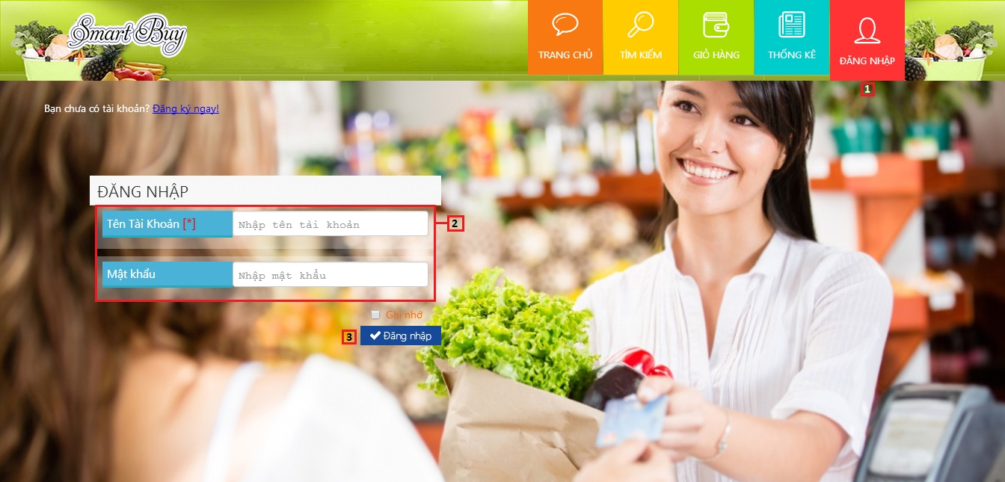

Figure 102: Login Page

|  |  |
| --- | --- |
| **Step** | **Description** |
| 1 | Click icon  on menu bar to go to login page |
| 2 | Fill “Tên tài khoản” and “Mật khẩu” |
| 3 | Click button “Đăng nhập” |

Table 46: Login Steps

#### Define Routes

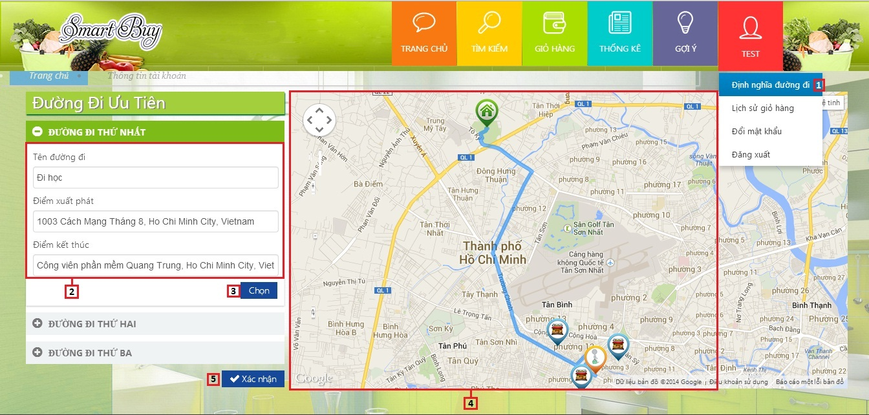

Figure 103: Defines Route Page

|  |  |
| --- | --- |
| **Step** | **Description** |
| 1 | Click “Đinh nghĩa đường đi” link on menu bar to go to define route page |
| 2 | Fill Route name, start place, finish place |
| 3 | Click button “Chọn” |
| 4 | View route on maps |
| 5 | Click button “Xác nhận” to save route |

Table 47: Define Routes Steps

#### Search Product

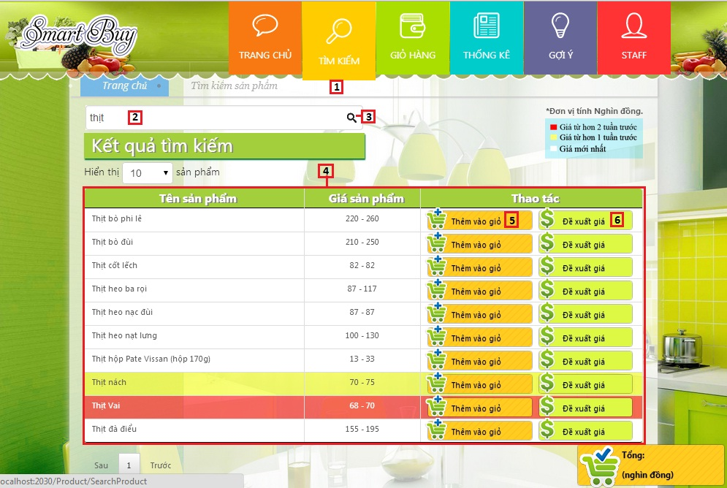

Figure 104: Search Product Page

|  |  |
| --- | --- |
| **Step** | **Description** |
| 1 | Click icon  on menu bar to go to search page |
| 2 | Fill search key |
| 3 | Click icon  to search product |
| 4 | View search product result list (product name, price) |
| 5 | Click button “Thêm vào giỏ” to add product to cart |
| 6 | Click button “Đề xuất giá“ to propose price |

Table 48: Search Product Steps

#### Propose Price

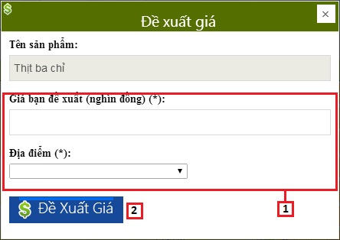

Figure 105: Propose Price UI

|  |  |
| --- | --- |
| **Step** | **Description** |
| 1 | Fill “Giá bạn đề xuất” and select “Địa điểm” |
| 2 | Click button “Đề xuất giá” |

Table 49: Propose Price Steps

#### Suggest Route

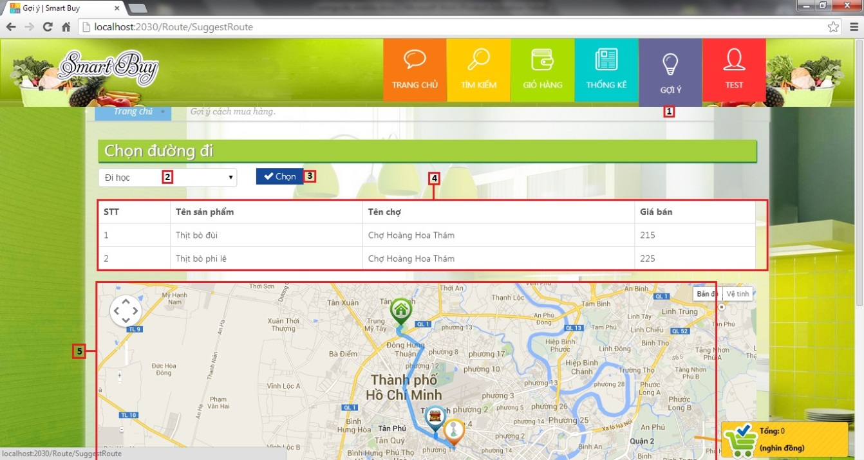

Figure 106: Suggest Route Page

|  |  |
| --- | --- |
| **Step** | **Description** |
| 1 | Click icon  on menu bar to go to suggest route page |
| 2 | Select route “Chọn đường đi” |
| 3 | Click button “Chọn” |
| 4 | View suggest route list (product name, market, price) |
| 5 | View route on maps |

Table 50: Suggest Route Steps

#### View Cart

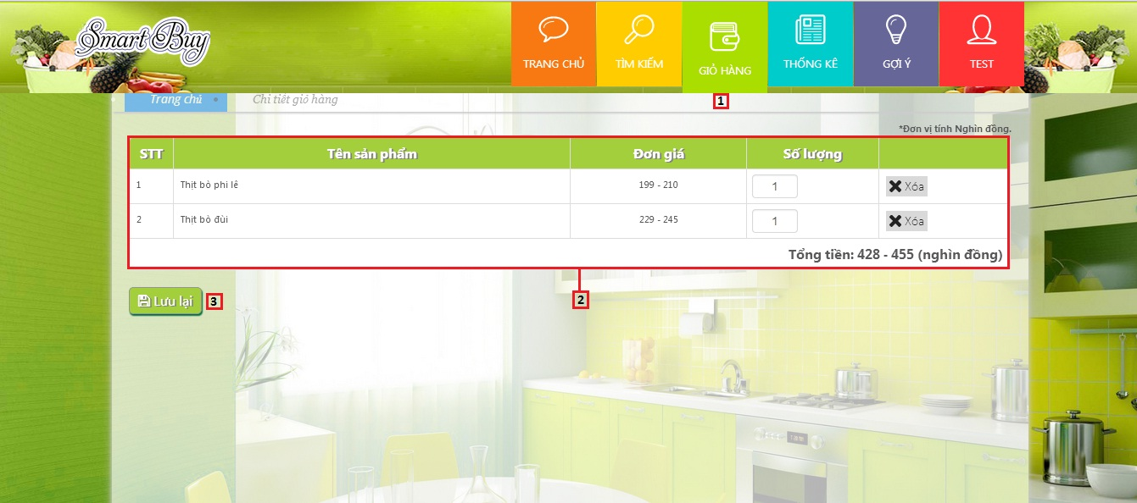

Figure 107: View Cart Page

|  |  |
| --- | --- |
| **Step** | **Description** |
| 1 | Click icon  to go to view cart page |
| 2 | View cart info (product name, price, quantity) |
| 3 | Click button “Lưu lại” to save cart |

Table 51: View Cart Steps

#### View History

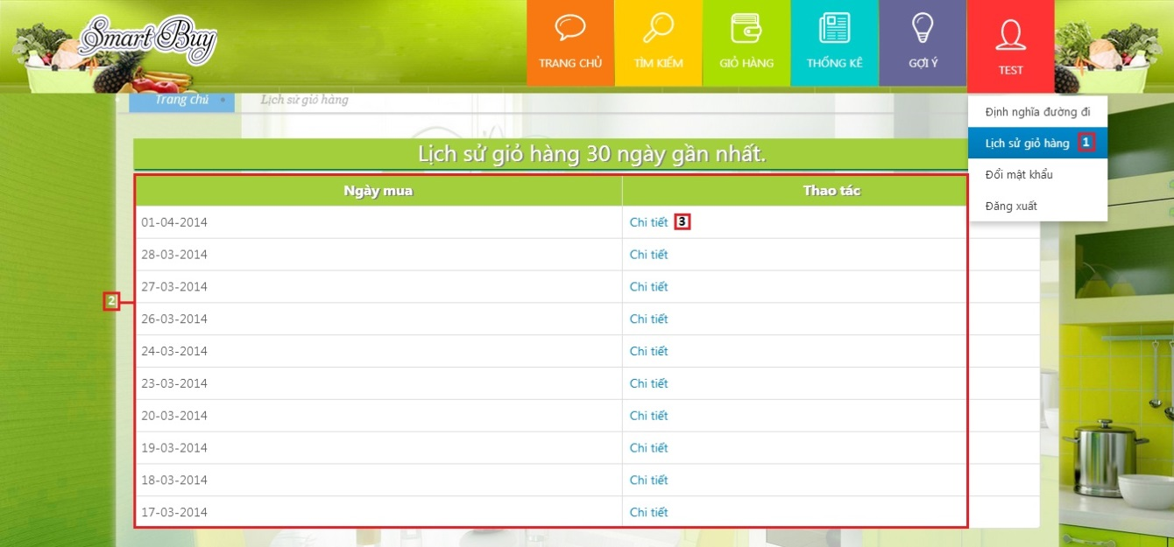

Figure 108: View History Page

|  |  |
| --- | --- |
| **Step** | **Description** |
| 1 | Click “Lịch sử giỏ hàng” link on menu bar to go to view history page |
| 2 | View history list (date saved) |
| 3 | Click “Chi tiết” link to go to history detail page |

Table 52: View History Steps

#### View History Detail

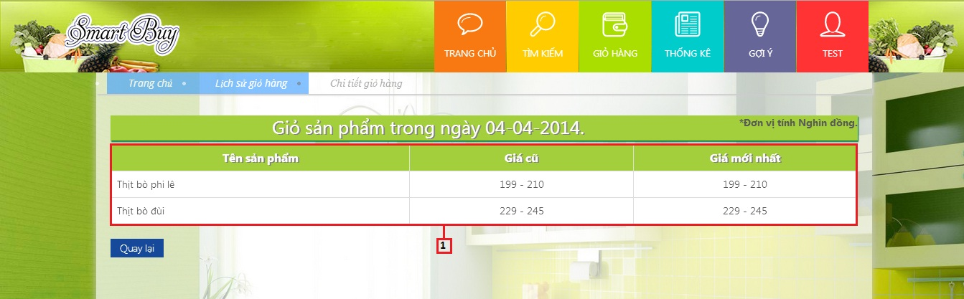

Figure 109: View History Detail Page

|  |  |
| --- | --- |
| **Step** | **Description** |
| 1 | View history detail list (product name, old price, new price) |

Table 53: View History Detail Steps

### Mobile Guide

#### Login

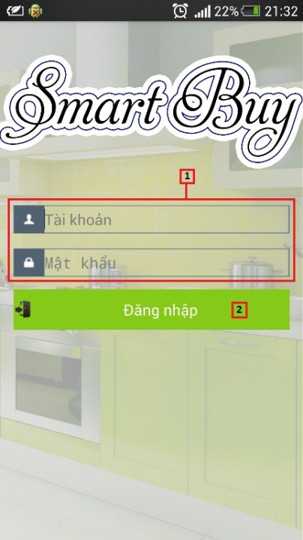

Figure 110: Login Mobile

|  |  |
| --- | --- |
| **Step** | **Description** |
| 1 | Fill “Tài khoản” and “Mật khẩu” |
| 2 | Click button “Đăng nhập” |

Table 54: Login Mobile Steps

#### View Favourite Product

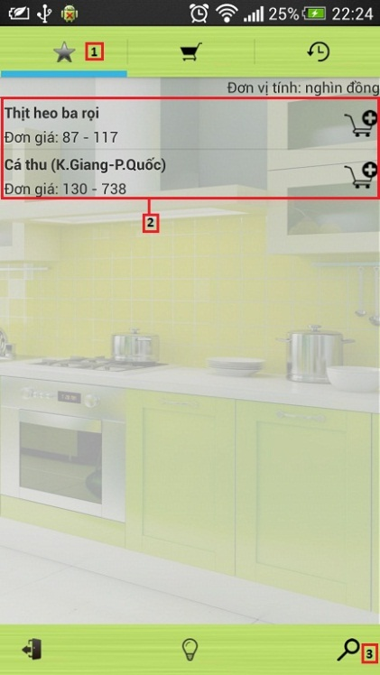

Figure 111: View Favourite Product Mobile

|  |  |
| --- | --- |
| **Step** | **Description** |
| 1 | Click icon  to view favourite product |
| 2 | View favourite product list (product name, price) |
| 3 | Click icon  to search product |

Table 55: View Favourite Product Mobile Steps

#### Search Product

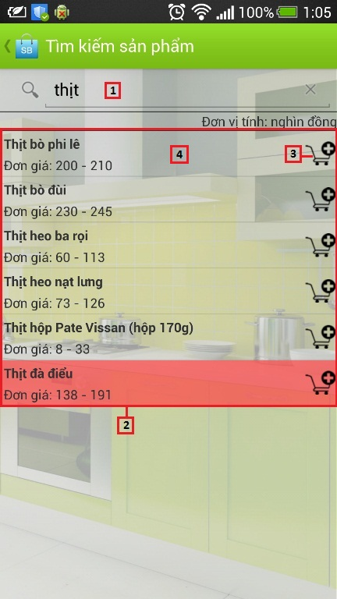

Figure 112: Search Product Mobile

|  |  |
| --- | --- |
| **Step** | **Description** |
| 1 | Fill search key |
| 2 | View search product result list (product name, price) |
| 3 | Click icon  to add product to cart |
| 4 | Click on row to propose price |

Table 56: Search Product Mobile Steps

#### Propose Price

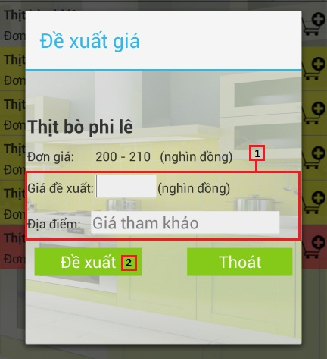

Figure 113: Propose Price Mobile

|  |  |
| --- | --- |
| **Step** | **Description** |
| 1 | Fill “Giá đề xuất” and “Địa điểm” |
| 2 | Click button “Đề xuất” |

Table 57: Propose Price Mobile Steps

#### View Cart

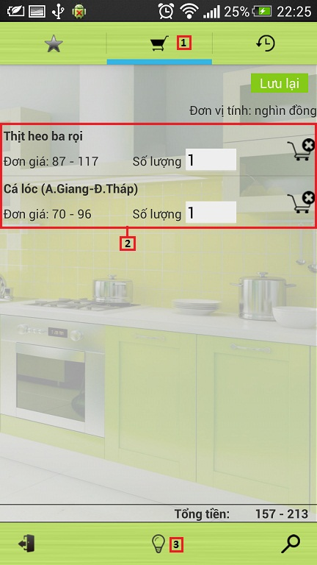

Figure 114: View Cart Mobile

|  |  |
| --- | --- |
| **Step** | **Description** |
| 1 | Click icon  to view cart |
| 2 | View cart info (product name, price, quantity) |
| 3 | Click icon  to view suggest route |

Table 58: View Cart Mobile Steps

#### View Suggestion

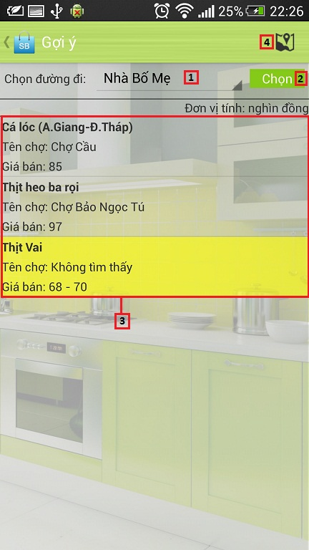

Figure 115: View Suggestion Mobile

|  |  |
| --- | --- |
| **Step** | **Description** |
| 1 | Select route “Chọn đường đi” |
| 2 | Click button “Chọn” |
| 3 | View suggest route list (product name, market, price) |
| 4 | Click icon  to view maps |

Table 59: View Suggestion Mobile Steps

#### View Map

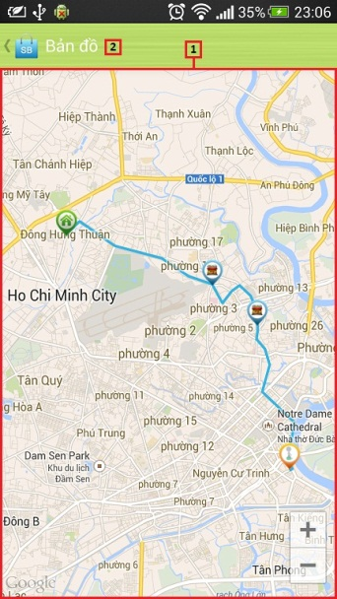

Figure 116: View Map Mobile

|  |  |
| --- | --- |
| **Step** | **Description** |
| 1 | View route on maps |
| 2 | Click icon  to back suggest route screen |

Table 60: View Map Mobile Steps

#### View History

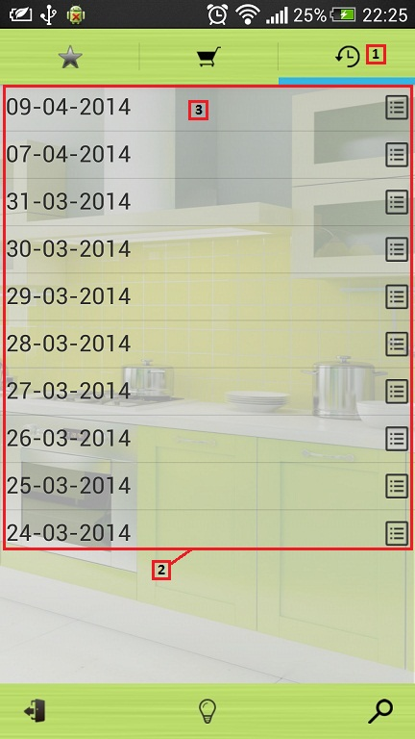

Figure 117: View History Mobile

|  |  |
| --- | --- |
| **Step** | **Description** |
| 1 | Click icon  to view history |
| 2 | View history list (date saved) |
| 3 | Click on row to view history detail |

Table 61: View History Mobile Steps

#### View History Detail

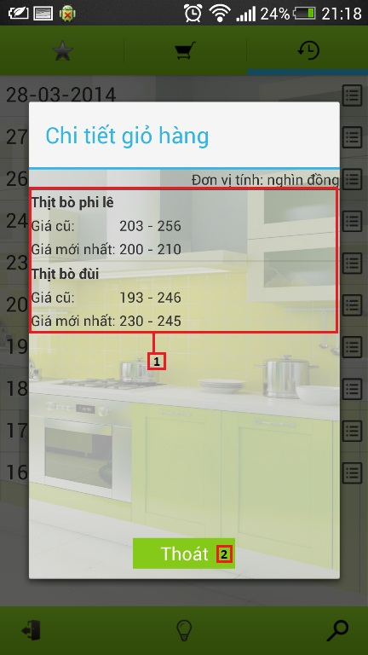

Figure 118: View History Detail Mobile

|  |  |
| --- | --- |
| **Step** | **Description** |
| 1 | View history detail list (product name, old price, new price) |
| 2 | Click button “Thoát” to cancel |

Table 62: View History Detail Mobile Steps

### Staff Guide

#### Import Excel

##### Save Data

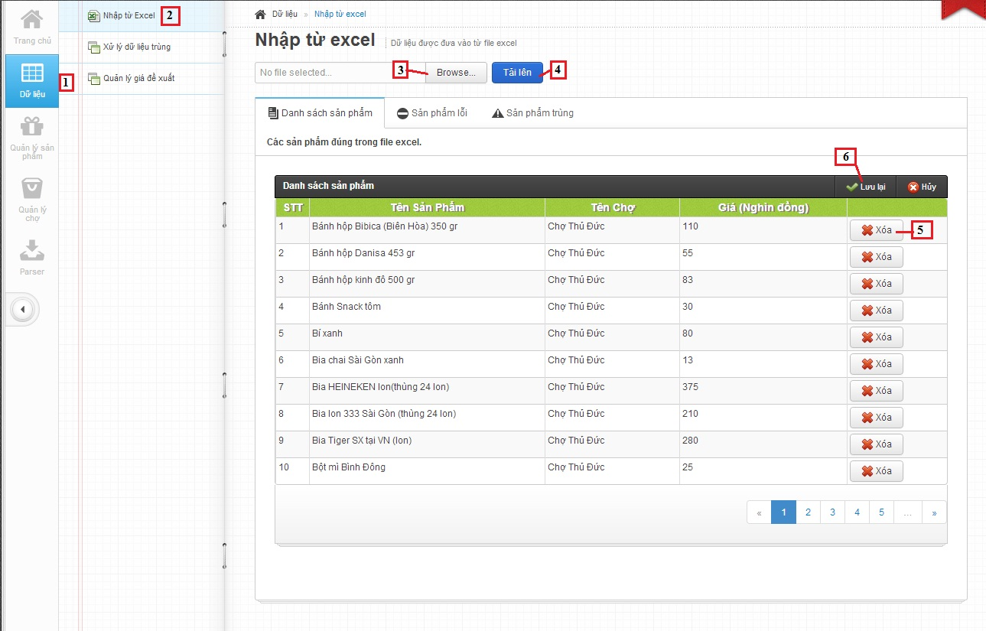

Figure 119: Save Imported Data Page

|  |  |
| --- | --- |
| **Step** | **Description** |
| 1 | Click to button “Dữ Liệu”. |
| 2 | Click to “Nhập từ Excel” link. |
| 3 | Click to select file excel. |
| 4 | Click button “Tải lên” to upload file excel. |
| 5 | Click button “Xóa” to remove product. |
| 6 | Click button “Lưu lại” to save products into database. |

Table 63: Save Imported Data Steps

##### Handle Name Conflict

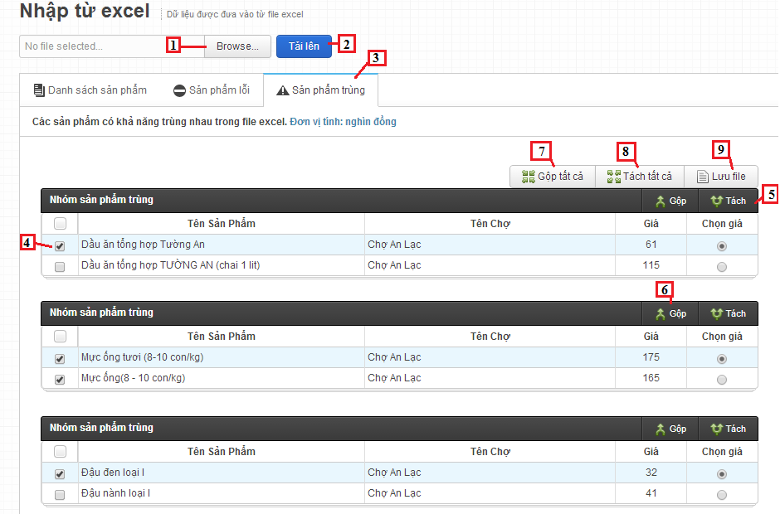

Figure 120: Handle Name Conflict Page

|  |  |
| --- | --- |
| **Step** | **Description** |
| 1 | Click to select file excel. |
| 2 | Click button “Tải lên” to upload file excel. |
| 3 | Click button “Sản phẩm trùng” tab. |
| 4 | Select product by checkbox. |
| 5 | Click button “Tách” to divide duplicate product. |
| 6 | Click button “Gộp” to join duplicate products. |
| 7 | Click button “Gộp tất cả” to join all duplicate products. |
| 8 | Click button “Tách tất cả” to divide all duplicate product. |
| 9 | Click button “Lưu file” to export duplicate products to text file. |

Table 64: Handle Name Conflict Steps

#### Manage Parser

##### Create Parser

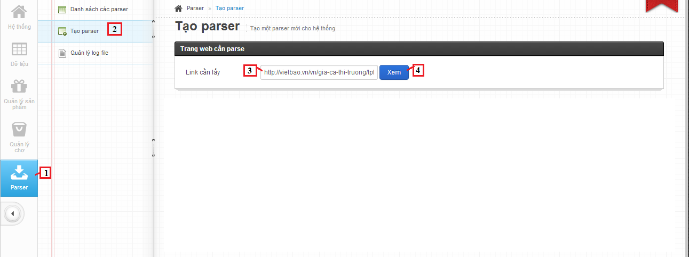

Figure 121: Create Parser Page - 1

|  |  |
| --- | --- |
| **Step** | **Description** |
| 1 | Click tab Parser. |
| 2 | Click link “Tạo parser”. |
| 3 | Fill link to parse. |
| 4 | Click button “Xem” to view website parse. |

Table 65: Create Parser Steps – 1

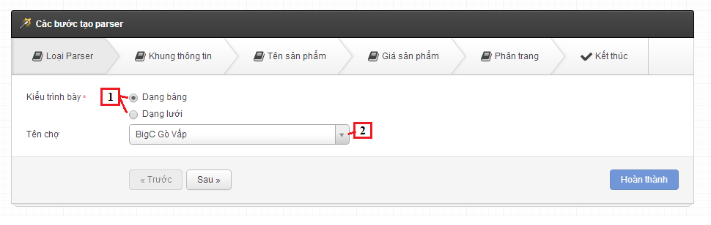

Figure 122: Create Parser Page – 2

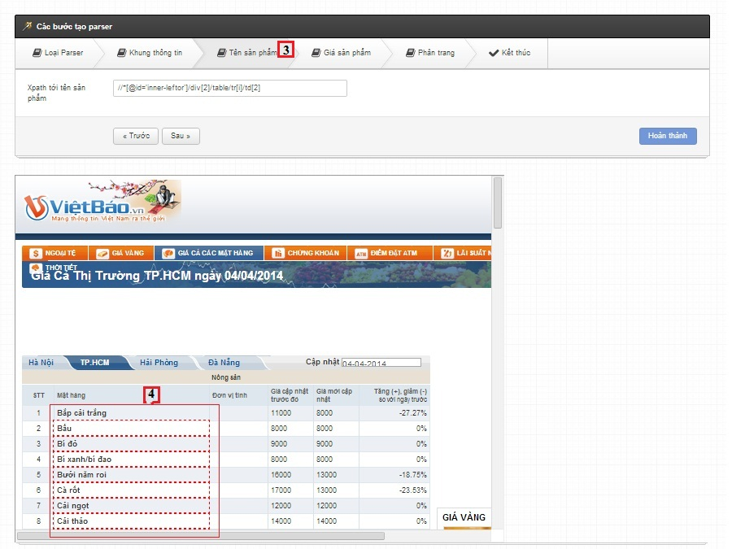

Figure 123: Create Parser Page – 3

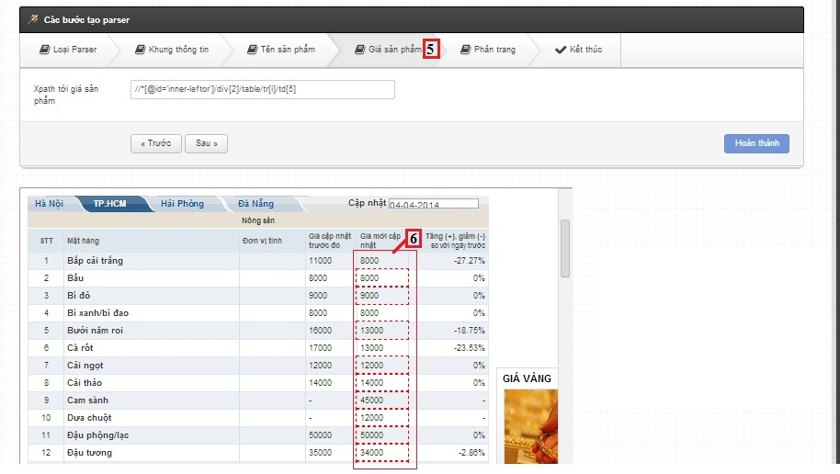

Figure 124: Create Parser Page – 4

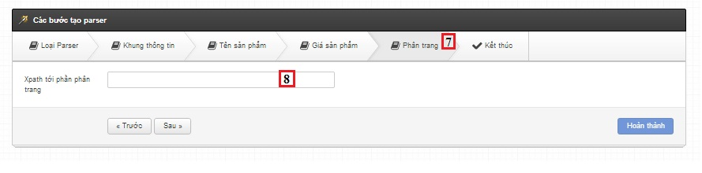

Figure 125: Create Parser Page – 5

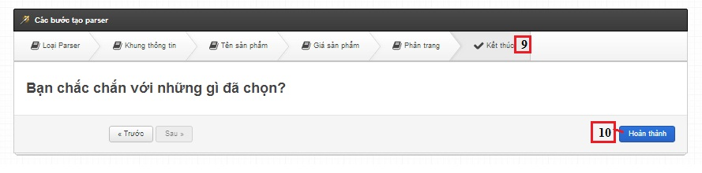

Figure 126: Create Parser Page – 6

|  |  |
| --- | --- |
| **Step** | **Description** |
| 1 | Choose style of product view |
| 2 | Click to select Market |
| 3 | Click tab “Tên sản phẩm” |
| 4 | Select column product name |
| 5 | Click tab “Giá sản phẩm” |
| 6 | Select column product price |
| 7 | Click tab “Phân trang” |
| 8 | Select paged list |
| 9 | Click tab “Kết thúc” |
| 10 | Click button “Hoàn thành” |

Table 66: Create Parser Steps - 2

# Appendix

1. Dynamic Programming: <http://en.wikipedia.org/wiki/Dynamic_programming>
2. String Comparison: <http://www.catalysoft.com/articles/StrikeAMatch.html>
3. Google API: <https://developers.google.com/maps/documentation/javascript/tutorial>